Illicit Discharge Detection and
Elimination (IDDE) Plan

Central Massachusetts Regional
Storm water Coalition

June , 2019

This project has been financed with Funds from the Massachusetts Department of Environmental Protection (the Department). The contents do not necessarily reflect the views and policies of the Department, nor does the mention of trade names or commercial products constitute endorsement or recommendation for use.

Table of Contents

Illicit Discharge Detection and Elimination Plan
Central Massachusetts Regional Storm water Coalition
1 Introduction 3
1.1 MS4 Program 3
1.2 Illicit Discharges 3
1.3 Allowable Non-Stormwater Discharges 4
1.4 Receiving Waters and Impairments 4
1.5 IDDE Program Goals, Framework, and Timeline 5
1.6 Work Completed to Date 7
2 Authority and Statement of IDDE Responsibilities 8
2.1 Legal Authority 8
2.2 Statement of Responsibilities 8
3 Stormwater System Mapping 10
3.1 Phase I Mapping 10
3.2 Phase II Mapping 11
3.3 Additional Recommended Mapping Elements 12
4 Sanitary Sewer Overflows (SSOs) 13
5 Assessment and Priority Ranking of Outfalls 15
5.1 Outfall Catchment Delineations 15
5.2 Outfall and Interconnection Inventory and Initial Ranking 15
6 Dry Weather Outfall Screening and Sampling 19
6.1 Weather Conditions 19
6.2 Dry Weather Screening/Sampling Procedure 19
6.2.1 General Procedure 19
6.2.2 Field Equipment 20
6.2.3 Sample Collection and Analysis 21
6.3 Interpreting Outfall Sampling Results 24
6.4 Follow-up Ranking of Outfalls and Interconnections 24
7 Catchment Investigations 25
7.1 System Vulnerability Factors 25
7.2 Dry Weather Manhole Inspections 28
7.3 Wet Weather Outfall Sampling 29
7.4 Source Isolation and Confirmation 30
7.4.1 Sandbagging 31
7.4.2 Smoke Testing 31
7.4.3 Dye Testing 31
7.4.4 CCTV/Video Inspection 32
7.4.5 Optical Brightener Monitoring 32
7.4.6 IDDE Canines 32
7.5 Illicit Discharge Removal 32
7.5.1 Confirmatory Outfall Screening 33
7.6 Ongoing Screening 34
8 Training 35
9 Progress Reporting 35

Tables
Table 1-1. Impaired Waters 5
Table 1-2. IDDE Program Implementation Timeline 6
Table 4-1. SSO Inventory 14
Table 5-1. Outfall Inventory and Priority Ranking Matrix 18
Table 6-1. Field Equipment – Dry Weather Outfall Screening and Sampling 20
Table 6-2. Sampling Parameters and Analysis Methods 22
Table 6-3. Required Analytical Methods, Detection Limits, Hold Times, and Preservatives⁴ 23
Table 6-4. Benchmark Field Measurements for Select Parameters 24
Table 7-1. Outfall Catchment System Vulnerability Factor (SVF) Inventory 27

Figures
Figure 1-1. IDDE Investigation Procedure Framework 6

Appendices
Appendix A – Legal Authority (IDDE Bylaw or Ordinance)
Appendix B – Storm System Mapping
Appendix C – Field Forms, Sample Bottle Labels, and Chain of Custody Forms
Appendix D – Water Quality Analysis Instructions, User’s Manuals and Standard Operating Procedures
Appendix E – IDDE Employee Training Record
Appendix F – Source Isolation and Confirmation Methods: Instructions, Manuals, and SOPs

Introduction

MS4 Program
This Illicit Discharge Detection and Elimination (IDDE) Plan has been developed by Sturbridge to address the requirements of the United States Environmental Protection Agency’s (USEPA’s) 2016 National Pollutant Discharge Elimination System (NPDES) General Permit for Stormwater Discharges from Small Municipal Separate Storm Sewer Systems (MS4) in Massachusetts, hereafter referred to as the “2016 Massachusetts MS4 Permit” or “MS4 Permit.”

The 2016 Massachusetts MS4 Permit requires that each permittee, or regulated community, address six Minimum Control Measures. These measures include the following:

- Public Education and Outreach
- Public Involvement and Participation
- Illicit Discharge Detection and Elimination Program
- Construction Site Stormwater Runoff Control
- Stormwater Management in New Development and Redevelopment (Post Construction Stormwater Management); and
- Good Housekeeping and Pollution Prevention for Permittee Owned Operations.

Under Minimum Control Measure 3, the permittee is required to implement an IDDE program to systematically find and eliminate sources of non-stormwater discharges to its municipal separate storm sewer system and implement procedures to prevent such discharges. The IDDE program must also be recorded in a written (hardcopy or electronic) document. This IDDE Plan has been prepared to address this requirement.

Illicit Discharges
An “illicit discharge” is any discharge to a drainage system that is not composed entirely of stormwater, with the exception of discharges pursuant to a NPDES permit (other than the NPDES permit for discharges from the MS4) and discharges resulting from fire-fighting activities.

Illicit discharges may take a variety of forms. Illicit discharges may enter the drainage system through direct or indirect connections. Direct connections may be relatively obvious, such as cross-connections of sewer services to the storm drain system. Indirect illicit discharges may be more difficult to detect or address, such as failing septic systems that discharge untreated sewage to a ditch within the MS4, or a sump pump that discharges contaminated water on an intermittent basis.

Some illicit discharges are intentional, such as dumping used oil (or other pollutant) into catch basins, a resident or contractor illegally tapping a new sewer lateral into a storm drain pipe to avoid the costs of a sewer connection fee and service, and illegal dumping of yard wastes into surface waters.
Some illicit discharges are related to the unsuitability of original infrastructure to the modern regulatory environment. Examples of illicit discharges in this category include connected floor drains in old buildings, as well as sanitary sewer overflows that enter the drainage system. Sump pumps legally connected to the storm drain system may be used inappropriately, such as for the disposal of floor wash water or old household products, in many cases due to a lack of understanding on the part of the homeowner.

Elimination of some discharges may require substantial costs and efforts, such as funding and designing a project to reconnect sanitary sewer laterals. Others, such as improving self-policing of dog waste management, can be accomplished by outreach in conjunction with the minimal additional cost of dog waste bins and the municipal commitment to disposal of collected materials on a regular basis.

Regardless of the intention, when not addressed, illicit discharges can contribute high levels of pollutants, such as heavy metals, toxics, oil, grease, solvents, nutrients, and pathogens to surface waters.

Allowable Non-Stormwater Discharges
The following categories of non-storm water discharges are allowed under the MS4 Permit unless the permittee, USEPA or Massachusetts Department of Environmental Protection (MassDEP) identifies any category or individual discharge of non-storm water discharge as a significant contributor of pollutants to the MS4:

- Water line flushing
- Landscape irrigation
- Diverted stream flows
- Rising ground water
- Uncontaminated ground water infiltration (as defined at 40 CFR 35.2005(20))
- Uncontaminated pumped groundwater
- Discharge from potable water sources
- Foundation drains
- Air conditioning condensation
- Irrigation water, springs
- Water from crawl space pumps
- Footing drains
- Lawn watering
- Individual resident car washing
- De-chlorinated swimming pool discharges
- Street wash waters
- Residential building wash waters without detergents

If these discharges are identified as significant contributors to the MS4, they must be considered an “illicit discharge” and addressed in the IDDE Plan (i.e., control these sources so they are no longer significant contributors of pollutants, and/or eliminate them entirely).

Receiving Waters and Impairments
Table 1-1 lists the “impaired waters” within the boundaries of Sturbridge regulated area based on the Massachusetts Integrated List of Waters produced by MassDEP every two years. Impaired waters are water bodies that do not meet water quality standards for one or more designated use(s) such as recreation or aquatic habitat.

Refer to MassDEP’s website for most recent Integrated List of Waters (CWA Sections 303d, 305B, and 314): http://www.mass.gov/eea/agencies/massdep/water/watersheds/total-maximum-daily-loads-tmdls.html.

Table 1-1. Impaired Waters

Sturbridge, Massachusetts
Water Body Name | Segment ID | Category | Impairment(s) | Associated Approved TMDL
East Brimfield Reservoir | MA41014_2008 | 4c | Exotic Species, Mercury | NEHgTMDL
Quinebaug River | MA41-01_2008 | 5 | Chronic aquatic toxicity,  Fishes bioassessments,  Lack of cold water  Assembledge,
CedarPond | MA41008_2008 | 4c | Non- native aquatic plants
Pistol Pond | MA41057_2008 | 5 | Dissolved oxygen, secchi disk transperancy. Aquatic plants (noxious)
Category 4a Waters – impaired water bodies with a completed Total Maximum Daily Load (TMDL).
Category 4c Waters – impaired water bodies where the impairment is not caused by a pollutant. No TMDL required.
Category 5 Waters – impaired water bodies that require a TMDL.
“Approved TMDLs” are those that have been approved by EPA as of the date of issuance of the 2016 MS4 Permit.

IDDE Program Goals, Framework, and Timeline
The goals of the IDDE program are to find and eliminate illicit discharges to municipal separate storm sewer system and to prevent illicit discharges from happening in the future. The program consists of the following major components as outlined in the MS4 Permit:

- Legal authority and regulatory mechanism to prohibit illicit discharges and enforce this prohibition
- Storm system mapping
- Inventory and ranking of outfalls
- Dry weather outfall screening
- Catchment investigations
- Identification/confirmation of illicit sources
- Illicit discharge removal
- Follow up screening
- Employee training.

The IDDE investigation procedure framework is shown in Figure 1-1. The required timeline for implementing the IDDE program is shown in Table 1-2.

Figure 1-1. IDDE Investigation Procedure Framework
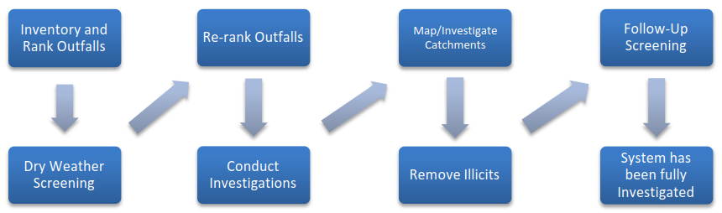

Table 1-2. IDDE Program Implementation Timeline
IDDE Program Requirement | Completion Date from Effective Date of Permit
 | 1 Year | 1.5 Years | 2 Years | 3 Years | 7 Years | 10 Years
Written IDDE Program Plan | X
SSO Inventory | X
Written Catchment Investigation Procedure |  | X
Phase I Mapping |  |  | X
Phase II Mapping |  |  |  |  |  | X
IDDE Regulatory Mechanism or By-law (if not already in place) |  |  |  | X
Dry Weather Outfall Screening |  |  |  | X
Follow-up Ranking of Outfalls and Interconnections |  |  |  | X
Catchment Investigations – Problem Outfalls |  |  |  |  | X
Catchment Investigations – all Problem, High and Low Priority Outfalls |  |  |  |  |  | X

Work Completed to Date
The 2003 MS4 Permit required each MS4 community to develop a plan to detect illicit discharges using a combination of storm system mapping, adopting a regulatory mechanism to prohibit illicit discharges and enforce this prohibition, and identifying tools and methods to investigate suspected illicit discharges. Each MS4 community was also required to define how confirmed discharges would be eliminated and how the removal would be documented.
The town of Sturbridge has completed the following IDDE program activities consistent with the 2003 MS4 Permit requirements:
- Developed a map of outfalls and receiving waters
- Adopted an IDDE bylaw or regulatory mechanism
- Developed procedures for locating illicit discharges (i.e., visual screening of outfalls for dry weather discharges, dye or smoke testing)
- Developed procedures for locating the source of the discharge
- Developed procedures for removal of the source of an illicit discharge
- Developed procedures for documenting actions and evaluating impacts on the storm sewer system subsequent to removal
In addition to the 2003 MS4 Permit requirements, other IDDE-related activities that may have been completed include:
- SSO inventory
- Outfall sampling
- Additional storm system mapping, including the locations of catch basins, manholes and pipe connectivity

Authority and Statement of IDDE Responsibilities

Legal Authority

The Town of Sturbridge has adopted a Storm Water By Law (2018). A copy of the Sturbridge storm water by law is provided in Appendix A . Sturbridge storm water by law provides the town of Sturbridge with adequate legal authority to:
- Prohibit illicit discharges
- Investigate suspected illicit discharges.
- Eliminate illicit discharges, including discharges from properties not owned by or controlled by the MS4 that discharge into the MS4 system
- Implement appropriate enforcement procedures and actions.
The town of Sturbridge will review its current ##NAME OF BYLAW and related land use regulations and policies for consistency with the 2016 MS4 Permit.

Statement of Responsibilities
The Department of Public Works is the lead municipal agency or department responsible for implementing the IDDE program pursuant to the provisions of the Storm water by law. Other agencies or departments with responsibility for aspects of the program include: planning, conservation, and the sewer department. The department of public works has been coordinating with conservation to implement the IDDE. Both departments worked to determine high priority outfalls, catchment investigations, and public outreach. The conservation department and public works will perform field investigations as the IDDE program goes forward. Monthly department head meetings are held in addition.
Our coordination process with conservation department began with presenting the drainage system to our new conservation agent along with our findings. Conservation is greatly involved due to their regulatory action and enforcement of the wetland protection act. From there conservation dept. used wetland and waterbody knowledge in order to determine number and proximity of outfalls near waterbodys. We also came up with a plan for the next phase which will be going to key junction manholes and starting catchment investigations. In the future we will work together to come up with BMPs for drainage improvements on some of our road projects. For illicit connections found, conservation will review our plan to rectify as well as review of drainage repairs. The public involvement section of the permit was coordinated . Lastly, our departments work together with planning, and building for construction site environmental protections procedures and inspections.

- Department of Public Works – Mapping, IDDE detection, permits, public outreach participation
- Highway Department – Mapping , IDDE detection, O&M plan, winter road maintenance.
- Sewer Department – SSO inventory, Sampling
- Building Inspector and/or Code Enforcement Officer – site plan inspections.
- Licensed Plumbing Inspector - None
- Health Department – Notified of IDDE, regulation of any waste going into stormwater.
- Engineering Department – Under D.P.W
- Conservation Agent - Public outreach , construction BMPs , site inspections
- Conservation Commission – Public outreach, inspection.
- Planning Board Chairperson – review stormwater laws and regulations.
- Board of Selectmen – Oversight, by laws
- Town Administrator and/or Mayor – Funding, oversight.

Stormwater System Mapping
The town of Sturbridge originally developed mapping of its storm water system to meet the mapping requirements of the 2003 MS4 Permit. A copy of the existing storm system map is provided in Appendix B. The 2016 MS4 Permit requires a more detailed storm system map than was required by the 2003 MS4 Permit. The revised mapping is intended to facilitate the identification of key infrastructure, factors influencing proper system operation, and the potential for illicit discharges.
The 2016 MS4 Permit requires the storm system map to be updated in two phases as outlined below. The Department of Public Works is responsible for updating the stormwater system mapping pursuant to the 2016 MS4 Permit. The town of Sturbridge will report on the progress towards completion of the storm system map in each annual report. Updates to the stormwater mapping will be included in Appendix B.

Phase I Mapping
Phase I mapping must be completed within two (2) years of the effective date of the permit (July 1, 2019) and include the following information:

- Outfalls and receiving waters (previously required by the MS4-2003 permit)
- Open channel conveyances (swales, ditches, etc.)
- Interconnections with other MS4s and other storm sewer systems
- Municipally owned stormwater treatment structures
- Water bodies identified by name and indication of all use impairments as identified on the most recent EPA approved Massachusetts Integrated List of Waters report
- Initial catchment delineations. Topographic contours and drainage system information may be used to produce initial catchment delineations.

The town of Sturbridge has completed the following updates to its stormwater mapping to meet the Phase I requirements:

- INCLUDED IN MAP SECTION
- Outfalls and receiving waters (previously required by the MS4-2003 permit)

Interconnections with other MS4s and other storm sewer systems
- Municipally owned stormwater treatment structures
- Water bodies identified by name and indication of all use impairments as identified on the most recent EPA approved Massachusetts Integrated List of Waters report
- Initial catchment delineations. Any available system data and topographic information may be used to produce initial catchment delineations –(will be mapped year 2 of permit)
I
The Town of Sturbridge will update its stormwater mapping by July 1, 2019 to include the remaining Phase I information.

Phase II Mapping
Phase II mapping must be completed within ten (10) years of the effective date of the permit (July 1, 2027) and include the following information:

- Outfall spatial location (latitude and longitude with a minimum accuracy of +/-30 feet)
- Pipes
- Manholes
- Catch basins
- Refined catchment delineations. Catchment delineations must be updated to reflect information collected during catchment investigations.
- Municipal Sanitary Sewer system (if available)
- Municipal combined sewer system (if applicable).

The town of Sturbridge has completed the following updates to its stormwater mapping to meet the Phase II requirements:

Recently Mapped:
- Outfall spatial location (latitude and longitude with a minimum accuracy of +/-30 feet)
- Pipes
- Manholes
- Catch basins
- Municipal Sanitary Sewer system (if available)-Sewer system is mapped in arc gis online
- Municipal combined sewer system (if applicable) –Not applicable

The town of Sturbridge will update its stormwater mapping by July 1, 2027 to include the remaining following Phase II information.

Additional Recommended Mapping Elements
Although not a requirement of the 2016 MS4 Permit, the town of Sturbridge HAS/WILL include the following recommended elements in its storm system mapping:

- Storm sewer material, size (pipe diameter), age
- Sanitary sewer system material, size (pipe diameter), age

Sanitary Sewer Overflows (SSOs)
The 2016 MS4 Permit requires municipalities to prohibit illicit discharges, including sanitary sewer overflows (SSOs), to the separate storm sewer system. SSOs are discharges of untreated sanitary wastewater from a municipal sanitary sewer that can contaminate surface waters, cause serious water quality problems and property damage, and threaten public health. SSOs can be caused by blockages, line breaks, sewer defects that allow storm water and groundwater to overload the system, power failures, improper sewer design, and vandalism.

The town of Sturbridge has completed an inventory of SSOs that have discharged to the MS4 within the five (5) years prior to the effective date of the 2016 MS4 Permit, based on review of available documentation pertaining to SSOs (Table 4-1). The inventory includes all SSOs that occurred during wet or dry weather resulting from inadequate conveyance capacities or where interconnectivity of the storm and sanitary sewer infrastructure allows for transfer of flow between systems.

Upon detection of an SSO, the town of Sturbridge will eliminate it as expeditiously as possible and take interim measures to minimize the discharge of pollutants to and from its MS4 until the SSO is eliminated. Upon becoming aware of an SSO to the MS4, the town of Sturbridge will provide oral notice to EPA within 24 hours and written notice to EPA and MassDEP within five (5) days of becoming aware of the SSO occurrence.

The inventory in Table 4-1 will be updated by the Department of Public Works and Sewer Department when new SSOs are detected. The SSO inventory will be included in the annual report, including the status of mitigation and corrective measures to address each identified SSO.

Table 4-1. SSO Inventory
Sturbridge, Massachusetts
Revision Date: 07/16/2018

SSO Location¹ | Discharge Statement² | Date³ | Time Start³ | Time End³ | Estimated Volume⁴ | Description⁵ | Mitigation Completed⁶ | Mitigation Planned⁷
216 Charlton Rd  Wendy’s restaurant | Unanticipated SSO or  bypass | 07/16/2018 | 1:41  pm | 8:45  pm | <10,000  gallons | Caused by a sewer system blockage collapse, overflow discharge went from road to catch basin to detention basin. | Repaired sewer/ & cleared blockage. EPA was  Notified. Shoveled sludge into Septage receiving used shop vacc to clean off truck and hosed it down.

¹ Location (approximate street crossing/address and receiving water, if any)
² A clear statement of whether the discharge entered a surface water directly or entered the MS4
³ Date(s) and time(s) of each known SSO occurrence (i.e., beginning and end of any known discharge)
⁴ Estimated volume(s) of the occurrence
⁵ Description of the occurrence indicating known or suspected cause(s)
⁶ Mitigation and corrective measures completed with dates implemented
⁷ Mitigation and corrective measures planned with implementation schedules

Assessment and Priority Ranking of Outfalls
The 2016 MS4 Permit requires an assessment and priority ranking of outfalls in terms of their potential to have illicit discharges and SSOs and the related public health significance. The ranking helps determine the priority order for performing IDDE investigations and meeting permit milestones.

Outfall Catchment Delineations
A catchment is the area that drains to an individual outfall or interconnection. The catchments for each of the MS4 outfalls will be delineated to define contributing areas for investigation of potential sources of illicit discharges. Catchments are typically delineated based on topographic contours and mapped drainage infrastructure, where available. As described in Section 3, initial catchment delineations will be completed as part of the Phase I mapping, and refined catchment delineations will be completed as part of the Phase II mapping to reflect information collected during catchment investigations

Outfall and Interconnection Inventory and Initial Ranking
The department of public works will complete an initial outfall and interconnection inventory and priority ranking to assess illicit discharge potential based on existing information. The initial inventory and ranking will be completed within one (1) year from the effective date of the permit. An updated inventory and ranking will be provided in each annual report thereafter. The inventory will be updated annually to include data collected in connection with dry weather screening and other relevant inspections.

The outfall and interconnection inventory will identify each outfall and interconnection discharging from the MS4, record its location and condition, and provide a framework for tracking inspections, screenings and other IDDE program activities.

Outfalls and interconnections will be classified into one of the following categories:

- Problem Outfalls: Outfalls/interconnections with known or suspected contributions of illicit discharges based on existing information shall be designated as Problem Outfalls. This shall include any outfalls/interconnections where previous screening indicates likely sewer input. Likely sewer input indicators are any of the following:

- Olfactory or visual evidence of sewage,
- Ammonia ≥ 0.5 mg/L, surfactants ≥ 0.25 mg/L, and bacteria levels greater than the water quality criteria applicable to the receiving water, or
- Ammonia ≥ 0.5 mg/L, surfactants ≥ 0.25 mg/L, and detectable levels of chlorine.

Dry weather screening and sampling, as described in Section 6 of this IDDE Plan and Part 2.3.4.7.b of the MS4 Permit, is not required for Problem Outfalls.

- High Priority Outfalls: Outfalls/interconnections that have not been classified as Problem Outfalls and that are:

  - Discharging to an area of concern to public health due to proximity of public beaches, recreational areas, drinking water supplies or shellfish beds
  - Determined by the permittee as high priority based on the characteristics listed below or other available information.

- Low Priority Outfalls: Outfalls/interconnections determined by the permittee as low priority based on the characteristics listed below or other available information.

- Excluded outfalls: Outfalls/interconnections with no potential for illicit discharges may be excluded from the IDDE program. This category is limited to roadway drainage in undeveloped areas with no dwellings and no sanitary sewers; drainage for athletic fields, parks or undeveloped green space and associated parking without services; cross-country drainage alignments (that neither cross nor are in proximity to sanitary sewer alignments) through undeveloped land.

Outfalls will be ranked into the above priority categories (except for excluded outfalls, which may be excluded from the IDDE program) based on the following characteristics of the defined initial catchment areas, where information is available. Additional relevant characteristics, including location-specific characteristics, may be considered but must be documented in this IDDE Plan.

- Previous screening results – previous screening/sampling results indicate likely sewer input (see criteria above for Problem Outfalls).

- Past discharge complaints and reports.

- Poor receiving water quality – the following guidelines are recommended to identify waters as having a high illicit discharge potential:
  - Exceeding water quality standards for bacteria
  - Ammonia levels above 0.5 mg/l
  - Surfactants levels greater than or equal to 0.25 mg/l

- Age of development and infrastructure – Industrial areas greater than 40 years old and areas where the sanitary sewer system is more than 40 years old will probably have a high illicit discharge potential. Developments 20 years or younger will probably have a low illicit discharge potential.

- Sewer conversion – Contributing catchment areas that were once serviced by septic systems, but have been converted to sewer connections may have a high illicit discharge potential.

- Surrounding density of aging septic systems – Septic systems thirty years or older in residential land use areas are prone to have failures and may have a high illicit discharge potential.

- Culverted streams – Any river or stream that is culverted for distances greater than a simple roadway crossing may have a high illicit discharge potential.

- Water quality limited waterbodies that receive a discharge from the MS4 or waters with approved TMDLs applicable to the permittee, where illicit discharges have the potential to contain the pollutant identified as the cause of the water quality impairment.

Table 5-1 provides a sample format for an outfall inventory and priority ranking matrix.

Table 5-1. Outfall Inventory and Priority Ranking Matrix
Town of Sturidge, Massachusetts
Revision Date: June 2019

Outfall ID | Receiving Water | Previous Screening Results Indicate Likely Sewer Input? ¹ | Discharging to Area of Concern to Public Health? ² | Frequency of Past Discharge Complaints | Receiving Water Quality ³ | Density of Generating Sites ⁴ | Age of Development/ Infrastructure ⁵ | Historic Combined Sewers or Septic? ⁶ | Aging Septic? ⁷ | Culverted Streams? ⁸ | Additional Characteristics | Score | Priority Ranking
Information Source |  | Outfall inspections and sample results | GIS Maps | Town Staff | Impaired Waters List | Land Use/GIS Maps, Aerial Photography | Land Use Information, Visual Observation | Town Staff, GIS Maps | Land Use, Town Staff | GIS and Storm System Maps | Other
Scoring Criteria |  | Yes = 3 (Problem Outfall)  No = 0 | Yes = 3  No = 0 | Frequent = 3  Occasional = 2  None = 0 | Poor = 3  Fair = 2  Good = 0 | High = 3  Medium = 2  Low = 1 | High = 3  Medium = 2  Low = 1 | Yes = 3  No = 0 | Yes = 3  No = 0 | Yes = 3  No = 0 | TBD
WALL-OF  01-HP | Quinnebaug River | NO=0 | Yes=-3 | None=0 | Fair=2 | High=3 | High=3 | No=0 | Yes=3 | NO=0 | None | 14 | High Priority
SHEP OF#7  HP | Unnamed tributary to  Quinnebaug River | NO=0 | Yes=3 | None=0 | Fair=2 | High=3 | High=3 | No=0 | Yes=3 | No=0 | None | 14 | High Priority
HILL-HP-OF#1 | Quinnebaug River | NO=0 | No=0 | None=0 | Fair=2 | High=3 | High=3 | No=0 | Yes=3 | No=0 | None | 11 | High Priority
FAIR-OF-H3 | Unamed tributary to  Quinnebaug River | NO=0 | No=0 | None=0 | Fair=2 | High=3 | High=3 | No=0 | Yes=3 | No=0 | None | 11 | High Priority
CHAR-01-HP | Hobbs Brook /Pistol  Pond | No=0 | No=0 | None=0 | Poor=3 | High=3 | High=3 | No=0 | Yes=3 | No=0 | None | 13 | High Priority
RIVER RD  #1 | Breakneck Brook, to  quinnebaug | No=0 | No=0 | None=0 | Fair=2 | High=3 | High=3 | No=0 | Yes=3 | No=0 | None | 11 | High Priority
CEDAR-st  OF#1 | Cedar Pond | NO=0 | Yes=3 | NO=0 | Poor=3 | High=3 | High=3 | No=0 | Yes=3 | No=0 | None | 15 | High Priority
Brookfield  OF 8 HP | East Brimfield  Resovoir | NO=0 | Yes=3 | NO=0 | Poor=3 | High=3 | High=3 | No=0 | Yes=3 | NO=0 | None | 15 | High Priority
Cedar Pond OF  #2 | Cedar Pond | No=0 | Yes=3 | No=0 | Poor=3 | High=3 | High=3 | No=0 | Yes=3 | No=0 | None | 15 | High Priority
Holland  Rd, OF #1 | Quinnebaug River #5 | No=0 | Yes=3 | No=0 | Poor=3 | High=3 | High=3 | No=0 | Yes=3 | No=0 | None | 15 | High Priority
Coll-HP  OF#1 | Quinnebaug River#5  Tritutary to river | No=0 | Yes=3 | No=0 | Poor=3 | High=3 | High=3 | No=0 | Yes=3 | No=0 | None | 15 | High Priority
HP-ARN-  OF-OF#1 | Unamed tributary to  Quinnebaug river#% | No=0 | Yes=3 | No=0 | Poor=3 | High=3 | High=3 | No=0 | Yes=3 | N0=0 | None | 15 | High Priority
Glen-OF  HP | Unamed tributary to  Cedar pond | No=0 | Yes=3 | No=0 | Poor=3 | High=3 | High=3 | No=0 | Yes=3 | No=0 | None | 15 | High Priority
ND-HP-HP  #1 | Unamed tributary  To Brimfield resovoir | No=0 | Yes=3 | No=0 | Poor=3 | High=3 | High=3 | No=0 | Yes=3 | No=0 | None | 15 | High Priority
Acorn-HP-  OF#1 | Unamed tributary to  To cedar pond | NO=0 | Yes=3 | No=0 | Poor=3 | High=3 | High=3 | No=0 | Yes=3 | NO=0 | NOne | 15 | High Priority

Scoring Criteria:
¹ Previous screening results indicate likely sewer input if any of the following are true:
- Olfactory or visual evidence of sewage,
- Ammonia ≥ 0.5 mg/L, surfactants ≥ 0.25 mg/L, and bacteria levels greater than the water quality criteria applicable to the receiving water, or
- Ammonia ≥ 0.5 mg/L, surfactants ≥ 0.25 mg/L, and detectable levels of chlorine
² Outfalls/interconnections that discharge to or in the vicinity of any of the following areas: public beaches, recreational areas, drinking water supplies, or shellfish beds
³ Receiving water quality based on latest version of MassDEP Integrated List of Waters.
- Poor = Waters with approved TMDLs (Category 4a Waters) where illicit discharges have the potential to contain the pollutant identified as the cause of the impairment
- Fair = Water quality limited waterbodies that receive a discharge from the MS4 (Category 5 Waters)
- Good = No water quality impairments
⁴ Generating sites are institutional, municipal, commercial, or industrial sites with a potential to contribute to illicit discharges (e.g., car dealers, car washes, gas stations, garden centers, industrial manufacturing, etc.)
⁵ Age of development and infrastructure:
- High = Industrial areas greater than 40 years old and areas where the sanitary sewer system is more than 40 years old
- Medium = Developments 20-40 years old
- Low = Developments less than 20 years old
⁶ Areas once served by combined sewers and but have been separated, or areas once served by septic systems but have been converted to sanitary sewers.
⁷ Aging septic systems are septic systems 30 years or older in residential areas.
⁸ Any river or stream that is culverted for distance greater than a simple roadway crossing.

Dry Weather Outfall Screening and Sampling
Dry weather flow is a common indicator of potential illicit connections. The MS4 Permit requires all outfalls/interconnections (excluding Problem and excluded Outfalls) to be inspected for the presence of dry weather flow. The Department of Public Works is responsible for conducting dry weather outfall screening, starting with High Priority outfalls, followed by Low Priority outfalls, based on the initial priority rankings described in the previous section.

Weather Conditions
Dry weather outfall screening and sampling may occur when no more than 0.1 inches of rainfall has occurred in the previous 24-hour period and no significant snow melt is occurring. For purposes of determining dry weather conditions, program staff will use precipitation data from Weather underground. If weather underground is not available or not reporting current weather data, then precision weather will be used as a back-up.

Dry Weather Screening/Sampling Procedure
http://centralmastormwater.org/Pages/crsc_toolbox/Dry%20Outfall%20Inspection%20SOP%20and%20Form_Final.pdf

General Procedure
The dry weather outfall inspection and sampling procedure consists of the following general steps:

- Identify outfall(s) to be screened/sampled based on initial outfall inventory and priority ranking
- Acquire the necessary staff, mapping, and field equipment (see Table 6-1 for list of potential field equipment)
- Conduct the outfall inspection during dry weather:
  - Mark and photograph the outfall
  - Record the inspection information and outfall characteristics (using paper forms or digital form using a tablet or similar device) (see form in Appendix C)
  - Look for and record visual/olfactory evidence of pollutants in flowing outfalls including odor, color, turbidity, and floatable matter (suds, bubbles, excrement, toilet paper or sanitary products). Also observe outfalls for deposits and stains, vegetation, and damage to outfall structures.
- If flow is observed, sample and test the flow following the procedures described in the following sections.
- If no flow is observed, but evidence of illicit flow exists (illicit discharges are often intermittent or transitory), revisit the outfall during dry weather within one week of the initial observation, if practicable, to perform a second dry weather screening and sample any observed flow. Other techniques can be used to detect intermittent or transitory flows including conducting inspections during evenings or weekends and using optical brighteners.
- Input results from screening and sampling into spreadsheet/database. Include pertinent information in the outfall/interconnection inventory and priority ranking.
- Include all screening data in the annual report.

Previous outfall screening/sampling conducted under the 2013 MS4 Permit may be used to satisfy the dry weather outfall/screening requirements of the 2016 MS4 Permit only if the previous screening and sampling was substantially equivalent to that required by the 2016 MS4 Permit, including the list of analytes outlined in Section 2.3.4.7.b.iii.4 of the 2016 permit.

Field Equipment
Table 6-1 lists field equipment commonly used for dry weather outfall screening and sampling.

Table 6-1. Field Equipment – Dry Weather Outfall Screening and Sampling
Equipment | Use/Notes
Clipboard | For organization of field sheets and writing surface
Field Sheets | Field sheets for both dry weather inspection and Dry weather sampling should be available with extras
Chain of Custody Forms | To ensure proper handling of all samples
Pens/Pencils/Permanent Markers | For proper labeling
Nitrile Gloves | To protect the sampler as well as the sample from contamination
Flashlight/headlamp w/batteries | For looking in outfalls or manholes, helpful in early mornings as well
Cooler with Ice | For transporting samples to the laboratory
Digital Camera | For documenting field conditions at time of inspection
Personal Protective Equipment (PPE) | Reflective vest, Safety glasses and boots at a minimum
GPS Receiver | For taking spatial location data
Water Quality Sonde | If needed, for sampling conductivity, temperature, pH
Water Quality Meter | Hand held meter, if available, for testing for various water quality parameters such as ammonia, surfactants and chlorine
Test Kits | Have extra kits on hand to sample more outfalls than are anticipated to be screened in a single day
Label Tape | For labeling sample containers
Sample Containers | Make sure all sample containers are clean.  Keep extra sample containers on hand at all times.  Make sure there are proper sample containers for what is being sampled for (i.e., bacteria requires sterile containers).
Pry Bar or Pick | For opening catch basins and manholes when necessary
Sandbags | For damming low flows in order to take samples
Small Mallet or Hammer | Helping to free stuck manhole and catch basin covers
Utility Knife | Multiple uses
Measuring Tape | Measuring distances and depth of flow
Safety Cones | Safety
Hand Sanitizer | Disinfectant/decontaminant
Zip Ties/Duct Tape | For making field repairs
Rubber Boots/Waders | For accessing shallow streams/areas
Sampling Pole/Dipper/Sampling Cage | For accessing hard to reach outfalls and manholes

Sample Collection and Analysis
If flow is present during a dry weather outfall inspection, a sample will be collected and analyzed for the required permit parameters listed in Table 6-2. The general procedure for collection of outfall samples is as follows:

- Fill out all sample information on sample bottles and field sheets (see Appendix C for Sample Labels and Field Sheets)
- Put on protective gloves (nitrile/latex/other) before sampling
- Collect sample with dipper or directly in sample containers. If possible, collect water from the flow directly in the sample bottle. Be careful not to disturb sediments.
- If using a dipper or other device, triple rinse the device with distilled water and then in water to be sampled (not for bacteria sampling)
- Use test strips, test kits, and field meters (rinse similar to dipper) for most parameters (see Table 6-2)
- Place laboratory samples on ice for analysis of bacteria and pollutants of concern
- Fill out chain-of-custody form (Appendix C) for laboratory samples
- Deliver samples to ##NAME OF LABORATORY(s)
- Dispose of used test strips and test kit ampules properly
- Decontaminate all testing personnel and equipment

In the event that an outfall is submerged, either partially or completely, or inaccessible, field staff will proceed to the first accessible upstream manhole or structure for the observation and sampling and report the location with the screening results. Field staff will continue to the next upstream structure until there is no longer an influence from the receiving water on the visual inspection or sampling.

Field test kits or field instrumentation are permitted for all parameters except indicator bacteria and any pollutants of concern. Field kits need to have appropriate detection limits and ranges. Table 6-2 lists various field test kits and field instruments that can be used for outfall sampling associated with the 2016 MS4 Permit parameters, other than indicator bacteria and any pollutants of concern. Analytic procedures and user’s manuals for field test kits and field instrumentation are provided in Appendix D.

Table 6-2. Sampling Parameters and Analysis Methods
Analyte or Parameter | Instrumentation (Portable Meter) | Field Test Kit
Ammonia | CHEMetrics™ V-2000 Colorimeter  Hach™ DR/890 Colorimeter  Hach™ Pocket Colorimeter™ II | CHEMetrics™ K-1410  CHEMetrics™ K-1510 (series)  Hach™ NI-SA  Hach™ Ammonia Test Strips
Surfactants (Detergents) | CHEMetrics™ I-2017 | CHEMetrics™ K-9400 and K-9404 Hach™ DE-2
Chlorine | CHEMetrics™ V-2000, K-2513  Hach™ Pocket Colorimeter™ II | NA
Conductivity | CHEMetrics™ I-1200  YSI Pro30  YSI EC300A  Oakton 450 | NA
Temperature | YSI Pro30  YSI EC300A  Oakton 450 | NA
Salinity | YSI Pro30  YSI EC300A  Oakton 450 | NA
Temperature | YSI Pro30  YSI EC300A  Oakton 450 | NA
Indicator Bacteria:  E. coli (freshwater) or Enterococcus (saline water) | EPA certified laboratory procedure (40 CFR § 136) | NA
Pollutants of Concern¹ | EPA certified laboratory procedure (40 CFR § 136) | NA
¹ Where the discharge is directly into a water quality limited water or a water subject to an approved TMDL, the sample must be analyzed for the pollutant(s) of concern identified as the cause of the water quality impairment.

Testing for indicator bacteria and any pollutants of concern must be conducted using analytical methods and procedures found in 40 CFR § 136. Samples for laboratory analysis must also be stored and preserved in accordance with procedures found in 40 CFR § 136. Table 6-3 lists analytical methods, detection limits, hold times, and preservatives for laboratory analysis of dry weather sampling parameters.

Table 6-3. Required Analytical Methods, Detection Limits, Hold Times, and Preservatives⁴
Analyte or Parameter | Analytical Method | Detection Limit | Max. Hold Time | Preservative
Ammonia | EPA: 350.2, SM: 4500-NH3C | 0.05 mg/L | 28 days | Cool ≤6°C, H₂SO₄ to pH <2, No preservative required if analyzed immediately
Surfactants | SM: 5540-C | 0.01 mg/L | 48 hours | Cool ≤6°C
Chlorine | SM: 4500-Cl G | 0.02 mg/L | Analyze within 15 minutes | None Required
Temperature | SM: 2550B | NA | Immediate | None Required
Specific Conductance | EPA: 120.1, SM: 2510B | 0.2 µs/cm | 28 days | Cool ≤6°C
Salinity | SM: 2520 |  | 28 days | Cool ≤6°C
Indicator Bacteria:  E.coli  Enterococcus | E.coli  EPA: 1603  SM: 9221B, 9221F , 9223 B  Other: Colilert ®, Colilert-18®  Enterococcus  EPA: 1600  SM: 9230 C  Other: Enterolert® | E.coli  EPA: 1 cfu/100mL  SM: 2 MPN/100mL  Other: 1 MPN/100mL  Enterococcus  EPA: 1 cfu/100mL  SM: 1 MPN/100mL  Other: 1 MPN/100mL | 8 hours | Cool ≤10°C, 0.0008% Na₂S₂O₃
Total Phosphorus | EPA: Manual-365.3, Automated Ascorbic acid digestion-365.1 Rev. 2, ICP/AES4-200.7 Rev. 4.4  SM: 4500-P E-F | EPA: 0.01 mg/L  SM : 0.01 mg/L | 28 days | Cool ≤6°C, H₂SO₄ to pH <2
Total Nitrogen (Ammonia + Nitrate/Nitrite, methods are for Nitrate-Nitrite and need to be combined with Ammonia listed above.) | EPA: Cadmium reduction (automated)-353.2 Rev. 2.0, SM: 4500-NO₃ E-F | EPA: 0.05 mg/L  SM : 0.05 mg/L | 28 days | Cool ≤6°C, H₂SO₄ to pH <2
SM = Standard Methods

Interpreting Outfall Sampling Results
Outfall analytical data from dry weather sampling can be used to help identify the major type or source of discharge. Table 6-4 shows values identified by the U.S. EPA and the Center for Watershed Protection as typical screening values for select parameters. These represent the typical concentration (or value) of each parameter expected to be found in stormwater. Screening values that exceed these benchmarks may be indicative of pollution and/or illicit discharges.

Table 6-4. Benchmark Field Measurements for Select Parameters
Analyte or Parameter | Benchmark
Ammonia | >0.5 mg/L
Conductivity | >2,000 μS/cm
Surfactants | >0.25 mg/L
Chlorine | >0.02 mg/L  (detectable levels per the 2016 MS4 Permit)
Indicator Bacteria:  E.coli  Enterococcus | E.coli: the geometric mean of the five most recent samples taken during the same bathing season shall not exceed 126 colonies per 100 ml and no single sample taken during the bathing season shall exceed 235 colonies per 100 ml  Enterococcus: the geometric mean of the five most recent samples taken during the same bathing season shall not exceed 33 colonies per 100 ml and no single sample taken during the bathing season shall exceed 61 colonies per 100 ml

Follow-up Ranking of Outfalls and Interconnections
The town of Stubridge will update and re-prioritize the initial outfall and interconnection rankings based on information gathered during dry weather screening. The rankings will be updated periodically as dry weather screening information becomes available, but will be completed within three (3) years of the effective date of the permit (July 1, 2020).

Outfalls/interconnections where relevant information was found indicating sewer input to the MS4 or sampling results indicating sewer input are highly likely to contain illicit discharges from sanitary sources.
Such outfalls/interconnections will be ranked at the top of the High Priority Outfalls category for investigation. Other outfalls and interconnections may be re-ranked based on any new information from the dry weather screening.

Catchment Investigations
Once stormwater outfalls with evidence of illicit discharges have been identified, various methods can be used to trace the source of the potential discharge within the outfall catchment area. Catchment investigation techniques include but are not limited to review of maps, historic plans, and records; manhole observation; dry and wet weather sampling; video inspection; smoke testing; and dye testing. This section outlines a systematic procedure to investigate outfall catchments to trace the source of potential illicit discharges. All data collected as part of the catchment investigations will be recorded and reported in each annual report.

System Vulnerability Factors
The Department of Public Works will review relevant mapping and historic plans and records to identify areas within the catchment with higher potential for illicit connections. The following information will be reviewed:

- Plans related to the construction of the drainage network
- Plans related to the construction of the sewer drainage network
- Prior work on storm drains or sewer lines
- Board of Health or other municipal data on septic systems
- Complaint records related to SSOs
- Septic system breakouts.

Based on the review of this information, the presence of any of the following System Vulnerability Factors (SVFs) will be identified for each catchment:

- History of SSOs, including, but not limited to, those resulting from wet weather, high water table, or fat/oil/grease blockages
- Common or twin-invert manholes serving storm and sanitary sewer alignments
- Common trench construction serving both storm and sanitary sewer alignments
- Crossings of storm and sanitary sewer alignments where the sanitary system is shallower than the storm drain system
- Sanitary sewer alignments known or suspected to have been constructed with an underdrain system
- Inadequate sanitary sewer level of service (LOS) resulting in regular surcharging, customer back-ups, or frequent customer complaints
- Areas formerly served by combined sewer systems
- Sanitary sewer infrastructure defects such as leaking service laterals, cracked, broken, or offset sanitary infrastructure, directly piped connections between storm drain and sanitary sewer infrastructure, or other vulnerability factors identified through Inflow/Infiltration Analyses, Sanitary Sewer Evaluation Surveys, or other infrastructure investigations
- Sewer pump/lift stations, siphons, or known sanitary sewer restrictions where power/equipment failures or blockages could readily result in SSOs
- Any sanitary sewer and storm drain infrastructure greater than 40 years old
- Widespread code-required septic system upgrades required at property transfers (indicative of inadequate soils, water table separation, or other physical constraints of the area rather that poor owner maintenance)
- History of multiple Board of Health actions addressing widespread septic system failures (indicative of inadequate soils, water table separation, or other physical constraints of the area rather that poor owner maintenance).

A SVF inventory will be documented for each catchment (see Table 7-1), retained as part of this IDDE Plan, and included in the annual report.

Table 7-1. Outfall Catchment System Vulnerability Factor (SVF) Inventory
Town of Sturbridge, Massachusetts
Revision Date: we’ll be completed 2020

Outfall ID | Receiving Water | 1  History of SSOs | 2  Common or Twin Invert Manholes | 3  Common Trench Construction | 4  Storm/Sanitary Crossings (Sanitary Above) | 5  Sanitary Lines with Underdrains | 6  Inadequate Sanitary Level of Service | 7  Areas Formerly Served by Combined Sewers | 8  Sanitary Infrastructure Defects | 9  SSO Potential In Event of System Failures | 10  Sanitary and Storm Drain Infrastructure >40 years Old | 11  Septic with Poor Soils or Water Table Separation | 12  History of BOH Actions Addressing Septic Failure
Sample 1 | XYZ River | Yes/No | Yes/No | Yes/No | Yes/No | Yes/No | Yes/No | Yes/No | Yes/No | Yes/No | Yes/No | Yes/No | Yes/No

Presence/Absence Evaluation Criteria:
- History of SSOs, including, but not limited to, those resulting from wet weather, high water table, or fat/oil/grease blockages
- Common or twin-invert manholes serving storm and sanitary sewer alignments
- Common trench construction serving both storm and sanitary sewer alignments
- Crossings of storm and sanitary sewer alignments where the sanitary system is shallower than the storm drain system
- Sanitary sewer alignments known or suspected to have been constructed with an underdrain system
- Inadequate sanitary sewer level of service (LOS) resulting in regular surcharging, customer back-ups, or frequent customer complaints
- Areas formerly served by combined sewer systems
- Sanitary sewer infrastructure defects such as leaking service laterals, cracked, broken, or offset sanitary infrastructure, directly piped connections between storm drain and sanitary sewer infrastructure, or other vulnerability factors identified through Inflow/Infiltration Analyses, Sanitary Sewer Evaluation Surveys, or other infrastructure investigations
- Sewer pump/lift stations, siphons, or known sanitary sewer restrictions where power/equipment failures or blockages could readily result in SSOs
- Any sanitary sewer and storm drain infrastructure greater than 40 years old
- Widespread code-required septic system upgrades required at property transfers (indicative of inadequate soils, water table separation, or other physical constraints of the area rather that poor owner maintenance)
- History of multiple Board of Health actions addressing widespread septic system failures (indicative of inadequate soils, water table separation, or other physical constraints of the area rather that poor owner maintenance)

Dry Weather Manhole Inspections
The Town of Sturbridge will implement a dry weather storm drain network investigation that involves systematically and progressively observing, sampling and evaluating key junction manholes in the MS4 to determine the approximate location of suspected illicit discharges or SSOs.

The Town of Sturbridge will be responsible for implementing the dry weather manhole inspection program and making updates as necessary. Infrastructure information will be incorporated into the storm system map, and catchment delineations will be refined based on the field investigation, where necessary. The SVF inventory will also be updated based on information obtained during the field investigations, where necessary.

Several important terms related to the dry weather manhole inspection program are defined by the MS4 Permit as follows:

- Junction Manhole is a manhole or structure with two or more inlets accepting flow from two or more MS4 alignments. Manholes with inlets solely from private storm drains, individual catch basins, or both are not considered junction manholes for these purposes.

- Key Junction Manholes are those junction manholes that can represent one or more junction manholes without compromising adequate implementation of the illicit discharge program. Adequate implementation of the illicit discharge program would not be compromised if the exclusion of a particular junction manhole as a key junction manhole would not affect the permittee’s ability to determine the possible presence of an upstream illicit discharge. A permittee may exclude a junction manhole located upstream from another located in the immediate vicinity or that is serving a drainage alignment with no potential for illicit connections.

For all catchments identified for investigation, during dry weather, field crews will systematically inspect key junction manholes for evidence of illicit discharges. This program involves progressive inspection and sampling at manholes in the storm drain network to isolate and eliminate illicit discharges.

The manhole inspection methodology will be conducted in one of two ways (or a combination of both):

- By working progressively up from the outfall and inspecting key junction manholes along the way, or
- By working progressively down from the upper parts of the catchment toward the outfall.

For most catchments, manhole inspections will proceed from the outfall moving up into the system.
However, the decision to move up or down the system depends on the nature of the drainage system and the surrounding land use and the availability of information on the catchment and drainage system. Moving up the system can begin immediately when an illicit discharge is detected at an outfall, and only a map of the storm drain system is required. Moving down the system requires more advance preparation and reliable drainage system information on the upstream segments of the storm drain system, but may be more efficient if the sources of illicit discharges are believed to be located in the upstream portions of the catchment area. Once a manhole inspection methodology has been selected, investigations will continue systematically through the catchment.

Inspection of key junction manholes will proceed as follows:

- Manholes will be opened and inspected for visual and olfactory evidence of illicit connections. A sample field inspection form is provided in Appendix C.

- If flow is observed, a sample will be collected and analyzed at a minimum for ammonia, chlorine, and surfactants. Field kits can be used for these analyses. Sampling and analysis will be in accordance with procedures outlined in Section 6. Additional indicator sampling may assist in determining potential sources (e.g., bacteria for sanitary flows, conductivity to detect tidal backwater, etc.).

- Where sampling results or visual or olfactory evidence indicate potential illicit discharges or SSOs, the area draining to the junction manhole will be flagged for further upstream manhole investigation and/or isolation and confirmation of sources.

- Subsequent key junction manhole inspections will proceed until the location of suspected illicit discharges or SSOs can be isolated to a pipe segment between two manholes.

- If no evidence of an illicit discharge is found, catchment investigations will be considered complete upon completion of key junction manhole sampling.

Wet Weather Outfall Sampling
Where a minimum of one (1) System Vulnerability Factor (SVF) is identified based on previous information or the catchment investigation, a wet weather investigation must also be conducted at the associated outfall. The department of public works will be responsible for implementing the wet weather outfall sampling program and making updates as necessary.

Outfalls will be inspected and sampled under wet weather conditions, to the extent necessary, to determine whether wet weather-induced high flows in sanitary sewers or high groundwater in areas served by septic systems result in discharges of sanitary flow to the MS4.

Wet weather outfall sampling will proceed as follows:

- At least one wet weather sample will be collected at the outfall for the same parameters required during dry weather screening.

- Wet weather sampling will occur during or after a storm event of sufficient depth or intensity to produce a stormwater discharge at the outfall. There is no specific rainfall amount that will trigger sampling, although minimum storm event intensities that are likely to trigger sanitary sewer interconnections are preferred. To the extent feasible, sampling should occur during the spring (March through June) when groundwater levels are relatively high.

- If wet weather outfall sampling indicates a potential illicit discharge, then additional wet weather source sampling will be performed, as warranted, or source isolation and confirmation procedures will be followed as described in Section 7.4.

- If wet weather outfall sampling does not identify evidence of illicit discharges, and no evidence of an illicit discharge is found during dry weather manhole inspections, catchment investigations will be considered complete.

Source Isolation and Confirmation

http://centralmastormwater.org/Pages/crsc_toolbox/Locating%20Illicit%20Discharges%20SOP%20and%20Form_FINAL.pdf

Sample Smoke Testing SOP: ftp://ftp.ocfl.net/divisions/Utilities/pub/C%20I%20P/Specifications/Smoke%20Testing%20SOP.pdf
Sample Dye Testing SOP:
http://www.oseh.umich.edu/pdf/guideline/dye_testing_guideline.pdf

Once the source of an illicit discharge is approximated between two manholes, more detailed investigation techniques will be used to isolate and confirm the source of the illicit discharge. The following methods may be used in isolating and confirming the source of illicit discharges

- Sandbagging
- Smoke Testing
- Dye Testing
- CCTV/Video Inspections
- Optical Brightener Monitoring
- IDDE Canines

These methods are described in the sections below. Instructions and Standard Operating Procedures (SOPs) for these and other IDDE methods are provided in Appendix F.

Public notification is an important aspect of a detailed source investigation program. Prior to smoke testing, dye testing, or TV inspections, the D.P.W will notify property owners in the affected area. Smoke testing notification will include NOTIFICATIONS, for single family homes, businesses and building lobbies for multi-family dwellings.

Sandbagging
This technique can be particularly useful when attempting to isolate intermittent illicit discharges or those with very little perceptible flow. The technique involves placing sandbags or similar barriers (e.g., caulking, weirs/plates, or other temporary barriers) within outlets to manholes to form a temporary dam that collects any intermittent ﬂows that may occur. Sandbags are typically left in place for 48 hours, and should only be installed when dry weather is forecast. If flow has collected behind the sandbags/barriers after 48 hours it can be assessed using visual observations or by sampling. If no ﬂow collects behind the sandbag, the upstream pipe network can be ruled out as a source of the intermittent discharge. Finding appropriate durations of dry weather and the need for multiple trips to each manhole makes this method both time-consuming and somewhat limiting.

Smoke Testing
Smoke testing involves injecting non-toxic smoke into drain lines and noting the emergence of smoke from sanitary sewer vents in illegally connected buildings or from cracks and leaks in the system itself. Typically a smoke bomb or smoke generator is used to inject the smoke into the system at a catch basin or manhole and air is then forced through the system. Test personnel are place in areas where there are suspected illegal connections or cracks/leaks, noting any escape of smoke (indicating an illicit connection or damaged storm drain infrastructure). It is important when using this technique to make proper notifications to area residents and business owners as well as local police and fire departments.

If the initial test of the storm drain system is unsuccessful then a more thorough smoke-test of the sanitary sewer lines can also be performed. Unlike storm drain smoke tests, buildings that do not emit smoke during sanitary sewer smoke tests may have problem connections and may also have sewer gas venting inside, which is hazardous.

It should be noted that smoke may cause minor irritation of respiratory passages. Residents with respiratory conditions may need to be monitored or evacuated from the area of testing altogether to ensure safety during testing.

Dye Testing
Dye testing involves flushing non-toxic dye into plumbing fixtures such as toilets, showers, and sinks and observing nearby storm drains and sewer manholes as well as stormwater outfalls for the presence of the dye. Similar to smoke testing, it is important to inform local residents and business owners. Police, fire, and local public health staff should also be notified prior to testing in preparation of responding to citizen phone calls concerning the dye and their presence in local surface waters.

A team of two or more people is needed to perform dye testing (ideally, all with two-way radios). One person is inside the building, while the others are stationed at the appropriate storm sewer and sanitary sewer manholes (which should be opened) and/or outfalls. The person inside the building adds dye into a plumbing fixture (i.e., toilet or sink) and runs a sufficient amount of water to move the dye through the plumbing system. The person inside the building then radios to the outside crew that the dye has been dropped, and the outside crew watches for the dye in the storm sewer and sanitary sewer, recording the presence or absence of the dye.

The test can be relatively quick (about 30 minutes per test), effective (results are usually definitive), and inexpensive. Dye testing is best used when the likely source of an illicit discharge has been narrowed down to a few specific houses or businesses.

CCTV/Video Inspection
Another method of source isolation involves the use of mobile video cameras that are guided remotely through stormwater drain lines to observe possible illicit discharges. IDDE program staff can review the videos and note any visible illicit discharges. While this tool is both effective and usually definitive, it can be costly and time consuming when compared to other source isolation techniques.

Optical Brightener Monitoring
Optical brighteners are fluorescent dyes that are used in detergents and paper products to enhance their appearance. The presence of optical brighteners in surface waters or dry weather discharges suggests there is a possible illicit discharge or insufficient removal through adsorption in nearby septic systems or wastewater treatment. Optical brightener monitoring can be done in two ways. The most common, and least expensive, methodology involves placing a cotton pad in a wire cage and securing it in a pipe, manhole, catch basin, or inlet to capture intermittent dry weather flows. The pad is retrieved at a later date and placed under UV light to determine the presence/absence of brighteners during the monitoring period. A second methodology uses handheld fluorometers to detect optical brighteners in water sample collected from outfalls or ambient surface waters. Use of a fluorometer, while more quantitative, is typically more costly and is not as effective at isolating intermittent discharges as other source isolation techniques.

IDDE Canines
Dogs specifically trained to smell human related sewage are becoming a cost-effective way to isolate and identify sources of illicit discharges. While not widespread at the moment, the use of IDDE canines is growing as is their accuracy. The use of IDDE canines is not recommended as a standalone practice for source identification; rather it is recommended as a tool to supplement other conventional methods, such as dye testing, in order to fully verify sources of illicit discharges.

Illicit Discharge Removal
When the specific source of an illicit discharge is identified, the ##MUNICIPALITY will exercise its authority as necessary to require its removal. The annual report will include the status of IDDE investigation and removal activities including the following information for each confirmed source:

- The location of the discharge and its source(s)
- A description of the discharge
- The method of discovery
- Date of discovery
- Date of elimination, mitigation or enforcement action OR planned corrective measures and a schedule for completing the illicit discharge removal
- Estimate of the volume of flow removed.

Confirmatory Outfall Screening
Within one (1) year of removal of all identified illicit discharges within a catchment area, confirmatory outfall or interconnection screening will be conducted. The confirmatory screening will be conducted in dry weather unless System Vulnerability Factors have been identified, in which case both dry weather and wet weather confirmatory screening will be conducted. If confirmatory screening indicates evidence of additional illicit discharges, the catchment will be scheduled for additional investigation.

Ongoing Screening
Upon completion of all catchment investigations and illicit discharge removal and confirmation (if necessary), each outfall or interconnection will be re-prioritized for screening and scheduled for ongoing screening once every five (5) years. Ongoing screening will consist of dry weather screening and sampling consistent with the procedures described in Section 6 of this plan. Ongoing wet weather screening and sampling will also be conducted at outfalls where wet weather screening was required due to System Vulnerability Factors and will be conducted in accordance with the procedures described in Section 7.3. All sampling results will be reported in the annual report.

Training
Annual IDDE training will be made available to all employees involved in the IDDE program. This training will at a minimum include information on how to identify illicit discharges and SSOs and may also include additional training specific to the functions of particular personnel and their function within the framework of the IDDE program. Training records will be maintained in Appendix E. The frequency and type of training will be included in the annual report.

Progress Reporting
The progress and success of the IDDE program will be evaluated on an annual basis. The evaluation will be documented in the annual report and will include the following indicators of program progress:

- Number of SSOs and illicit discharges identified and removed
- Number and percent of total outfall catchments served by the MS4 evaluated using the catchment investigation procedure
- Number of dry weather outfall inspections/screenings
- Number of wet weather outfall inspections/sampling events
- Number of enforcement notices issued
- All dry weather and wet weather screening and sampling results
- Estimate of the volume of sewage removed, as applicable
- Number of employees trained annually.

The success of the IDDE program will be measured by the IDDE activities completed within the required permit timelines.

Appendix A

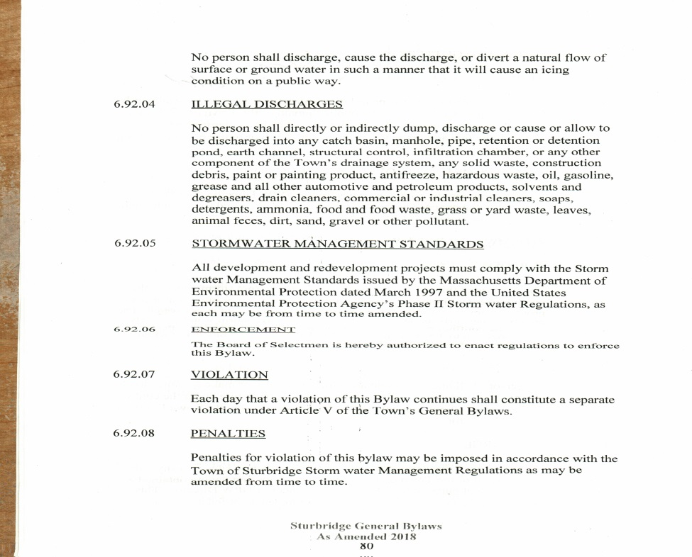Legal Authority (IDDE Bylaw or Ordinance)
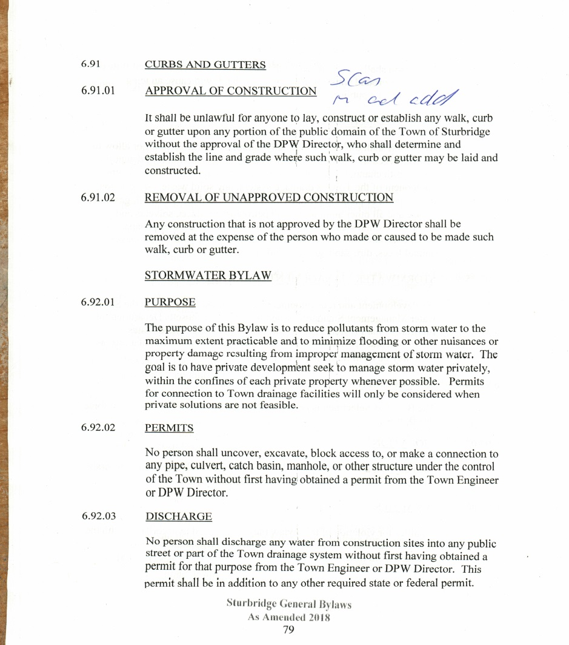

Appendix B

Storm System Mapping

Cloud version of storm system is available for quick for at mapsonline.net/sturbridgema/qa
MAP of pipes, outfalls, catch basins , drain manholes and waterways
Water & sewer system>>>right

Appendix C

Field Forms, Sample Bottle Labels, and Chain of Custody Forms
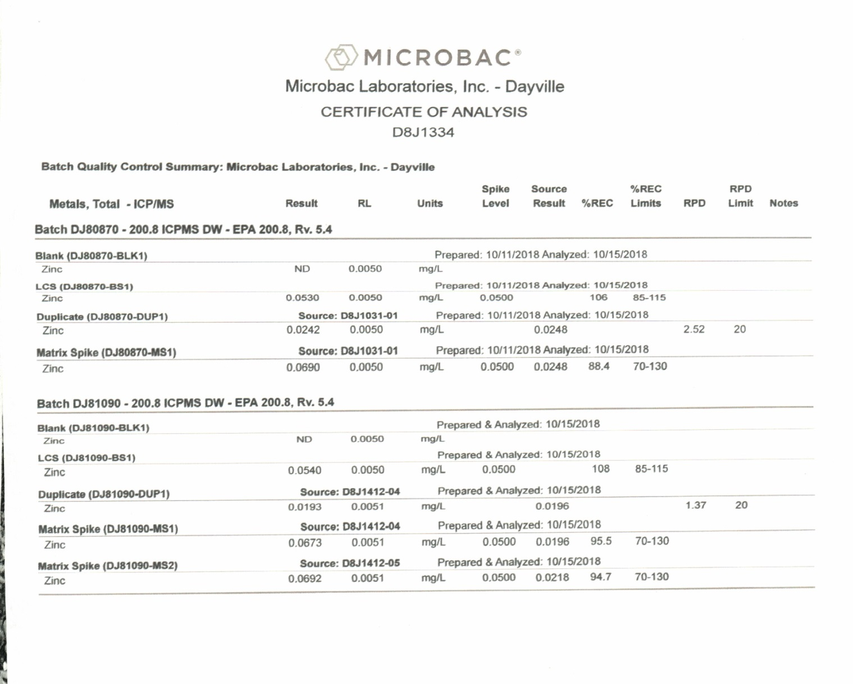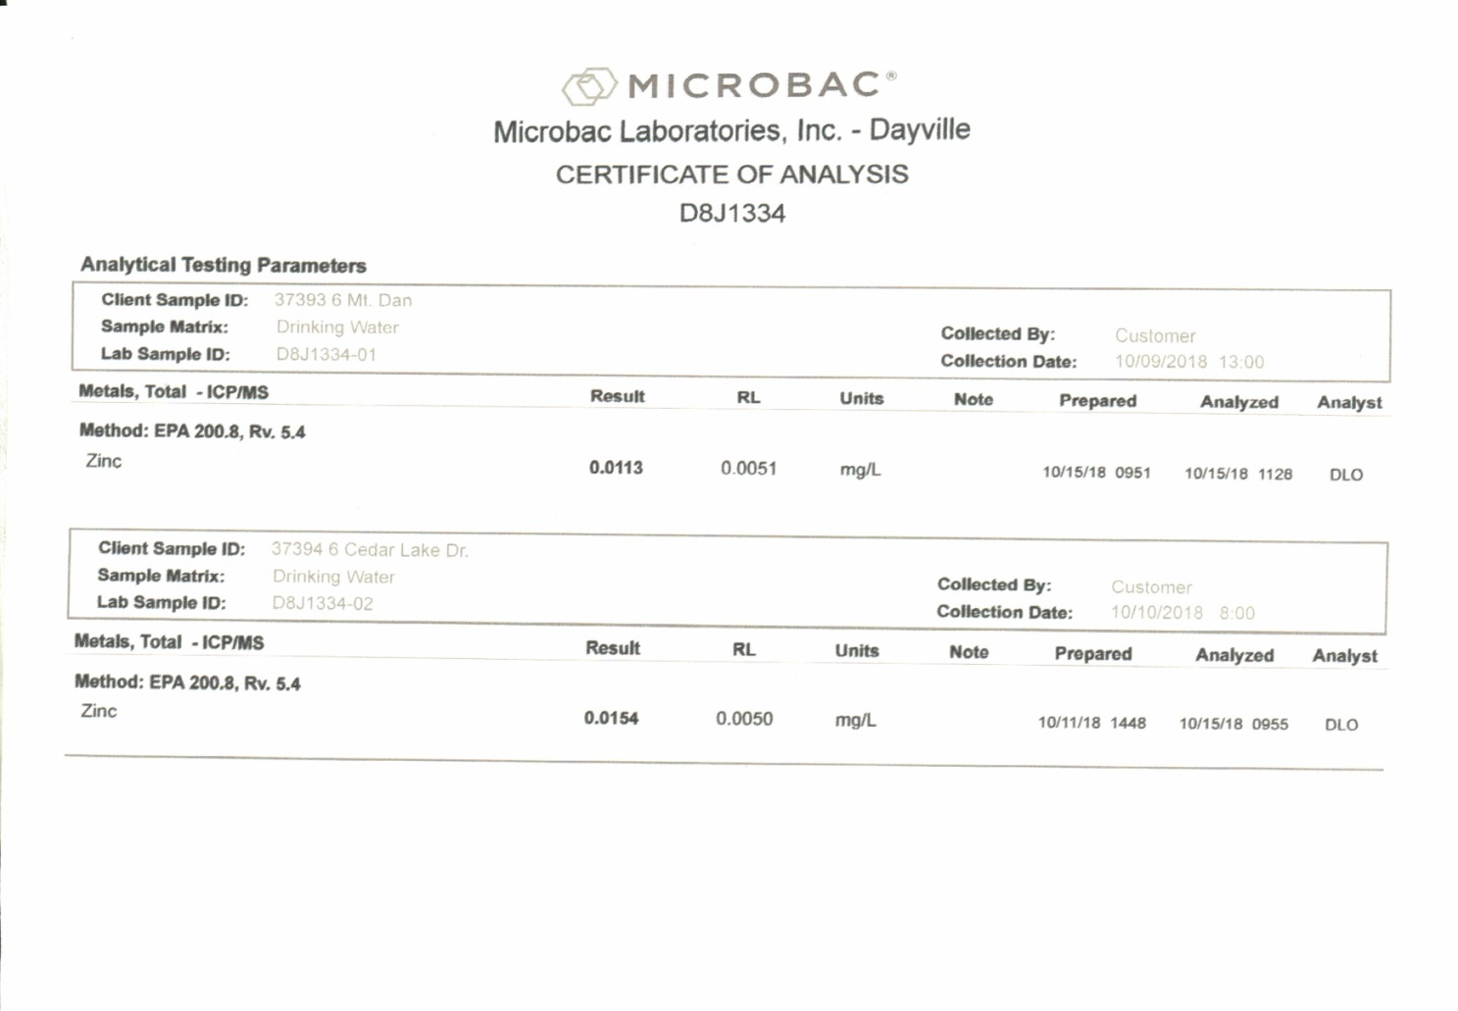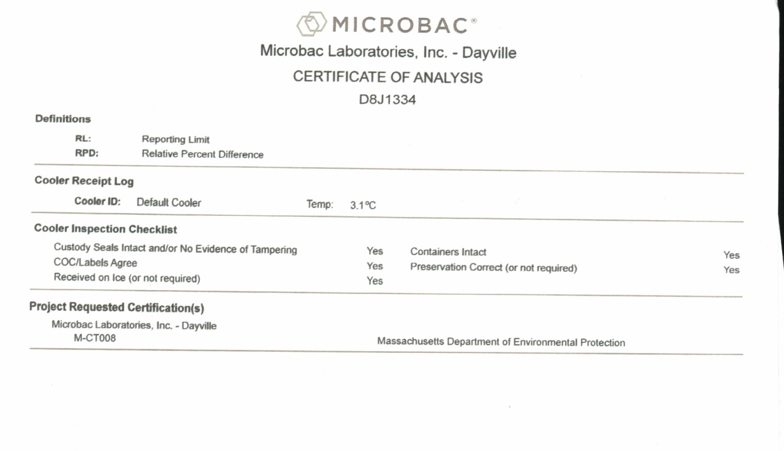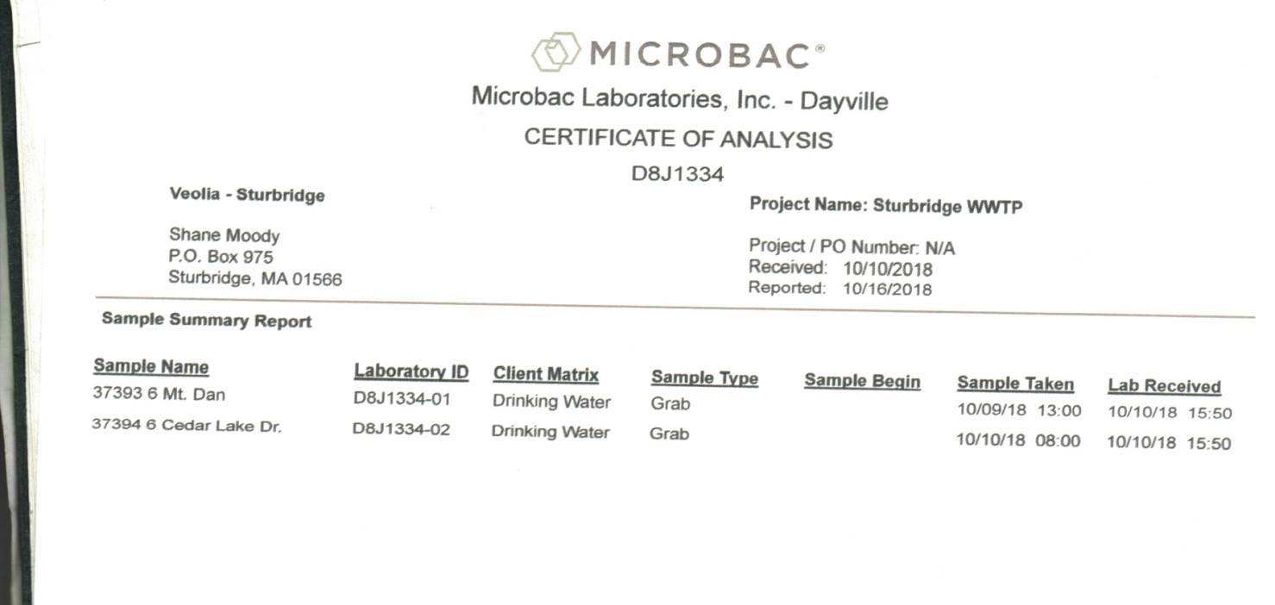
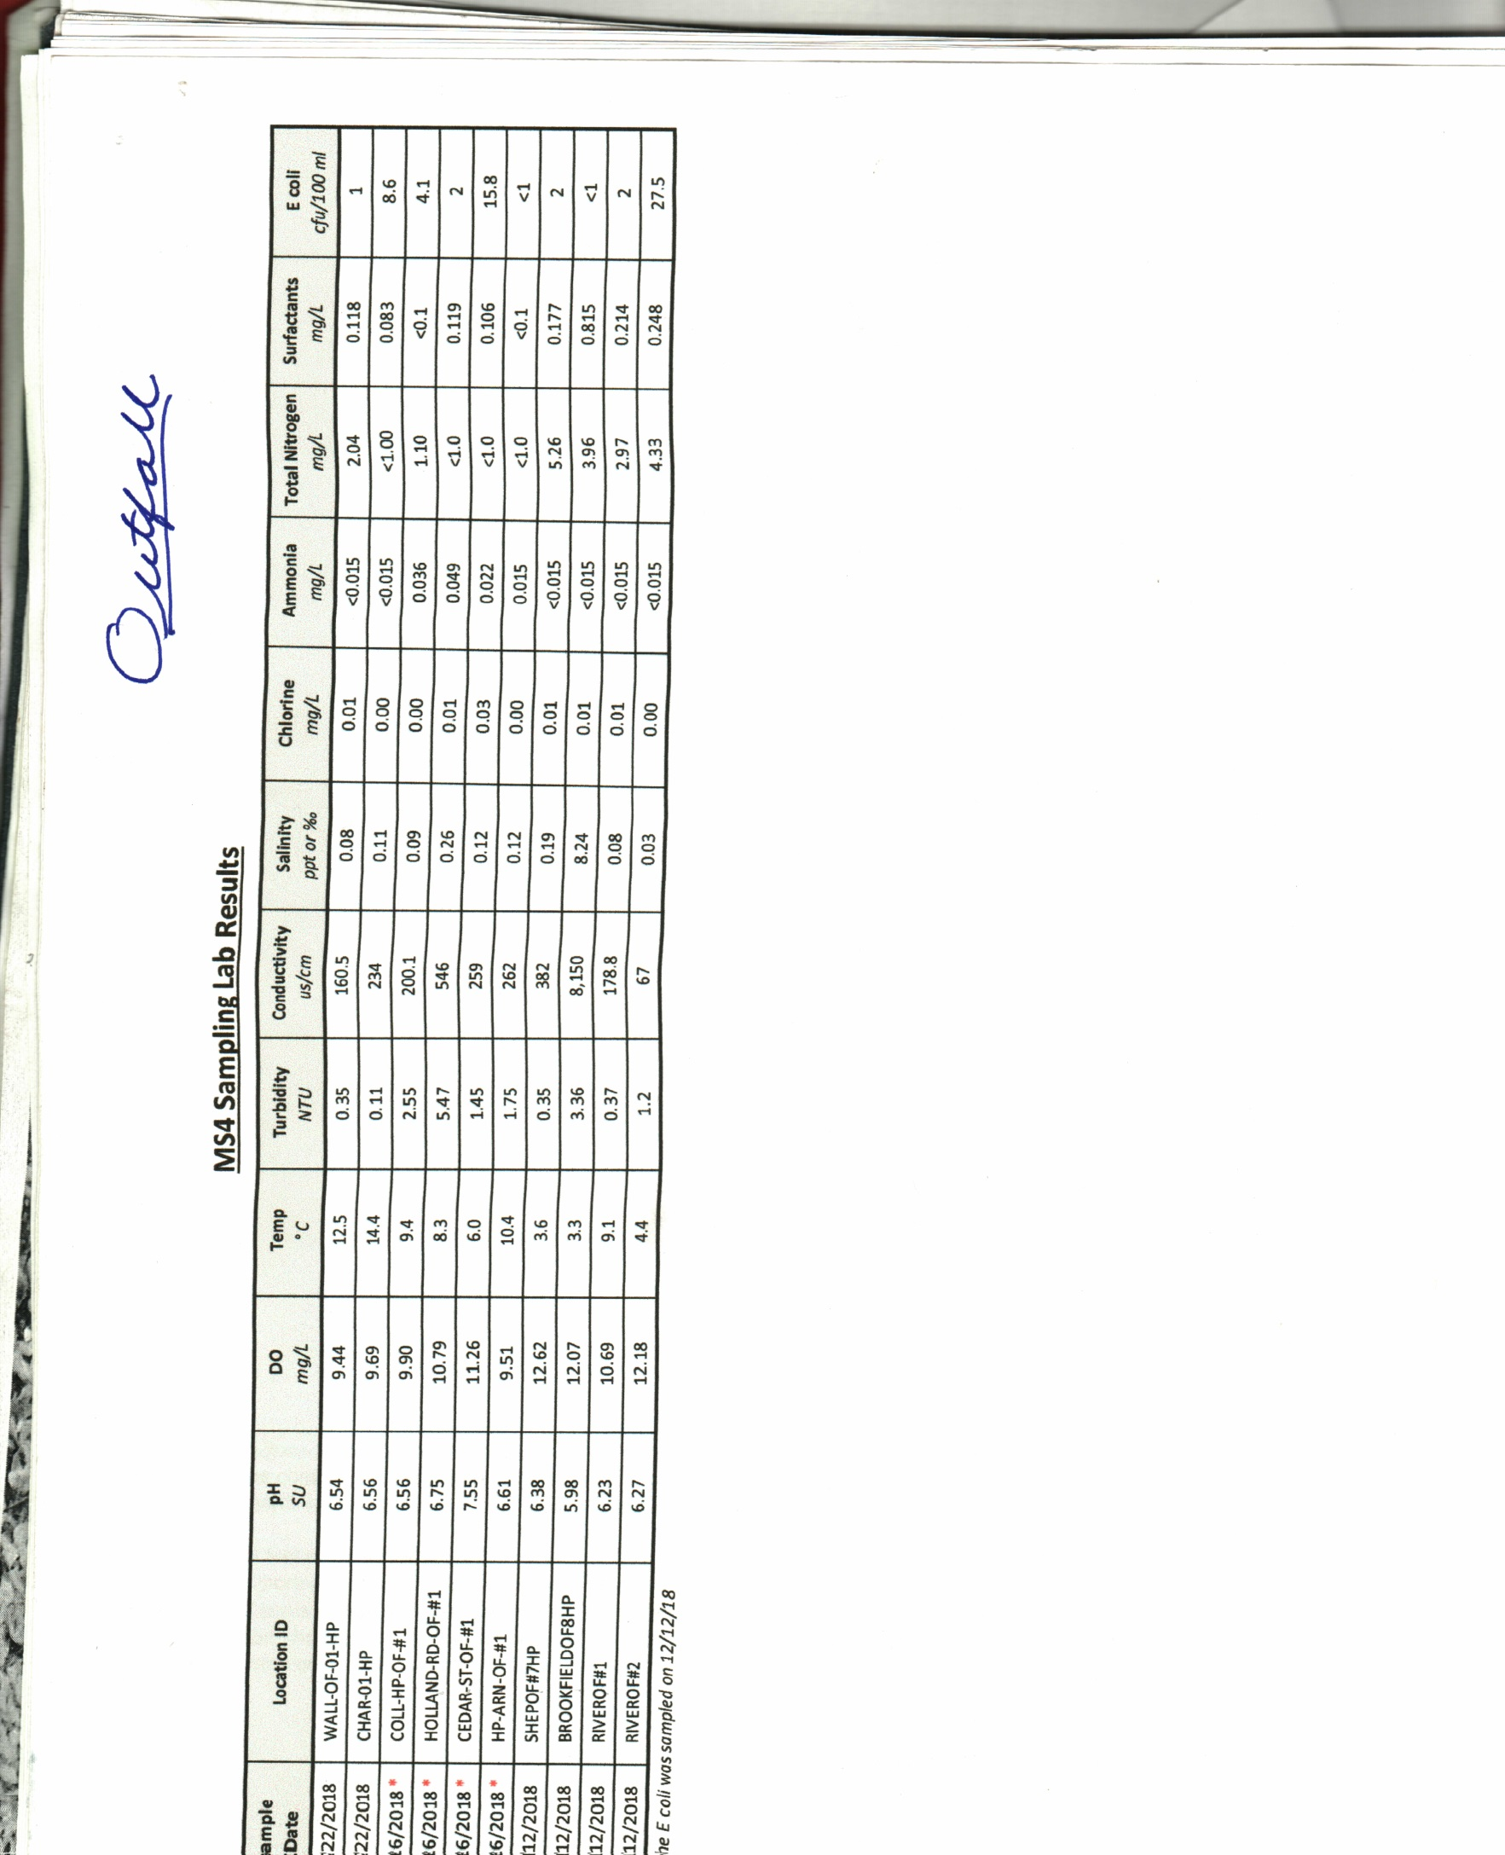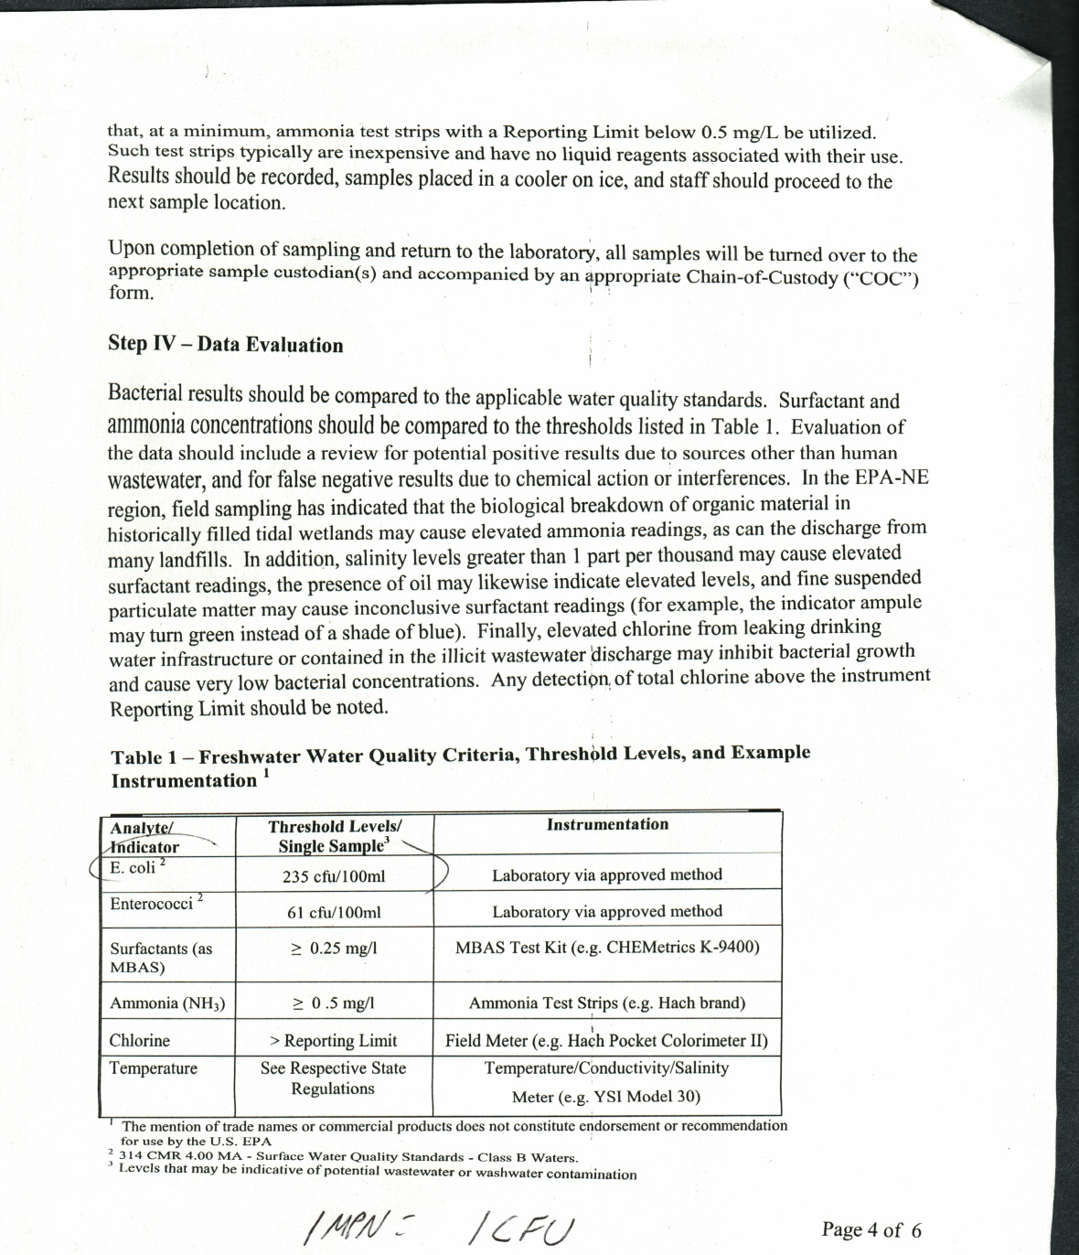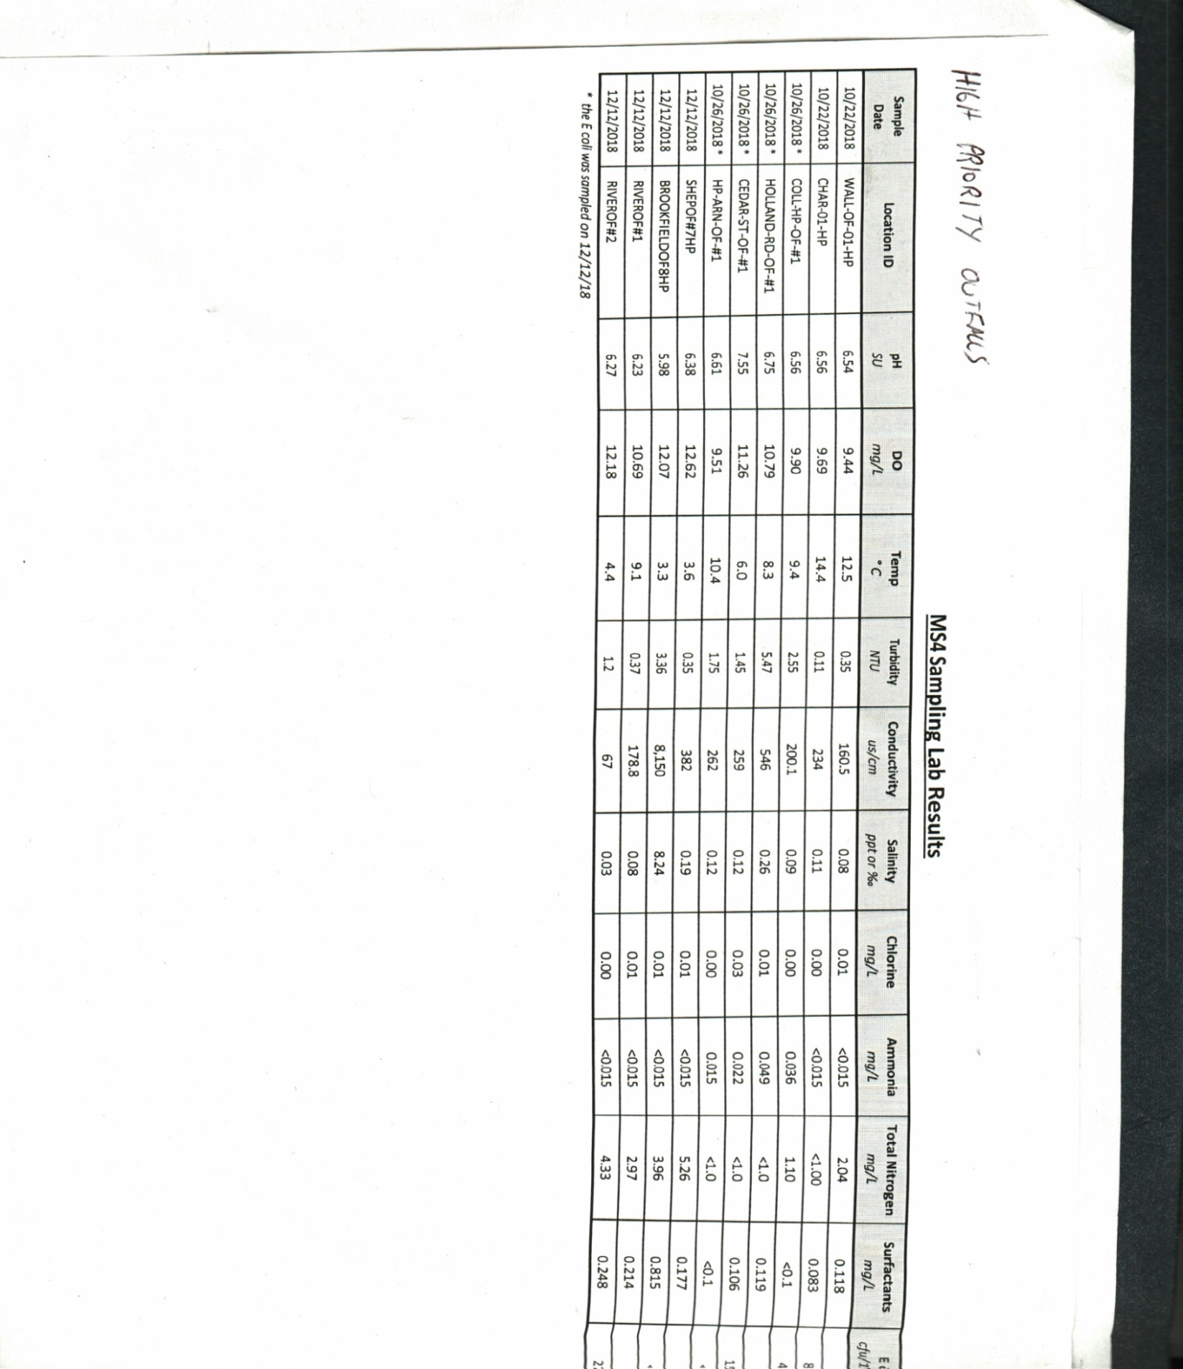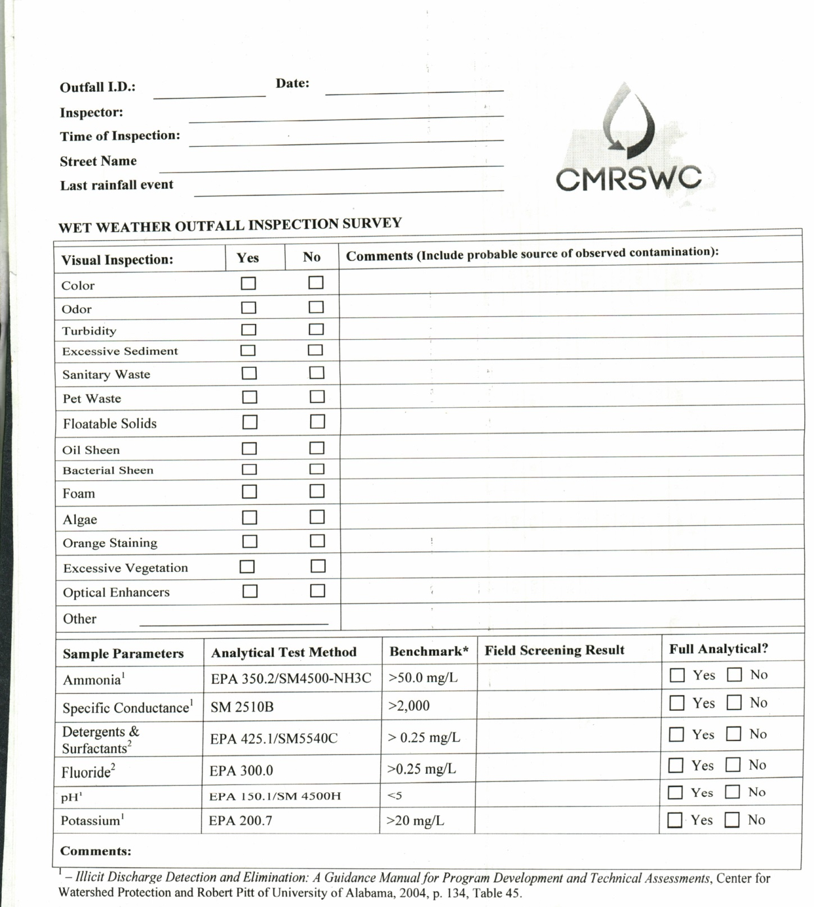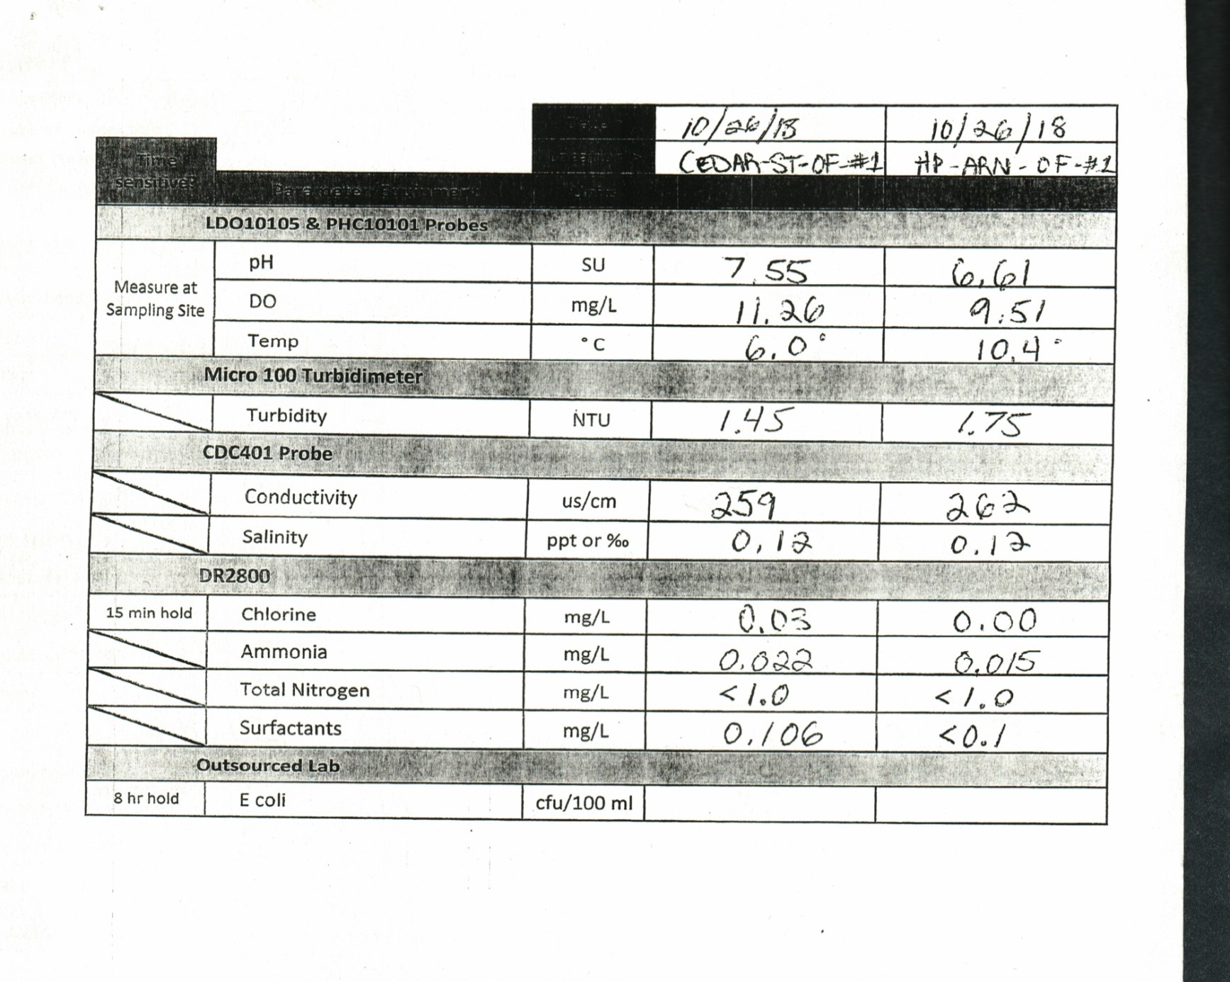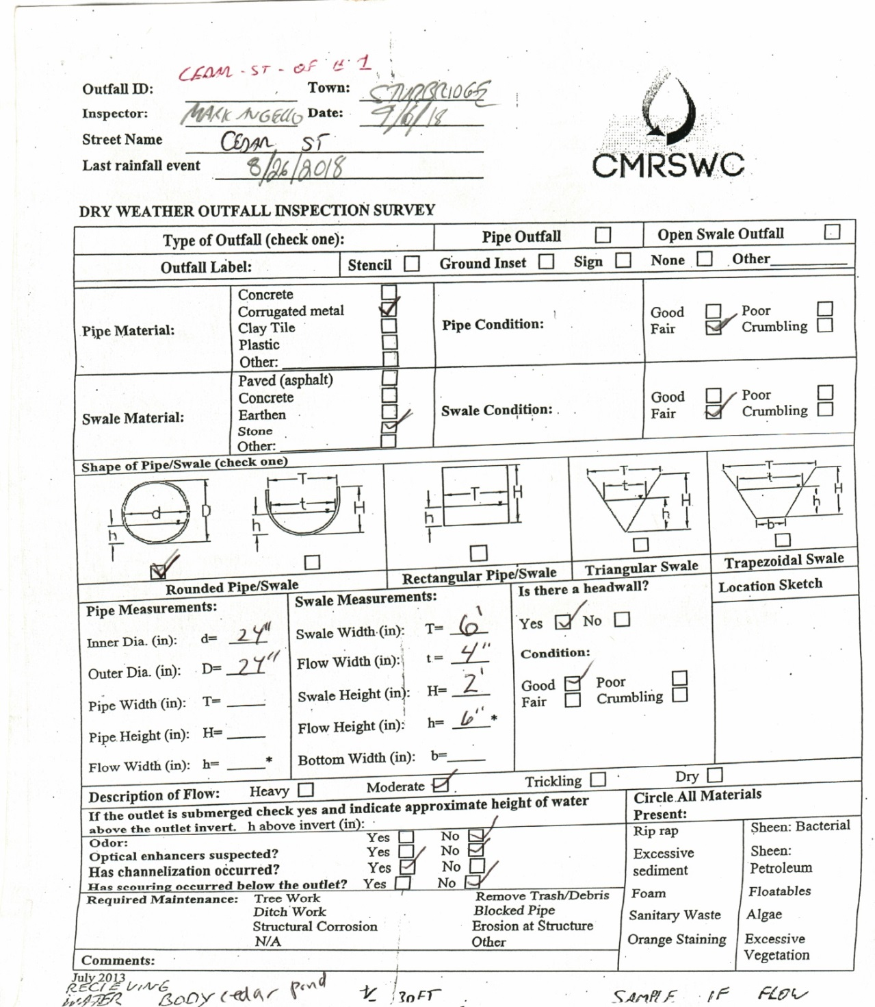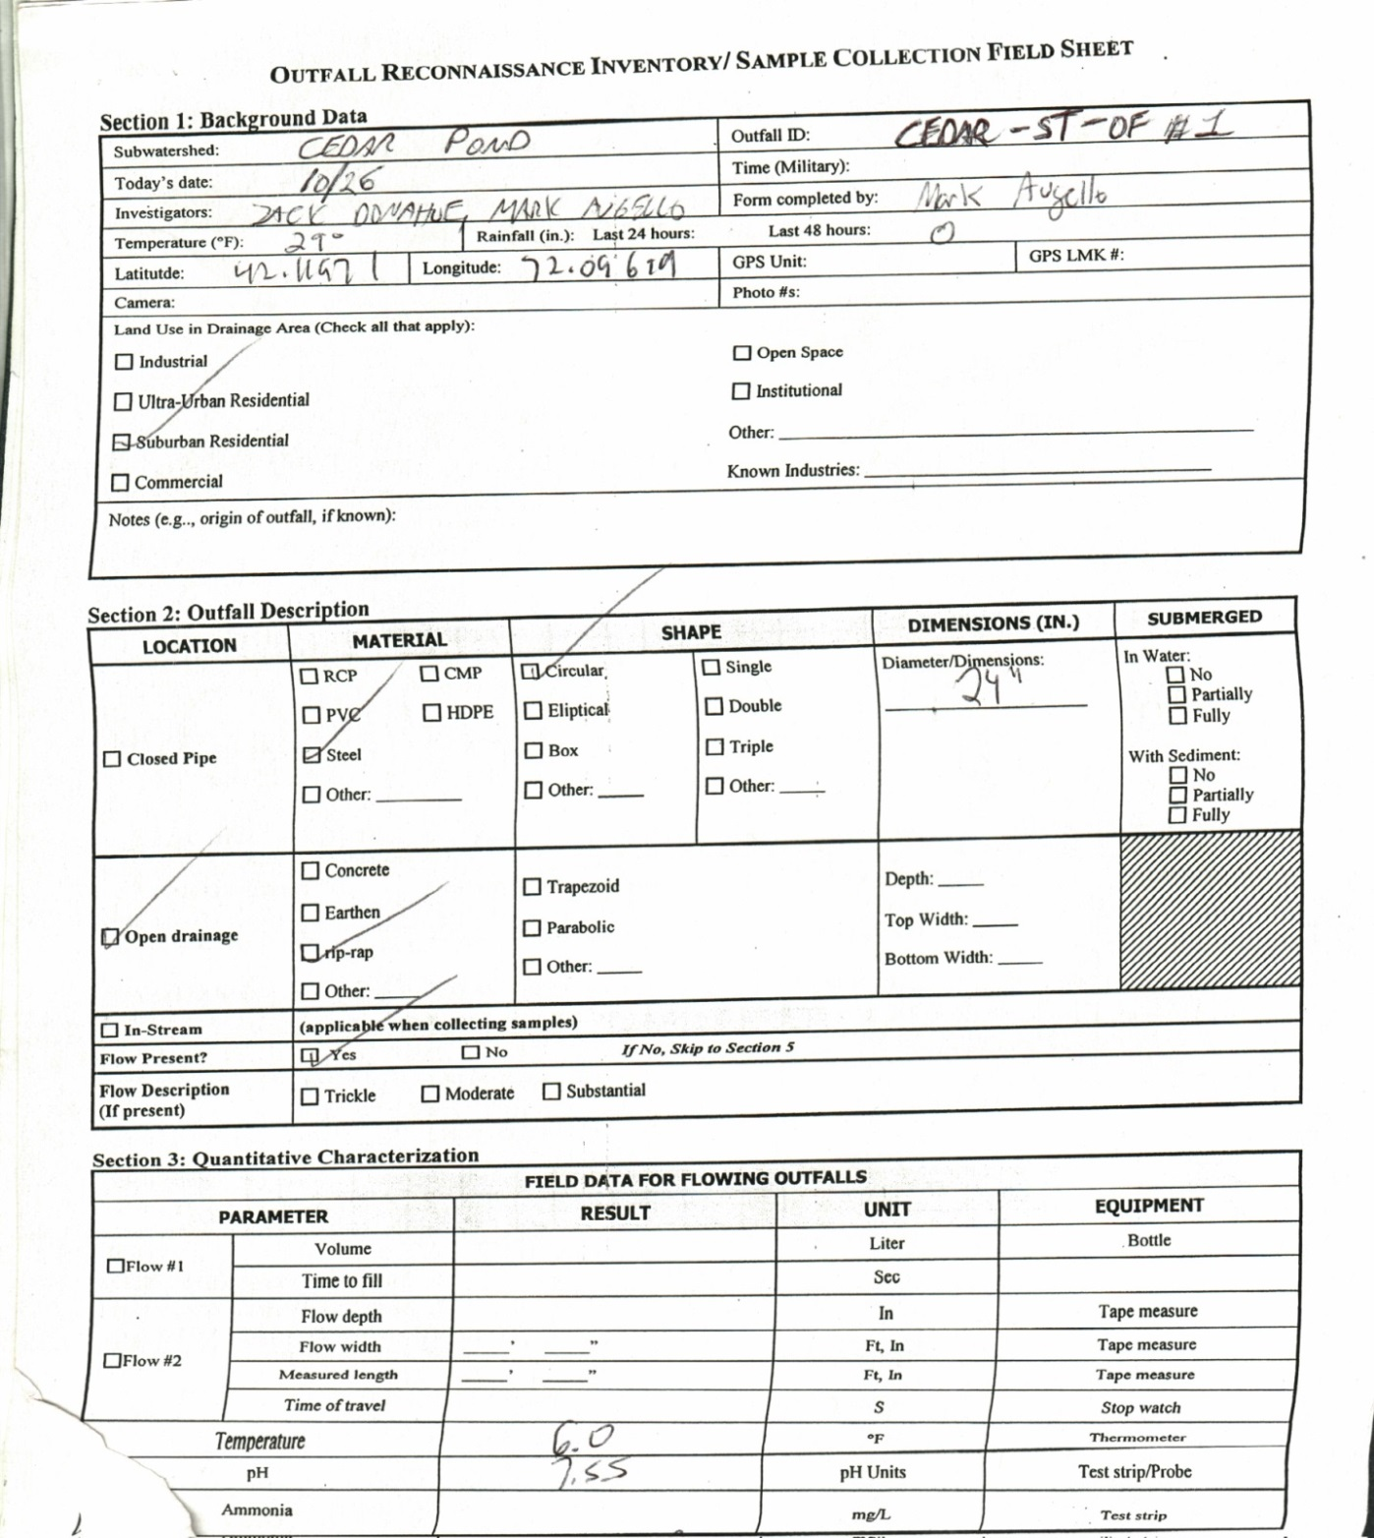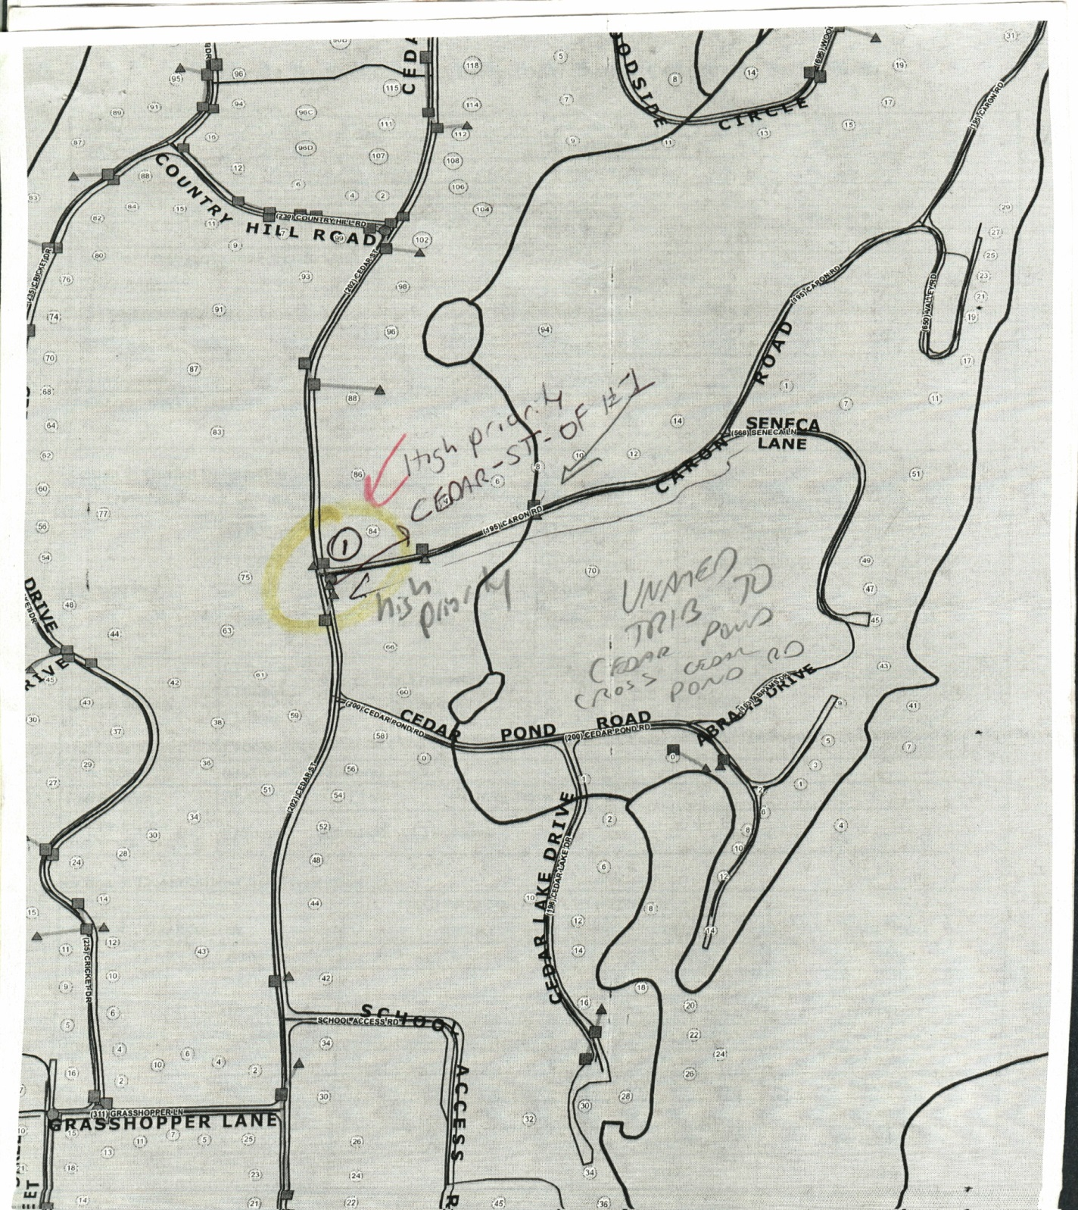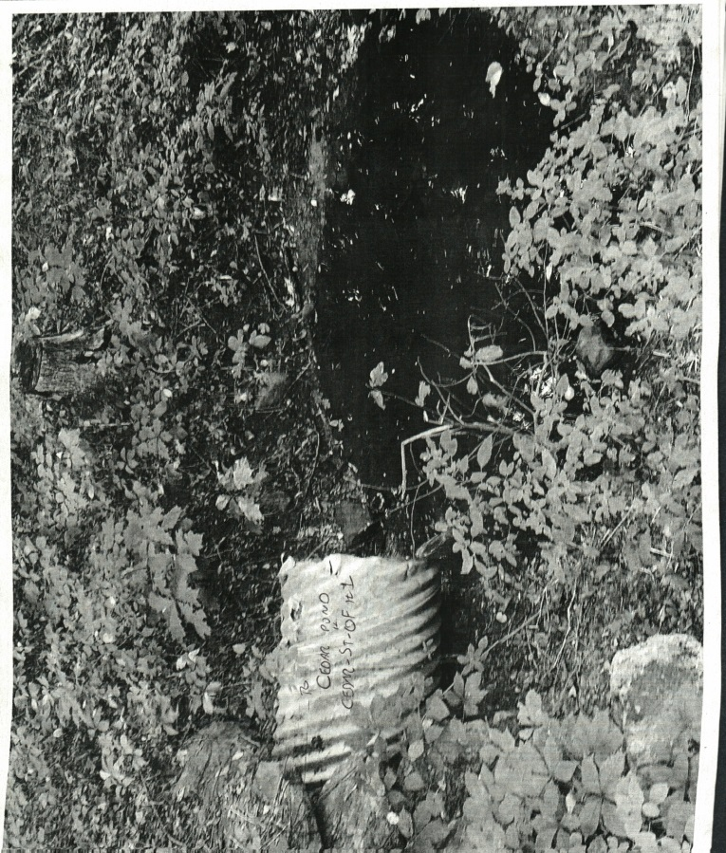

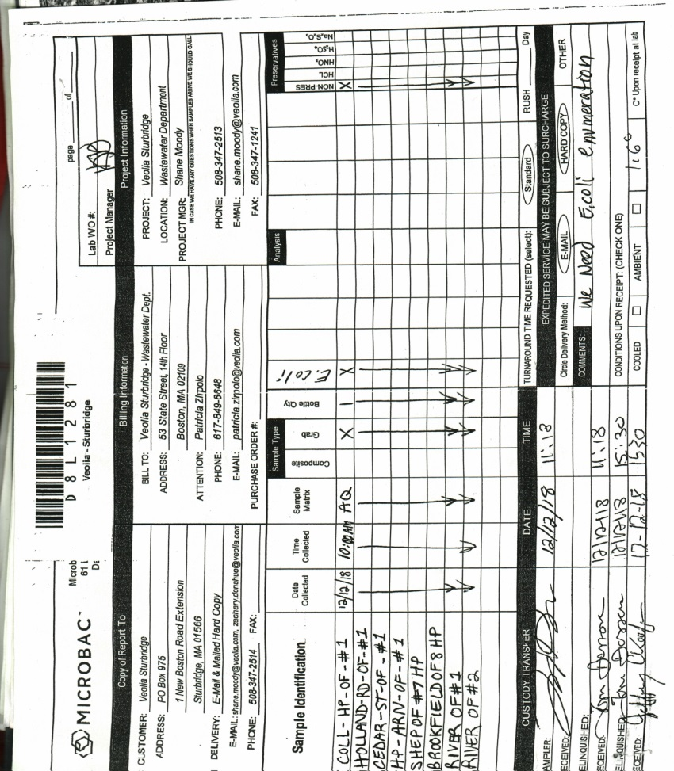

Appendix D

Water Quality Analysis Instructions, User’s Manuals and Standard Operating Procedures

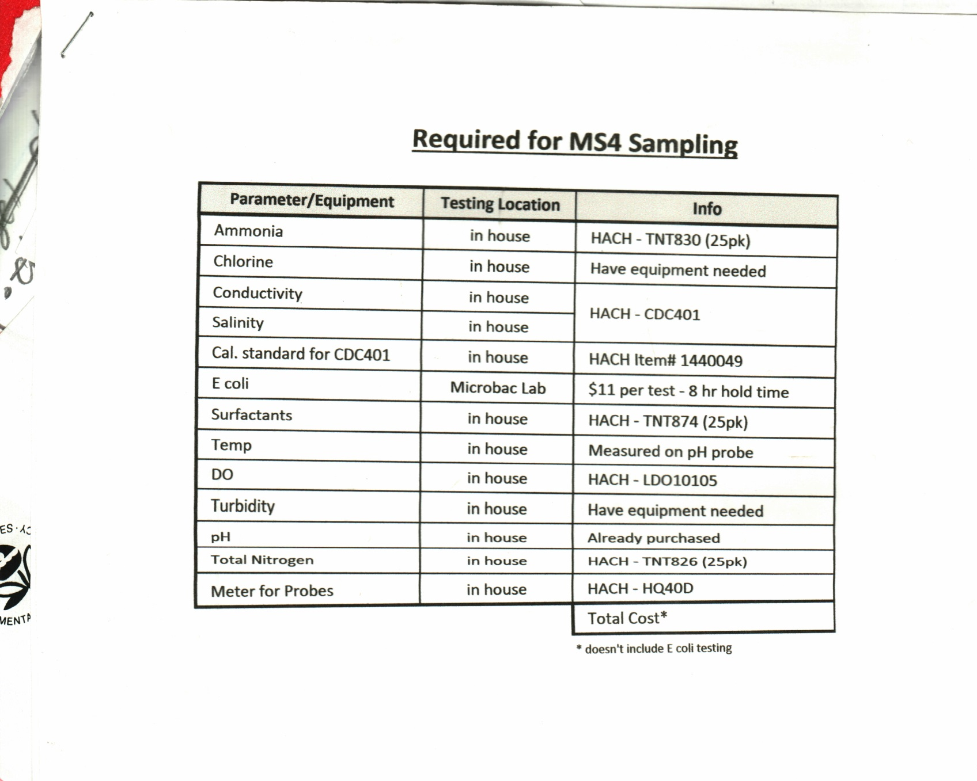

Appendix E

IDDE Employee Training Record

Illicit Discharge Detection and Elimination (IDDE)
Employee Training Record

Town of Sturbridge, Massachusetts

Date of Training: Wed April 24, 2019

Duration of Training: 6 hours Framingham MA D.P.W

Name | Title | Signature
Mark Augello | Operations Manager

Appendix F

Source Isolation and Confirmation Methods:
Instructions, Manuals, and SOPs

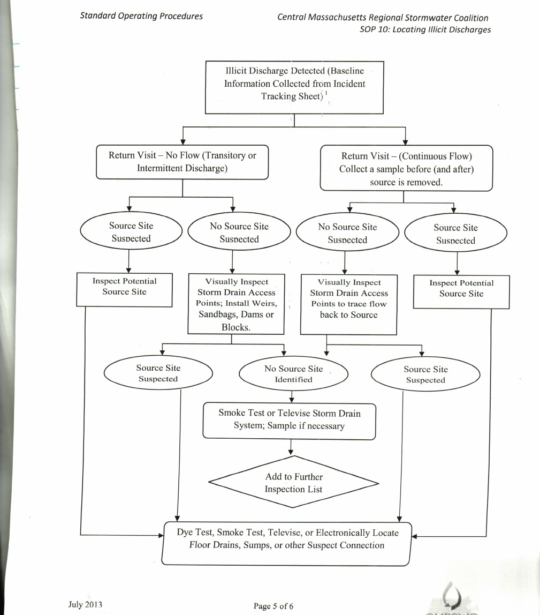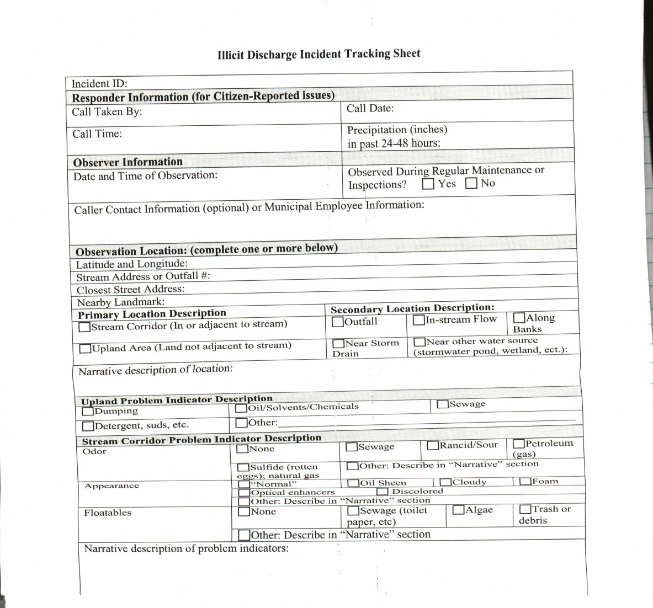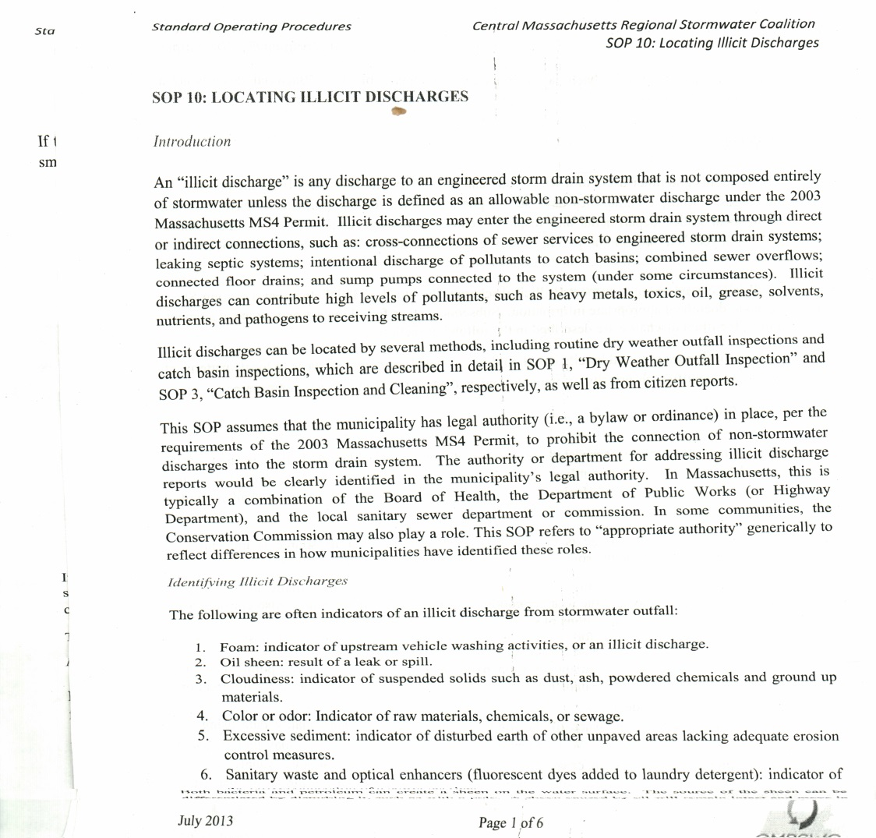

Outfall means a point source as defined by 40 CFR § 122.2 as the point where the municipal separate storm sewer discharges to waters of the United States. An outfall does not include open conveyances connecting two municipal separate storm sewers or pipes, tunnels or other conveyances that connect segments of the same stream or other waters of the United States and that are used to convey waters of the United States. Culverts longer than a simple road crossing shall be included in the inventory unless the permittee can confirm that they are free of any connections and simply convey waters of the United States.
Interconnection means the point (excluding sheet flow over impervious surfaces) where the permittee’s MS4 discharges to another MS4 or other storm sewer system, through which the discharge is conveyed to waters of the United States or to another storm sewer system and eventually to a water of the United States.
Other potentially useful parameters, although not required by the MS4 Permit, include fluoride (indicator of potable water sources in areas where water supplies are fluoridated), potassium (high levels may indicate the presence of sanitary wastewater), and optical brighteners (indicative of laundry detergents).
40 CFR § 136: http://www.ecfr.gov/cgi-bin/text-idx?SID=b3b41fdea0b7b0b8cd6c4304d86271b7&mc=true&node=pt40.25.136&rgn=div5
Massachusetts Water Quality Standards: http://www.mass.gov/eea/docs/dep/service/regulations/314cmr04.pdf

