Municipal Stormwater Infrastructure

Operation and Maintenance Plan

Central Massachusetts Regional

Stormwater Coalition

**November 5, 2020**

**Insert Town Logo Here**

*This project has been financed with Funds from the Massachusetts Department of Environmental Protection (the Department). The contents do not necessarily reflect the views and policies of the Department, nor does the mention of trade names or commercial products constitute endorsement or recommendation for use.*

Table of Contents

Municipal Stormwater Infrastructure

Operation and Maintenance Plan

Central Massachusetts Regional Stormwater Coalition

1 Introduction 1

2 Catch Basins 1

3 Streets and Parking Lots 2

4 Catch Basin Cleanings and Street Sweepings 3

5 Winter Road Maintenance 3

6 Structural Stormwater BMPs 4

Appendices

Appendix A – Stormwater Infrastructure Map

Appendix B – Catch Basin Inspection/Cleaning Procedure, Inspection Form, and Log

Appendix C – Street and Parking Lot Sweeping Log

Appendix D – Inventory of Structural Stormwater Best Management Practices

Appendix E – Structural Stormwater BMP Inspection Procedures and Checklists

# Introduction

This Operation and Maintenance (O&M) Plan has been prepared by Sturbridge to address Stormwater infrastructure O&M requirements [1]of the United States Environmental Protection Agency’s (USEPA’s) 2016 National Pollutant Discharge Elimination System (NPDES) General Permit for Stormwater Discharges from Small Municipal Separate Storm Sewer Systems (MS4) in Massachusetts, hereafter referred to as the “2016 Massachusetts MS4 Permit” or “MS4 Permit.”

This O&M Plan addresses Minimum Control Measure 6, Good Housekeeping and Pollution Prevention for Permittee Owned Operations, by describing the activities and procedures the town of Sturbridge will implement so that the MS4 infrastructure is maintained in a timely manner to reduce the discharge of pollutants from the MS4. The O&M Plan outlines inspection and maintenance procedures for catch basins, municipally-owned streets and parking lots, and structural stormwater Best Management Practices (BMPs).

The Department of Public Works is responsible for inspection and maintenance of the stormwater infrastructure in Sturbridge. A map of the existing stormwater infrastructure in Sturbridge is provided in **Appendix A**.

# Catch Basins

The department of public works performs routine inspections, cleaning, and maintenance of the approximately 2,000 catch basins that are located within the MS4 regulated area. The town of Sturbridge will implement the following catch basin inspection and cleaning procedures to reduce the discharge of pollutants from the MS4

* Routine inspection and cleaning of catch basins. Catch basins should be cleaned such that they are no more than 50 percent full[2] at any time. The town of sturbridge will initially inspect all catch basins within the regulated area within two (2) years of the effective date of the permit to evaluate sediment or debris accumulation and establish optimal inspection and maintenance frequencies to meet the “50 percent” goal. A catch basin inspection/cleaning procedure, inspection form, and log of catch basins cleaned or inspected are included in **Appendix B**.
* If a catch basin sump is more than 50 percent full during two consecutive routine inspections or cleaning events, the finding will be documented, the contributing drainage area will be investigated for sources of excessive sediment loading, and to the extent practicable, contributing sources will be addressed. If no contributing sources are found, the inspection and cleaning frequency will be increased.
* Catch basins located near construction activities (roadway construction, residential, commercial, or industrial development or redevelopment) will be inspected and cleaned more frequently if inspection and maintenance activities indicate excessive sediment or debris loadings (i.e., catch basins more than 50 percent full). Priority will also be given to catch basins that discharge to impaired waters.
* The following information will be included in each annual report:
  + Any action taken in response to excessive sediment or debris loadings
  + Total number of catch basins
  + Number of catch basins inspected
  + Number of catch basins cleaned
  + Total volume or mass of material removed from catch basins.

# Streets and Parking Lots

Streets and municipally-owned parking lots are swept once per year which is the SWEEPING FREQUENCY.

The Sturbridge will implement the following street and parking lot sweeping procedures to reduce the discharge of pollutants from the MS4:

The town of Sturbridge sweeps over 95 miles of public streets and sweeps over 10 municipal parking lots. The map in appendix c shows the streets in the urbanized areas. The list of roads swept is in appendix c. Street and parking lot sweeping will be conducted in accordance with the standard operating procedures for street and parking lot sweeping included in appendix C of this plan. A street sweeping log is maintained and a volume is put in the annual report at end of year.

* All streets with the exception of rural uncurbed roads with no catch basins or high speed limited access highways will be swept and/or cleaned a minimum of once per year in the spring (following winter activities such as sanding).
* More frequent sweeping will be considered for targeted areas based on pollutant load reduction potential, inspections, pollutant loads, catch basin cleaning or inspection results, land use, impaired waters, or other factors.
* More frequent sweeping is required for municipally-owned streets and parking lots in areas that discharge to certain nutrient-impaired waters. Sweeping must be performed in these areas a minimum of two times per year, once in the spring (following winter activities such as sanding) and at least once in the fall (Sept 1 – Dec 1; following leaf fall).
* For rural uncurbed roadways with no catch basins and limited access highways, the town of Sturbridge will either meet the minimum frequencies above, or develop and implement an inspection, documentation, and targeted sweeping plan outlining reduced frequencies within two (2) year of the effective date of the permit, and submit such plan with its year one annual report.
* The following information will be included in each annual report:
  + Number of miles cleaned or the volume or mass of material removed (see sweeping log in **Appendix C**).

# Catch Basin Cleanings and Street Sweepings

Catch basin cleanings (i.e., solid materials such as leaves, sand and twigs removed from stormwater collection systems during cleaning operations) and street sweepings will be managed in compliance with current Massachusetts Department of Environmental Protection policies: Catch basin cleanings and sweepings are stored in a pile at the sturbridge dpw in area that there is no discharge to any receiving waters.

* Catch Basin Cleanings

<http://www.mass.gov/eea/agencies/massdep/recycle/regulations/management-of-catch-basin-cleanings.html>

* Street Sweepings

<http://www.mass.gov/eea/docs/dep/recycle/laws/stsweep.pdf>

Prior to disposal or reuse, catch basin cleanings and street sweepings will be stored indoors or using proper controls such that they do not discharge to receiving waters.

# Winter Road Maintenance

The Sturbridge performs a variety of maintenance activities to ensure safe winter driving conditions on its roads and parking lots.

The town of Sturbridge will implement the following winter maintenance procedures to reduce the discharge of pollutants from the MS4:

* Minimize the use and optimize the application of sodium chloride and other salt[3] (while maintaining public safety) and consider opportunities for use of alternative materials.
* Optimize sand and/or chemical application rates through the use, where practicable, of automated application equipment (e.g., zero velocity spreaders), anti-icing and pre-wetting techniques, implementation of pavement management systems, and alternate chemicals. Maintain records of the application of sand, anti-icing and/or de-icing chemicals to document the reduction of chemicals to meet established goals.
* Prevent exposure of deicing product (salt, sand, or alternative products) storage piles to precipitation by enclosing or covering the storage piles. Implement good housekeeping, diversions, containment or other measures to minimize exposure resulting from adding to or removing materials from the pile. Store piles in such a manner as not to impact surface water resources, groundwater resources, recharge areas, and wells.
* The MS4 Permit prohibits snow disposal into waters of the United States. Snow disposal activities, including selection of appropriate snow disposal sites, will adhere to the Massachusetts Department of Environmental Protection Snow Disposal Guidance, Guideline No. BWR G2015-01 (Effective Date: December 21, 2015), located at: <http://www.mass.gov/eea/agencies/massdep/water/regulations/snow-disposal-guidance.html>
* Provide training for municipal employees on winter roadway maintenance procedures.

# Structural Stormwater BMPs

An inventory of structural stormwater Best Management Practices (BMPs) owned and/or maintained by Town of sturbridge is provided in **Appendix D**. The stormwater infrastructure map in **Appendix A** shows the locations of the structural BMPs.

|  |
| --- |
|  |

Structural stormwater BMPs will be inspected annually at a minimum. Recommended inspection procedures and checklists are provided in ***Appendix E***.

|  |
| --- |
|  |

Appendix A

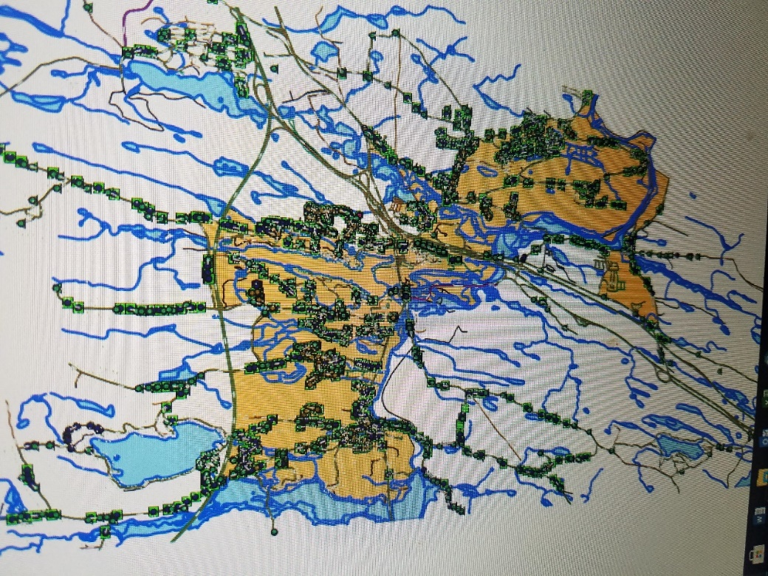 **Stormwater Infrastructure Map**

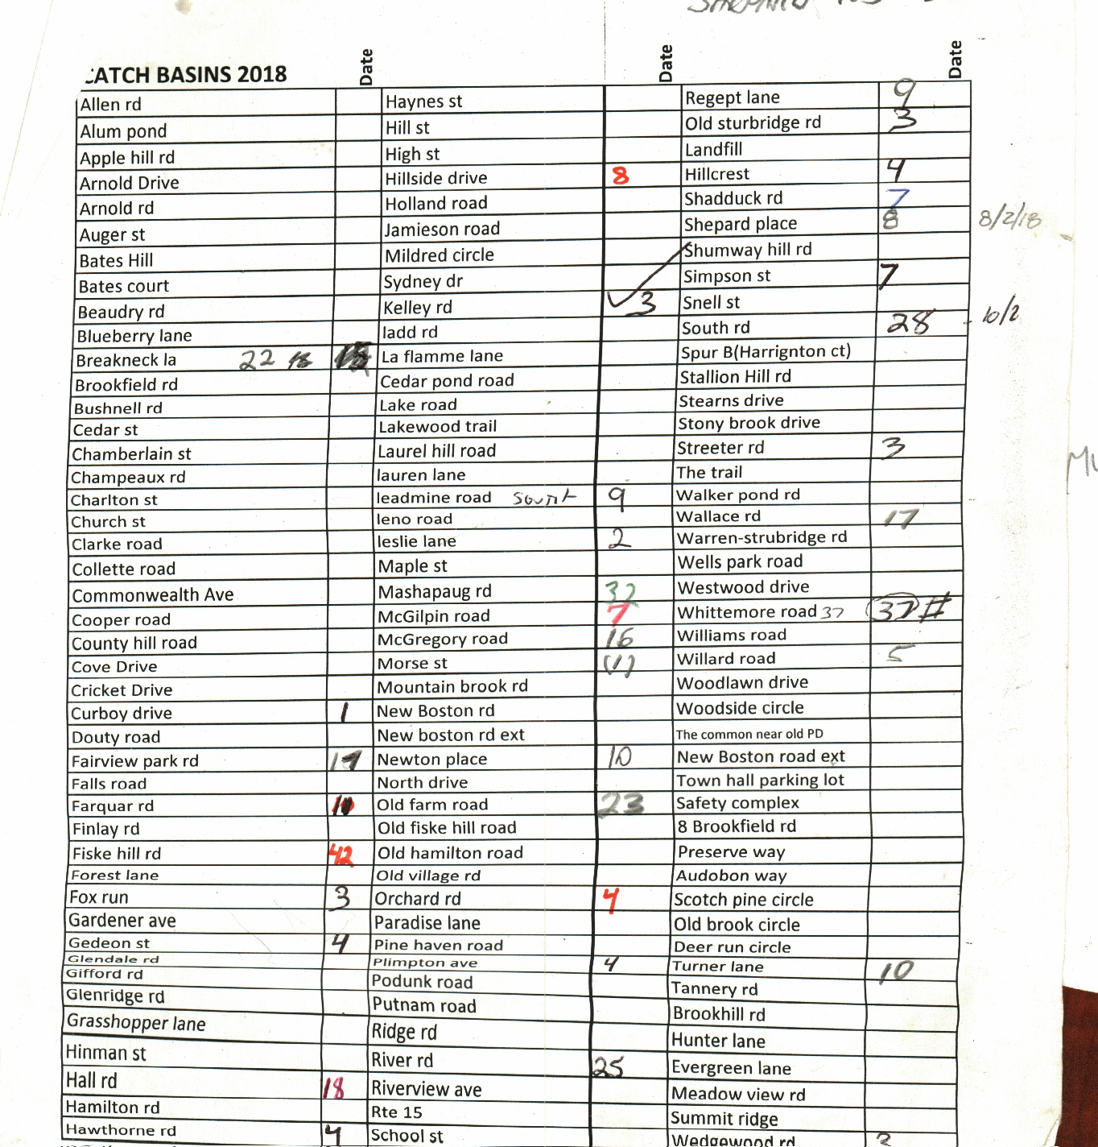

Appendix B

Catch Basin Inspection and Cleaning Procedure

Catch Basin Inspection Form

Catch Basin Cleaning Log

**Standard Operating Procedures**

Inspection and Cleaning Frequency • Each catch basin should be cleaned and inspected at least annually. • Catch basins near construction activities (roadway construction, residential, commercial, or industrial development or redevelopment) or high-use areas should be inspected and cleaned more frequently if inspection finds excessive sediments or debris loadings.

Standard Operating Procedures Central Massachusetts Regional Stormwater Coalition SOP 3: Catch Basin Inspection and Cleaning

• Catch basins should be cleaned to ensure that they are no more than 50 percent full1 at any time. Establish inspection and maintenance frequencies needed to meet this “50 percent” goal. If a catch basin sump is more than 50 percent full during two consecutive inspections, document the findings, investigate the contributing drainage area for sources of excessive sediment loading, and, if possible, address the contributing sources. If no contributing sources are found, increase the inspection and cleaning frequencies of the sump. • Street sweeping performed on an appropriate schedule will reduce the amount of sediment, debris, and organic matter entering the catch basins, which will in turn reduce the frequency with which they need to be cleaned. Reference SOP 16: Streets and Parking Lots for information on appropriate street sweeping frequencies. Street sweeping schedules should also be adjusted based on catch basin inspection findings, with more frequent sweepings for areas with higher catch basin loads. Inspection and Cleaning Procedures Catch basin inspection and cleaning procedures should address both the grate opening and the catch basin structure, including the sump and any inlet and outlet pipes. Document any and all observations about the condition of the catch basin structure and water quality (an inspection form and log of catch basins cleaned or inspected are included in the attachments). Collect data on the condition of the physical basin structure, its frame, and the grate, as well as on the quality of stormwater conveyed by the structure. Observations like those below can indicate sources of pollution within the storm drain system: • Oil sheen • Discoloration • Trash and debris

*CATCH BASIN CLEANING LOGS*

*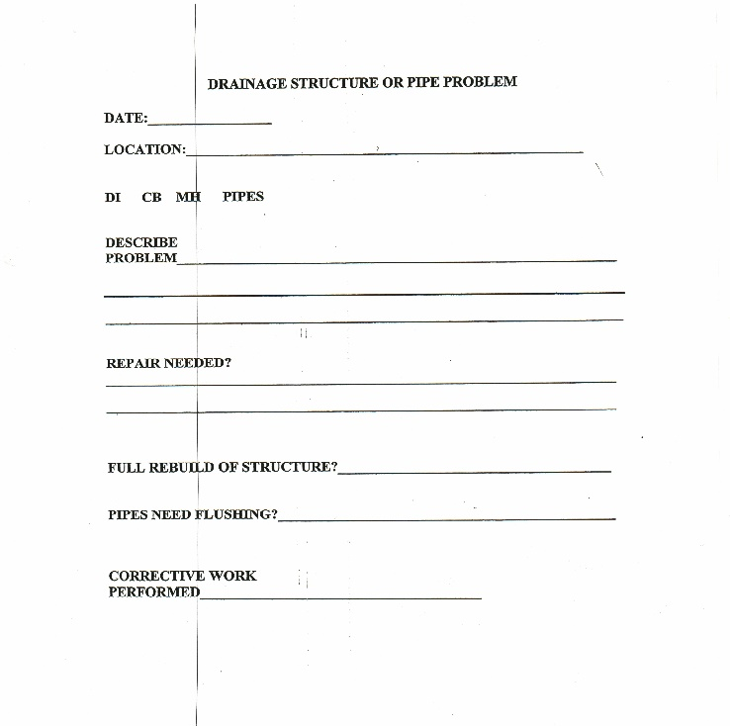-* 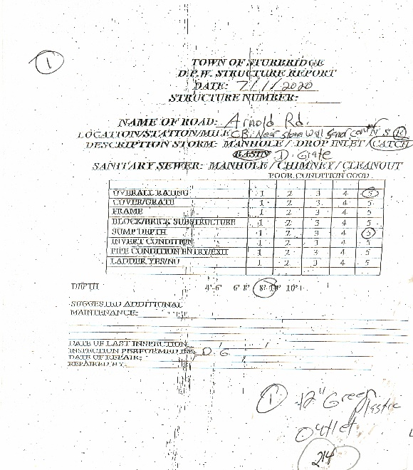

Appendix C

**Municipal Parking Lots**

Senior center

Burgess School Middle school

Tantasqua High School

Town Hall

Center office building

Old Fire Station

Safety complex

Town Hall Lower Parking lot

Town common area

Dpw headquarters

Sewer Plant

Water plant

Nursery School

**SWEEPING LOG**

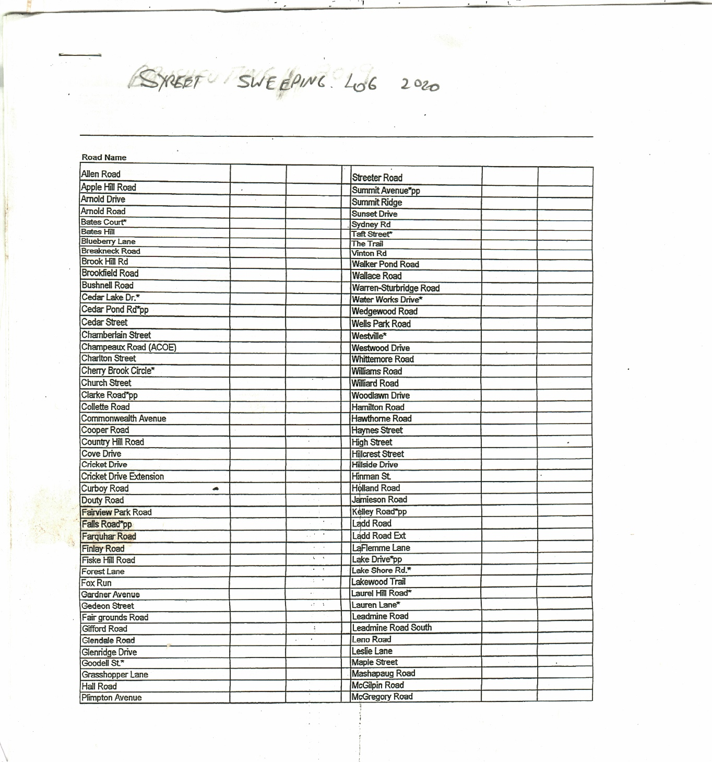

Street and Parking Lot Sweeping Log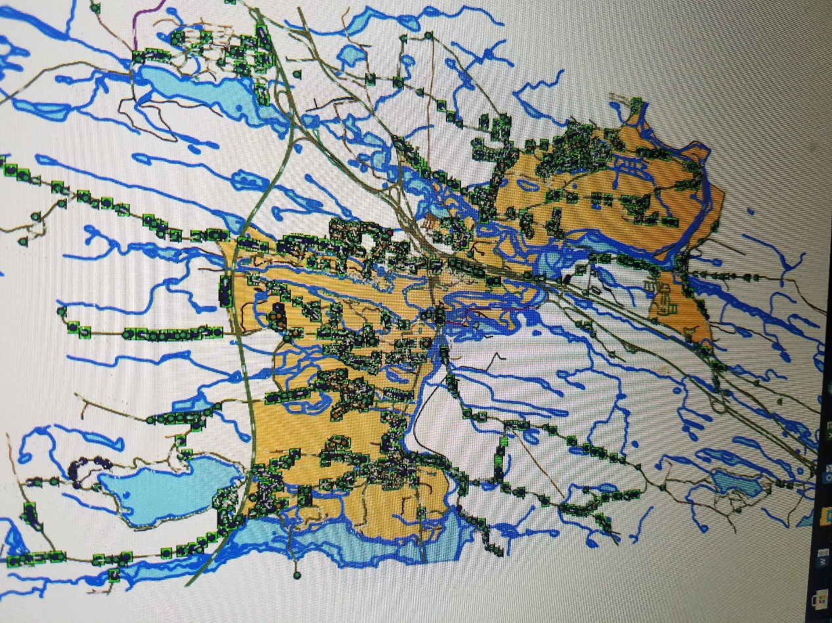

**Orange area =streets in urbanized area**

Appendix D

Inventory of Structural Stormwater Best Management Practices

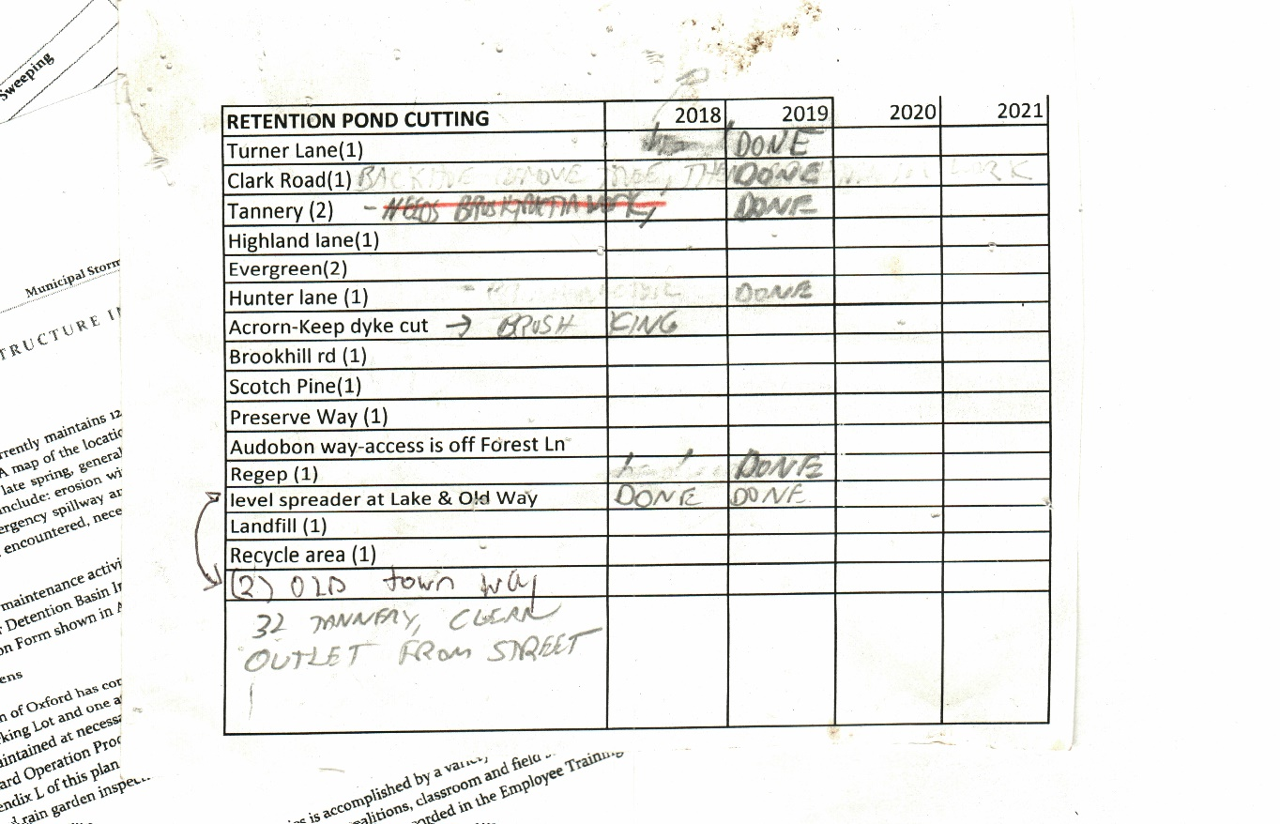

**IVENTORY OF RETENTION PONDS**

|  |
| --- |
|  |

**Inventory of Structural Stormwater Best Management Practices (BMPs)**

**Sturbridge, Massachusetts**

| **BMP ID or Description** | **Location** | **BMP Type** | **Inspection Frequency** | **Date of Last Inspection** | **Additional Notes** |
| --- | --- | --- | --- | --- | --- |
| Structural BMP, | Rte 20 , at mill park | Catch basin, cds unit to filter stormwater |  |  | Unit filters run off to quinebaug river |
| Structural BMP | New boston road | Vortenic units |  |  |  |
| Retention ponds | Located at various subdivisions in town | Stone swale and outfall pipe | Every year |  |  |
|  |  |  |  |  |  |
|  |  |  |  |  |  |
|  |  |  |  |  |  |
|  |  |  |  |  |  |
|  |  |  |  |  |  |
|  |  |  |  |  |  |
|  |  |  |  |  |  |
|  |  |  |  |  |  |
|  |  |  |  |  |  |
|  |  |  |  |  |  |

Appendix E

Structural Stormwater BMP Inspection Procedures and Checklists.

**

*\*

*INVENTORY TOWN OWNED VEHICLES*

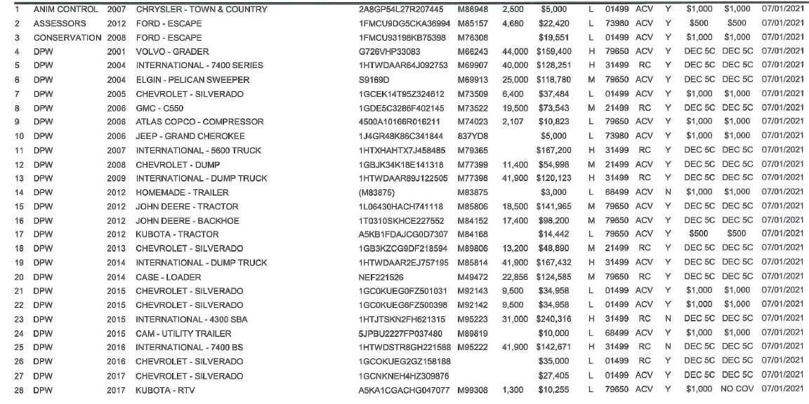

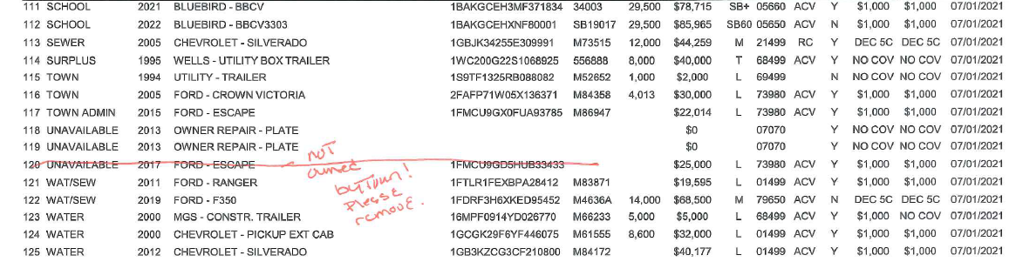

1. See Part 2.3.7.a.iii of the 2016 MS4 Permit for Infrastructure Operation and Maintenance program requirements.
2. A catch basin sump is more than 50 percent full if the contents within the sump exceed one half the distance between the bottom interior of the catch basin to the invert of the deepest outlet of the catch basin
3. For purposes of the MS4 Permit, salt means any chloride-containing material used to treat paved surfaces for deicing, including sodium chloride, calcium chloride, magnesium chloride, and brine solutions.