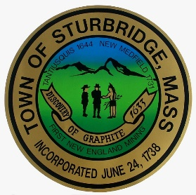
Welcome to Sturbridge
Good Neighbor Guide



Improving the quality of life in our community
Through collective expectations

Greetings from the Town of Sturbridge, Massachusetts. It is my pleasure to welcome you to our unique and historic community. We are a relatively small town in South Central Massachusetts with about 10,000 residents. When most people think of Sturbridge, they think of our beautiful open space, our immensely popular trail systems, our world class restaurants and hotels, and, of course, Old Sturbridge Village. We are all of that and then some!
Despite our size and the rural nature of so much of Sturbridge, we also have a fantastic economic base as well. Located at interchange the Mass Turnpike and Rte. 84, and bisected by Rte. 20, we are often referred to as sitting at the crossroads of New England. This makes us an ideal home for larger retail businesses and warehouses, as well as hosting large conventions and events including 5K road races and the Pan Mass Challenge. Additionally, we boast some of the finest schools in all of Central Massachusetts.
As I am sure you will discover, Sturbridge has a tremendous amount to offer and our team here in all Town Offices will do our best to welcome you to our community and assist you in any way possible.

Robin A. Grimm, Ph.D.
Sturbridge Town Administrator

Table of Contents

Helpful Sturbridge Telephone Numbers and Information ............. 1

Property Standards ....................................................................... 2

Property Maintenance ................................................................... 4

Animals.......................................................................................... 5

Driving/Parking .............................................................................. 6

Winter Restrictions ........................................................................ 7

Good Order/General Behavior ...................................................... 8

Trash Pick-Up & Recycling .................................................. ....... 10

Public Safety ....................................................................... ........ 11

Public Schools and Playgrounds ............. ................................... 12

Water Ban Information ........................................................................ 13

Helpful Sturbridge Telephone Numbers and Information

EMERGENCY CALLS (Police, Fire, Ambulance) ................... 911
Animal Control – 346 Main St., Safety Complex…..(774) 230-9239
Assessors – 308 Main St………..............................(508) 347-2503
Board of Health Dept. – 301 Main St........................(508)347-2504
Building Dept. – 301 Main St., 1st Floor………….…(508) 347-2505
Fire Department - 346 Main St., Safety Complex....(508) 347-2525
Family Resource (Sturbridge Public Schools) .........(508)961-6247
Gas Inspectors – 301 Main St…………………….…(508) 347-2505
Joshua Hyde Library – 306 Main St..........................(508)347-2512
Parking Clerk – 308 Main St., Finance Dept….…....(508) 347-2509
Planning Dept.- 301 Main St……………………….... (508)347-2508
Plumbing Inspector – 301 Main St………… ……… (508) 347-2505
Police Dept.- 346 Main St., Safety Complex…….... (508)347-2525
Public Schools – 320A Brookfield Rd…....................(508)347-3077
Public Works – 1 New Boston Rd. Ext………..….....(508) 347-2515
Recreation Department – 301 Main St................... ..(508)347-2041
Senior Center – 480 Main St……………...................(508)347-7575
Sewer Dept. – 1 New Boston Rd. Ext…………........(508) 347-2514
Tax Collector - 308 Main St......................................(508)347-2509
Town Clerk & Elections – 308 Main St......................(508)347-2500
Treasurer / Tax Collector – 308 Main St....................(508)347-2511
Town Administrator – 308 Main St.............................(508)347-2501
Town Website .......................................www.TownofSturbridge.gov
Water Dept. – 1 New Boston Rd. Ext……...…..….…(508) 347-2513
Wiring Inspector – 301 Main St………….…...……....(508) 347-2505
Zoning Enforcement Officer ......................................(508)347-2505
.

Utility Companies
Charter (Cable/Internet/Phone) ................................1-833-694-9259
National Grid (Electric) .............................................1-800-322-3223
National Grid (Gas)……………………...………...…..1-800-732-3400
Verizon (Cable/Internet/Phone) ................................1-800-837-4966

Property Standards


House Numbering. When responding to an emergency call, police officers and firefighters coming to your assistance can lose valuable time if they have difficulty locating your home. A prominent and visible house number is an essential part of identifying your home. Be sure your house number is large enough to be seen from the road and that it is also visible at night. Red House numbers can be obtained thru the Fire department for a fee of $15.00.

Landscaping. Landscaping is required in all front yards for all buildings and additions over 1,000 square feet and must be completed within one year from the date of occupancy of the building. Front yards shall be completely landscaped, except for those areas occupied by driveways, walls and paved walkways. In other words, you are not permitted to pave your front yard!

Downspouts/Sump Pumps/Drainage. Water from downspouts and sump pumps should never be connected to the Town’s sewer system. This can overwhelm the sewer system during storms. Please do not discharge your water so that it creates a flooding issue for neighboring properties. Placing drains or pipes that will discharge water or other liquids from private property onto town property or public ways is prohibited.

Junk/Unregistered Vehicles. The outdoor storage of more than one unregistered vehicle or any junk motor vehicle is prohibited. The Sturbridge Police Department WILL TOW any unregistered vehicles (in excess of one) on any property in Sturbridge. To report junk vehicles, please call (508) 347-2525.

Property Standards (continued)

Swimming Pools. Any swimming pool with # inches of water or more requires a fence, which must be locked to prevent unauthorized access to the pool. During the summer months, be sure to add the proper chemicals to your pool to help prevent the growth of mosquitoes, which can carry life threatening diseases. Once summer is over, the pool must be covered. Please refer to the Building Dept. for current regulations.

Foreclosed/Abandoned Properties. If you have a home in your neighborhood that is abandoned, it should have a designated property manager notice posted on the front door. If it does not, please contact the Board of Health by calling (508) 347-2505.


Building/Electrical/Plumbing Permits. Permits are necessary before beginning most renovation, demolition, addition or construction of any kind to your property, please contact the Building Department at (508) 347-2505 to obtain a Permit. Building permits are necessary to ensure that work is being done in accordance with state building codes.
You will need an electrical, sprinkler or plumbing/gas permit to install or repair any equipment or fixtures covered by the state building, plumbing, gas or electrical codes. Call the Building Department at (508) 347-2505 for the current codes and regulations as codes change often.

Dumpster Permits. A permit is required if you plan to hire a dumpster to be placed on your property on a temporary basis. Please contact the Board of Health to obtain a permit at (508) 347-2504.

Property Maintenance


Grass Cutting. Tall grass can attract ticks and rodents. Not only is it a common courtesy for your neighborhood, but it is also a bylaw of the Town of Sturbridge that you maintain your lawn. To report an overgrown lawn, please call the Board of Health (508) 347-2505, or report any violations at www.seeclickfix.com/Sturbridge. Well-kept lawns and properties are the hallmarks of a nice neighborhood, so please, mow your lawn.

Creeks and Detention Basins. Property owners are responsible for maintaining the ditches, creeks, and detention/retentions on their property. Not doing so can cause flooding on your property, as well as your neighbors.

Fences. It is strongly advised that you hire a Land Surveyor before installing a fence so that property lines can be determined. This is not a service that the Town provides. Placement of the fence must not make it difficult for others when pulling out of their driveway or street. Digging up the ground on any street or sidewalk of the Town is prohibited, so it is important to know exactly where your property line is located. Please contact the Building Department for current code and regulations.

Driveway Paving. Please be sure to call the DPW before you pave a new driveway or re-pave an existing one. There are bylaws preventing too much pavement on your property, so be sure you are in compliance before the work is done to avoid having to rip-up an expensive paving job!

Junk and Debris. Please do not allow junk or debris to accumulate on your property. Not only is it unsightly, but it attracts rodents and insects. To report any issues of accumulation, call Code Enforcement at (508) 347-2505.

Animals


Animal Control Officer: (774) 230-9239

Dog Licenses. The owner or keeper of a dog must annually register and license their dog once it reaches six months of age at the Town Clerk’s Office. The cost is currently $10.00 for spayed/neutered dogs, and $15.00 for dogs that are not spayed/neutered. There is a late fee of $25.00 after April 1, in addition to the licensing fee. The owner must provide a valid rabies certificate from the vet. For your convenience, a Dog License Form is also attached to your annual Town Census, which is mailed each January. At this time, we do not offer Kennel Licenses.

Leash Law. All dogs must be on a leash in the Town of Sturbridge. The leash shall not exceed seven feet in length, and the dog must be attended by a person of adequate age and ability to control the dog.

Barking. It shall be unlawful for a dog owner, keeper, or kennel owner to allow a dog, or dogs, within the Town to bark in the open, outside of any building, or inside a building in such a manner as to be heard beyond the premises for more than 30 minutes during the hours of 7:00 a.m. and 9:00 p.m., or for more than 10 minutes during the hours of 9:00 p.m. and 7:00 a.m.

Low Cost Rabies Clinic. The Town of Sturbridge Board of Health holds a low-cost rabies clinic each year in April for dogs and cats. Proceeds benefit the Dick Bustard Foundation, which provides care for stray and injured animals. For information, contact the Animal Control Officer.

Animal Waste Removal. Failure to clean up after your dog is punishable by a fine. Be sure to bring a bag when you take your pooch for a walk!

DO YOUR “DOODY” FOR CLEAN WATER
You hate stepping in it. And fish hate swimming in it, too! Dogs produce a lot of waste which, if not disposed of properly, can end up in our waterways. Do your part to keep our waters and public areas clean and healthy! Bag your pet’s waste and throw it in a trash can.
DO DON’T
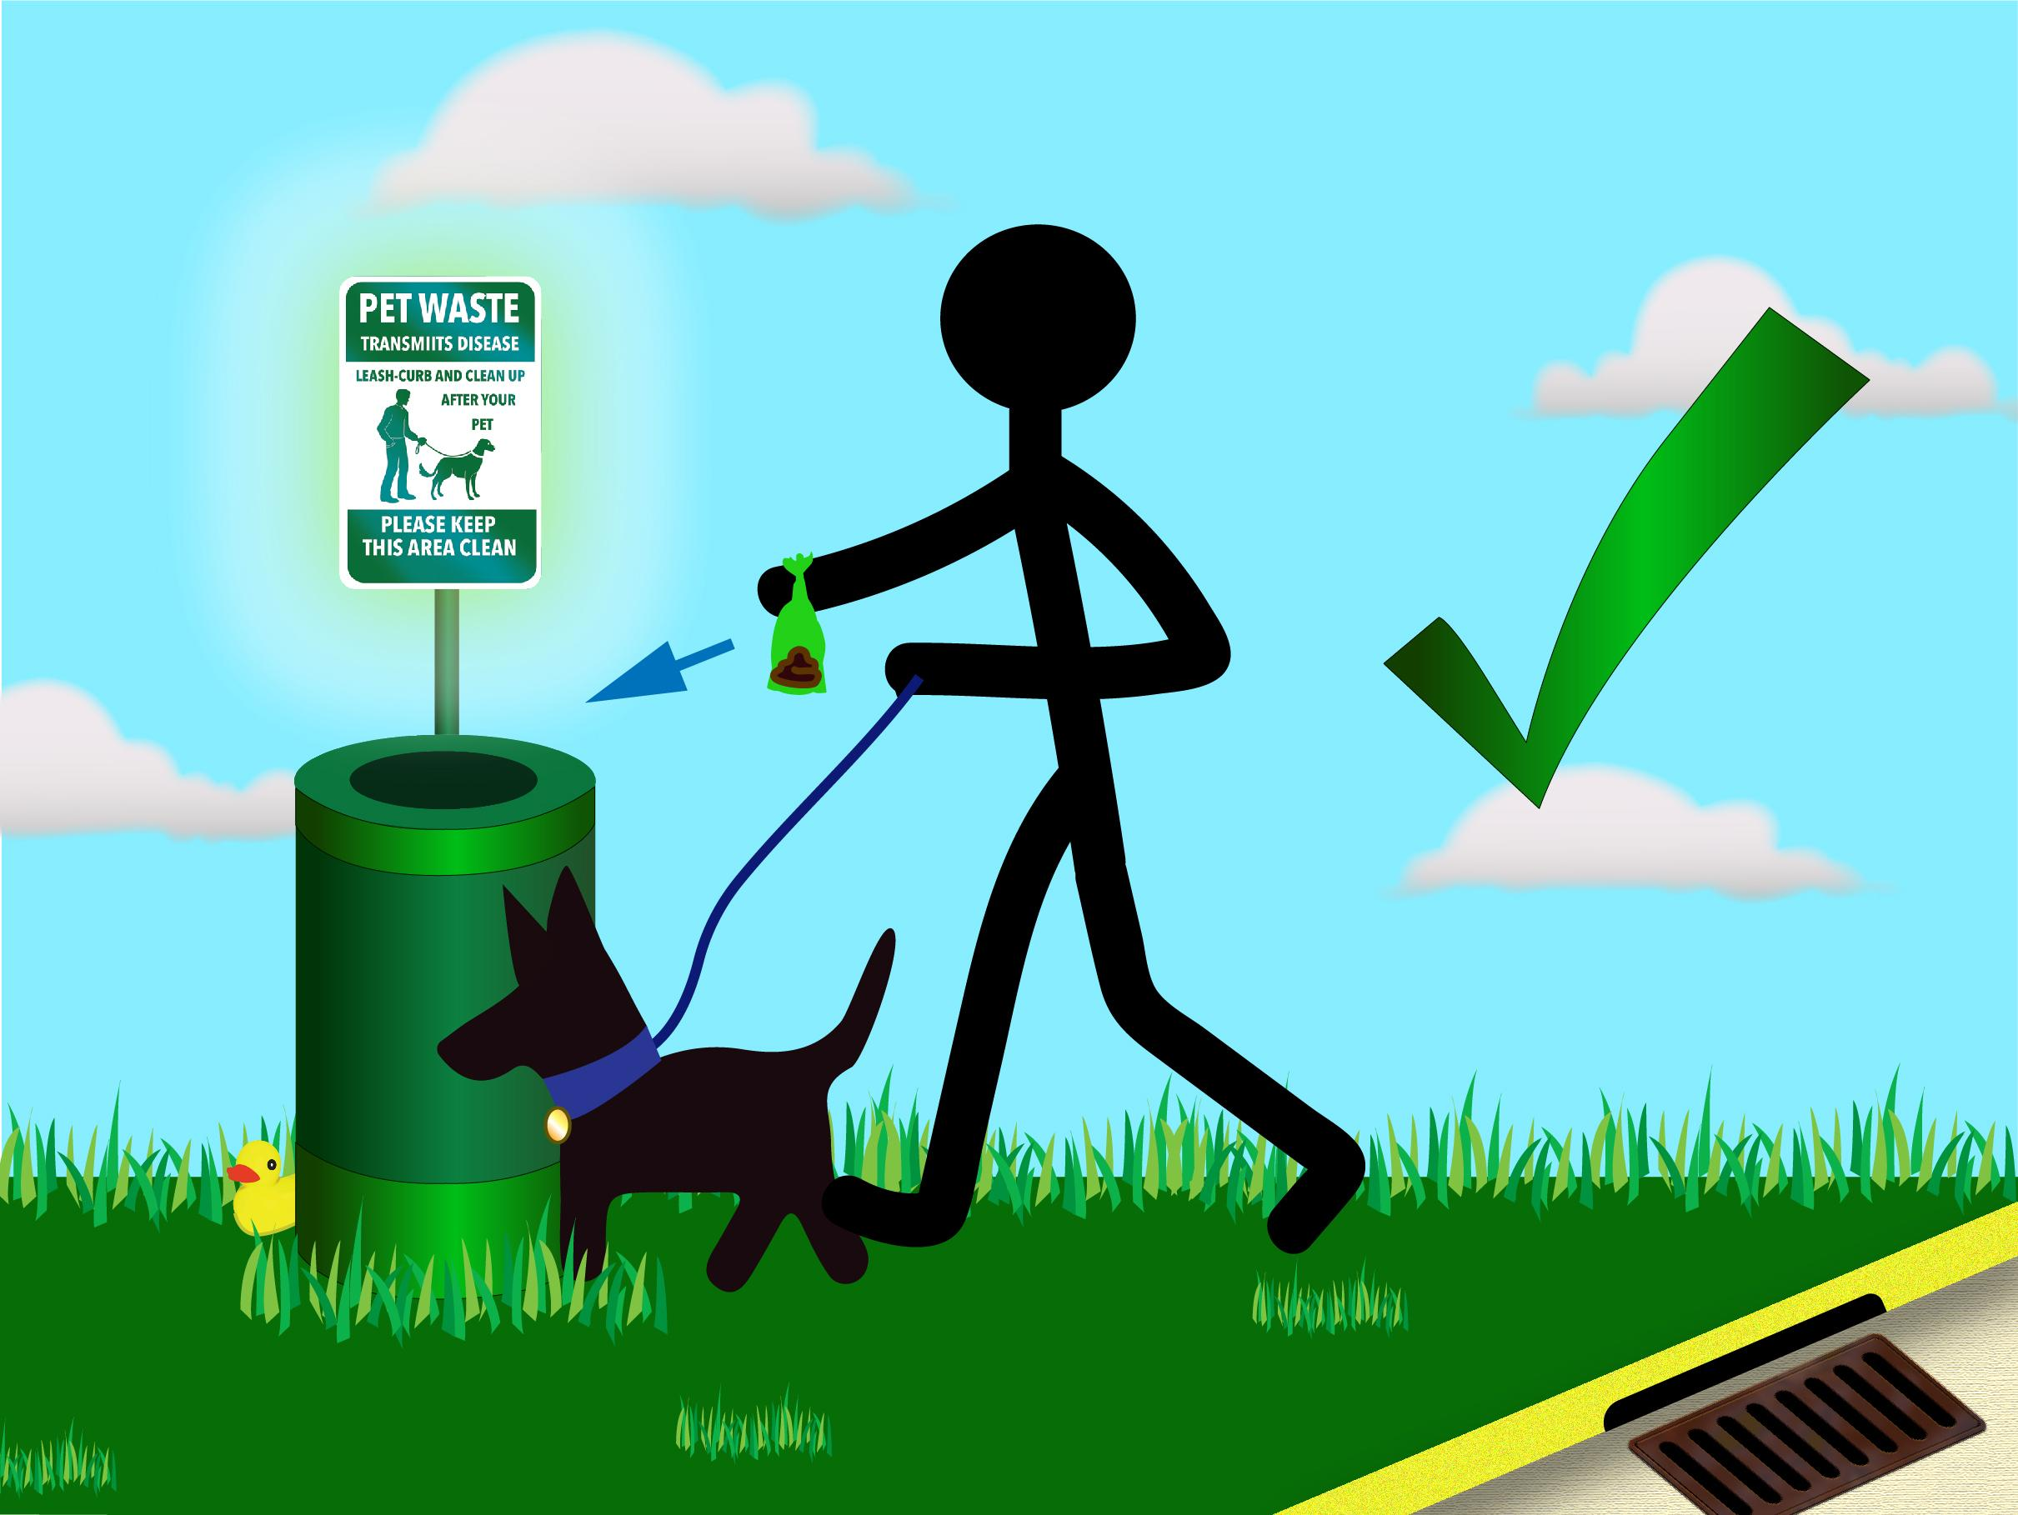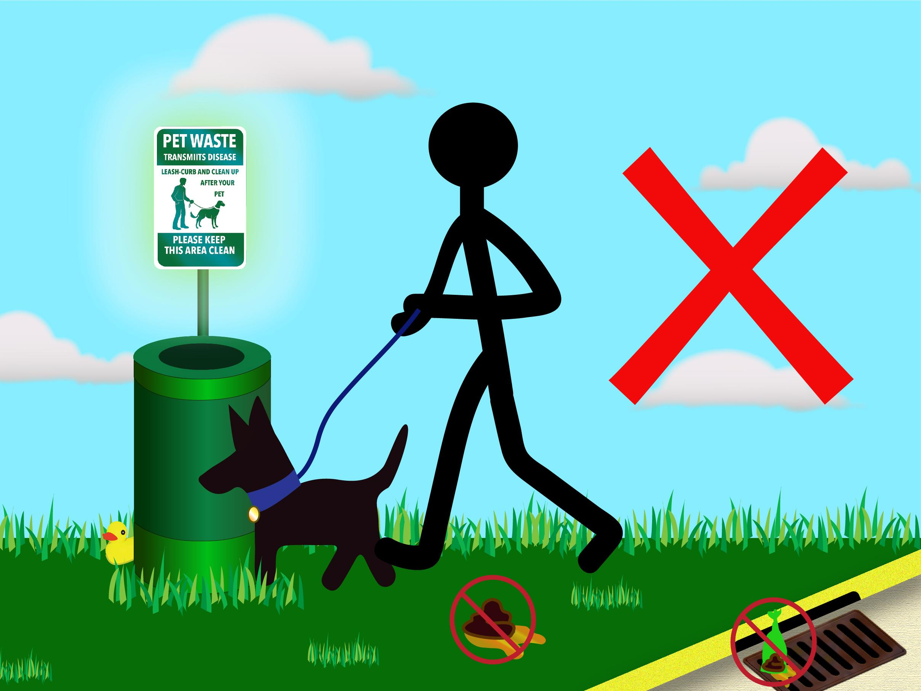
Did you know that the average dog can produce nearly a pound of waste each day?
- Pet waste left on lawns and in public spaces is not only gross. It can be quite harmful too.
- Pet waste contains twice as much bacteria as human waste!
- If left in your yard, pet waste can kill grass and other plants.
- Adults and children who come in contact with it can get sick.
- When pet waste washes into storm drains and waterways, it can make the water unhealthy for people and wildlife.
- Pet waste in waterways can even cause algae to grow, making the water turn an unpleasant green color.

Do your "doody" in both public areas and in your yard. To learn more, visit the www.ThinkBlueMassachusetts.org

Driving/Parking



Speed Limits. Please obey posted speed limits on all Town streets. Speeding tickets result in insurance surcharges for the driver of the vehicle and speeding could endanger the safety of others.

Crosswalks. Always STOP for pedestrians waiting to cross on a crosswalk – it’s the Law!

Safety Vehicles. Please remember to pull over to the right to allow ambulances, fire trucks and police cars with flashing lights and/or sirens to pass.

School Buses. If a school bus or a school van has its lights flashing and a stop sign extended, you must STOP -- It is the law. It does not matter which side of the road you are traveling on. Remain stopped until the lights stop flashing or the stop sign folds back. A first violation of this law can cause a license suspension and a $$$$ fine.


Handicapped Parking Spaces. Anyone found parking in a spot reserved for handicapped parking who does not display a Handicap Placard will be issued a ticket of $$$$$. Keep in mind that even if you are waiting in your vehicle with the car running, you are taking up a spot that someone who is handicapped may need, and you can still be issued a ticket.

Overnight Parking. There is no overnight parking on any street from 2:00 a.m. to 6:00 a.m. This law is in effect 365 days a year. Violators of this regulation will be assessed a $0.00 fine.

Blocking Sidewalks. There is NO parking on sidewalks at any time.


Winter Restrictions
Parking. If you park in the street during a snowstorm or during a parking ban declared by the Chief of Police, you could be issued a ticket for “Interfering with Snow Removal,” which carries a $00.00 fine and your vehicle may be towed at your expense. Please watch the Sturbridge Public Access Channel (Channel # on Charter), as well as the Town of Sturbridge website for updates.

Removing of Vehicles. The Chief of Police shall have the authority to remove any vehicle interfering with snow removal or road work, and may impose upon the owner of such vehicle, liability for the cost of such removal and of the storage charges of said vehicle.


Snow Removal. No person engaged in the removal of snow shall cause snow to be deposited so as to obstruct any public way or sidewalk. Any person removing or clearing snow whether by snow plowing, snow blowing, shoveling or any other kind of snow removal, who deposits or leaves snow in a public way, shall be punished by a fine or penalty of $00.00.


Fire Hydrants. Fire Safety is the responsibility of every member of the community. Please identify the fire hydrant nearest to your home and shovel a pathway to and around it. This will save precious time for firefighters responding to an emergency.

Good Order/General Behavior



Dangerous Weapons. No person shall carry “nun chucks,” sabers, swords or similar weapons, knives having a blade in excess of two and one-half inches or other object or tool so redesigned, prepared or treated that it may be used to inflict bodily harm or injury. No person shall discharge firearms, arrows, pellets, or other substances capable of causing physical harm or property damage. Hunting is not allowed in the Town of Sturbridge.

Fireworks. Pursuant to Massachusetts state law, no person shall possess, sell, or set off fireworks.

Peddling & Soliciting - Permit Required. No person shall sell, solicit or display goods or merchandise on public ways of the Town unless licensed to do so by the Licensing Board. No person shall hawk or peddle without registering with the Chief of Police.


Yard Sales. Yard sale Signs require permits, permit applications can be obtained from the Sturbridge Building Dept. (508) 347-2505

Shopping Carts. No person shall remove a shopping cart from a Business without written permission from the Business. Any person who removes a shopping cart from a business without written permission is subject to a fine,



Home Businesses. Sturbridge welcomes residents to have some home businesses with the following requirements: (1) you must have a business certificate on file in the Town Clerk’s Office, (2) your home business cannot change the residential character of your neighborhood (3) you cannot store or display goods or products outside of your home, and (4) you must have a physical address – post office boxes or mailing center boxes are not allowed. To find out if your business is allowed in a residential area, contact the Building Department at (508) 347-2505, or refer to our Zoning By-Laws on our Town Website. www.sturbridge.gov/contacts

Auto Sales/Repair. The sale or repair of automobiles, other than your own personal vehicle, is prohibited in residential areas.



Noise. In order to keep noise disturbances in our neighborhoods to a minimum, please follow these suggestions:
- Refrain from operating tools or equipment (i.e., leaf blowers and lawn mowers) from 8:00 p.m. - 7:00 a.m. on weekdays, and from 9:00 p.m. - 9:00 a.m. on weekends.
- Refrain from playing music and the use of loud speakers and public address systems from 9:00 p.m. – 8:00 a.m.




Town of Sturbridge Board of Health: (508) 347-2504

Visit the Board of Health for the following:

- Food establishment permitting: Restaurants, Retail, Temporary Food, Bed & Breakfast, Mobile Food, Catering, Residential Kitchen, Frozen Dessert, etc.
- Foodborne illness complaints
- Septic/Title V permitting/complaints: Onsite Disposal Systems, Perc Test Witnessing, Septic Installers, Septage Haulers, etc.
- Well permitting
- Communicable disease tracking
- Hotel/Motel permitting
- Rabid animal testing
- Housing: housing complaints, lead paint determinations, etc.
- State Sanitary Code related complaints, i.e. accumulation of trash/debris, etc.
- Nuisances: nuisance complaints (i.e. noise, dust, odor, etc.) and investigations
- Public & Semi-Public Pools/Spas permitting
- Body Art permitting
- Tanning Salon permitting
- Bathing Beach permitting
- Trash/Offal Haulers permitting
- Beaver Trapping permitting
- Tobacco Sales permitting
- Campgrounds permitting
- Mobile Home Parks permitting

All of the Board of Health applications can be found on our website: town.sturbridge.ma.us

Trash Disposal & Recycling Center Stickers for the Town Dump can be picked up at the Board of Health office or at the Town Dump. For information on disposing of bulk, paint or other Items please call Recycling Center directly at (508) 347-7608.

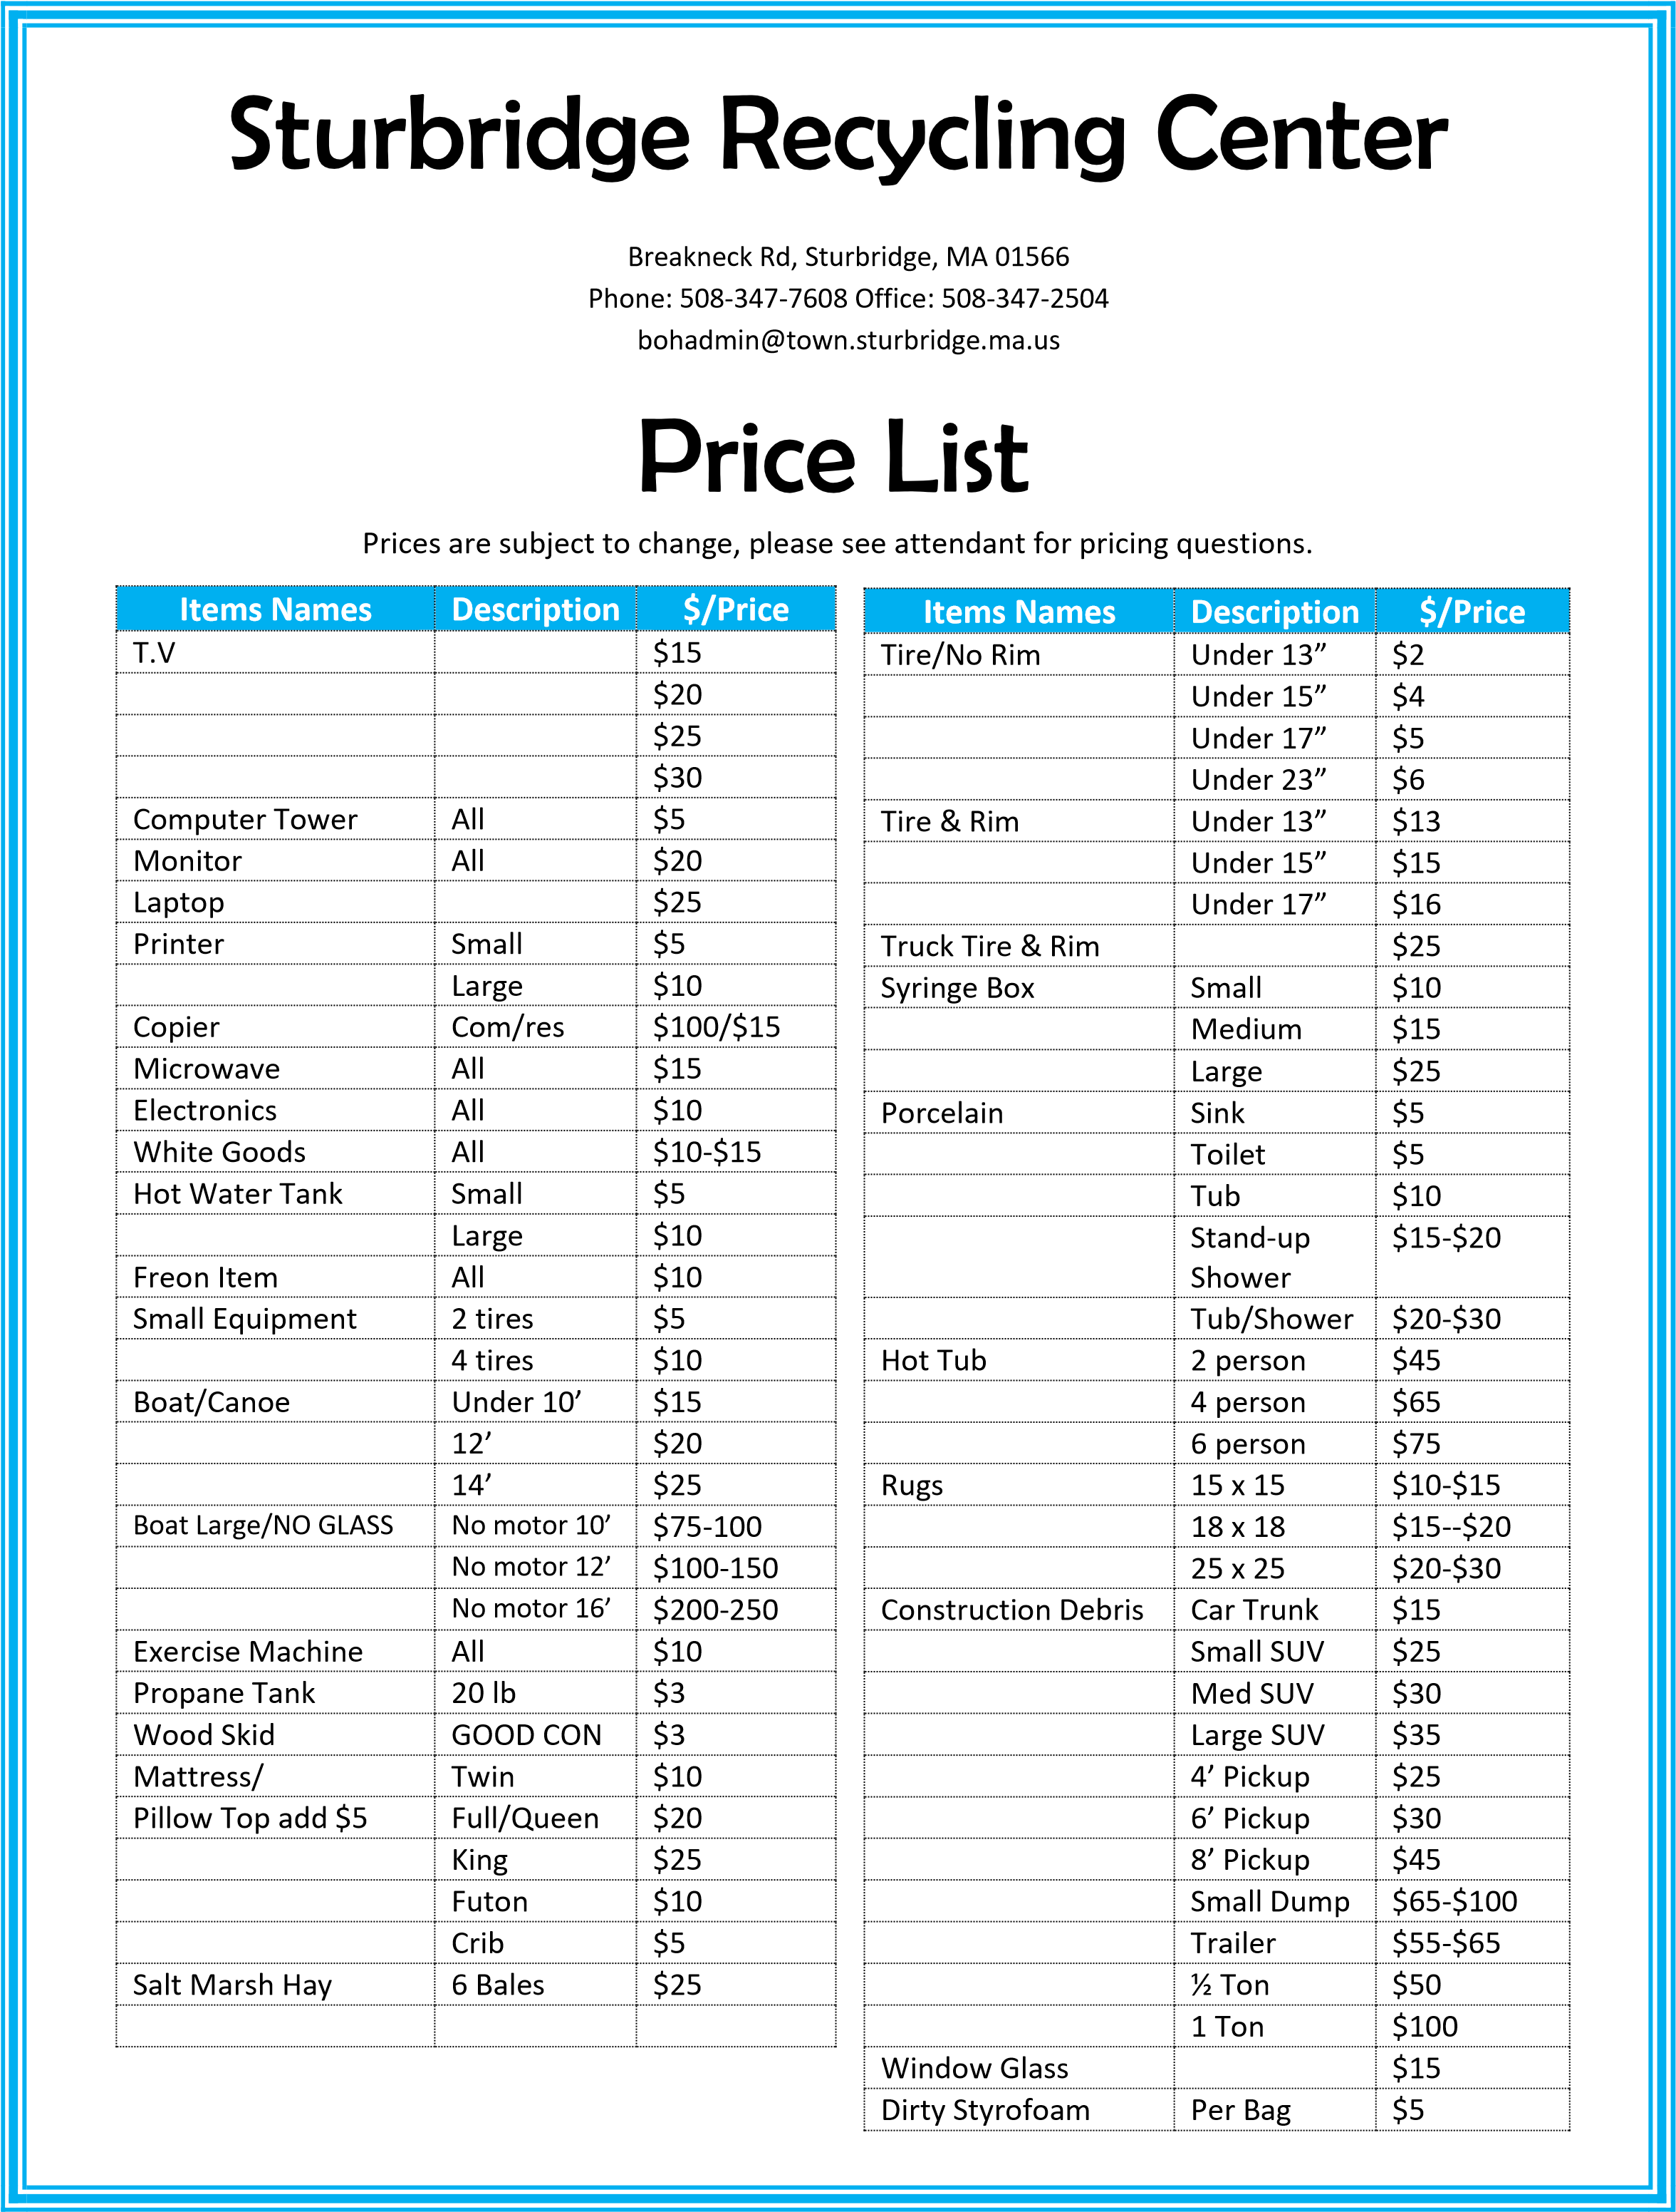

Sturbridge Safety Complex


Sturbridge Police Alert Network. To sign for updates about crimes, emergencies and other information visit: www.sturbridgepolice.gov Make sure to visit our Facebook and twitter pages.

Jaywalking/Sidewalks. Jaywalking is defined as the illegal or reckless pedestrian crossing of a roadway. When crossing a street, please use the designated crosswalks or appropriately marked way. Be Safe! When walking, if a sidewalk is available, use it!

Pot Holes/Street Lights Out. To report a pothole or a street light that needs repair, visit www.seeclickfix/Sturbridge. Once you register, you will be able to report these issues on the site and be able to track it until it has been resolved. When reporting a broken street light, please have the Pole Number available.

Be a Responsible Gun Owner. update your LTC information as needed.

Good Neighbors Look Out for Each Other. To report suspicious situations to the Sturbridge Police, or if you and your neighbors would like to form a neighborhood watch, call the police department at (508) 347-2525.

Car Seat Installation. The Sturbridge Fire and Police Departments are certified child car seat installation locations. Call the Sturbridge Safety Complex. at (508) 347-2525, for an appointment.

Fire Safety Reminder! Be sure to replace the batteries in all the smoke alarms and carbon monoxide detectors in your home when you set your clocks for daylight savings time.



Open Burning Season January 15th - May 1
As of 7am January 15th each year, you will be able to login to the burn permit website and create your new burn permit for that season.
If you are new to open burning, you will be able to create an account then open a new permit. The YouTube link below will bring you to a short video that covers the On-line Open Burning Season application process: https://www.youtube.com/watch?v=38guYWnxqwE&feature=youtu.be
The website address for the Town of Sturbridge Burn Permits is: https://sturbridge.burnpermits.com/

Public Schools and Playgrounds


Burgess Elementary Tantasqua Junior High School Tantasqua Senior High School
45 Burgess School Road 320 Brookfield Road 319 Brookfield Road
Sturbridge, MA 01566 Fiskdale, MA 01518 Fiskdale, MA 01518
(508) 947-7041 (508) 347-5977 (508) 347-9301

Playgrounds. There are three playgrounds in Sturbridge for your enjoyment. Two of the playgrounds are located at our elementary school and one at the Sturbridge Recreation Area. All elementary school playgrounds are open to the public except during school hours.

Assessors


The Board of Assessors is responsible for determining the fair and equitable valuation of all real and personal property in the Town. Field work is conducted year around by the Assessor and consultants on behalf of the Board of Assessors.


Please Visit the Assessor’s Office for the Following Services:

- Excise Abatements
- Real Estate & Personal Property Abatements
- Real Estate Exemptions
- Chapter Land



Council on Aging

.
The Sturbridge Senior Center is to provide a wide range of valuable, high quality services and programs to the aging population in town. We promote participants' health and welfare, provide opportunities for engaging in socialization, support their independence, and help them to continue to live full lives at home and in their community.
Senior Work Off Program
Meals on Wheels
Outreach Coordinator
Daily Activities
Assistance and Relief Programs
Senior and Veteran Work off Programs
Volunteer Opportunities
Fitness Classes Designed for Seniors



Joshua Hyde Public Library
306 Main Street
508-347-2512

LIBRARY HOURS:
Monday 10 am - 5pm
Tuesday - Thursday 10am - 8:00pm
Friday & Saturday 10am - 5pm
Open Sundays Mid-October to Mid-April


How do I obtain a library card?
Library cards are free! Adults must present a valid photo ID with their name and address in order to obtain a library card.

Does the library have computers for public use? The library has a total of 8 computers available for public use.
Can I use my laptop in the library?
Yes, the library provides free Wi-Fi with a mobile print option.

Does the library have a copier for public use?
Yes, the library has a copier for public use.
Black & white photocopies are $.15 each and color photocopies are $.40 each.


Does the library have a fax machine for public use?
Yes, the library has a fax machine for public use. The fee is $1.00 per page for both sending and receiving a fax. The fax number is: (508) 347-2872.

Where can I find downloadable e-audio and e-books for free?
Download the Libby app and sign in with your library card for access to thousands of downloadable materials.
How can I find out more information about the library collection and the programs that are offered?
Access to the online catalog and information about all of the programs for kids and adults can be found online at www.sturbridgelibrary.org or on Facebook and Instagram @sturbridgelibrary

Veterans Services


Sturbridge Veterans Agent ensures that those living within the Town who dutifully served in the United States Armed Forces are awarded the care and benefits that are befitting them.

Federal V.A. health care
Pension Concerns
Education and training benefits
Life insurance
State benefits including tuition assistance
Emergency medical and financial assistance under Mass General Laws.



Town Water Department


Veolia has been operating Sturbridge’s Water Department for 34 Years to ensure the quality of the towns water. The Water Plant must meet an array of State and federal drinking water quality Requirements. These regulations require testing for everything from the aesthetic quality of the water, including color and clarity, t
Conservation and Trails

The Town of Sturbridge has over 6,000 acres of protected open space! These open space parcels are held by the Town, the state of MA, federal agencies and private land trusts. Many of these lands have passive recreational trails and many scenic and historic features to be explored. The Sturbridge Trails Committee plans, constructs and maintains many miles of trails on town owned lands.
While there are popular open space areas throughout the Town such as: Wells State Park, Westville Lake Recreation Area and the Leadmine Mountain Conservation lands (which includes the former Camp Robinson Cruscoe), there are also less familiar spots. For Example, Heins Farm with its wonderful views and walks through fields and mountain laurel filled deciduous forests, or Opacum Woods, with its beaver ponds and interesting plant life, to The Trustees’ Tantiusques Reservation, where the Nipmuc mined graphite which became the site of the first mining location in New England. Information on open space properties and trails can be found at: https://www.sturbridge.gov/conservation-commission/pages/trail-maps.
Sturbridge is large in size at 39 square miles and due to the landscape we have many valuable resource areas including the Quinebaug River and 6 Great Ponds! Great ponds are public waterbodies owned by the Commonwealth for the people. Public access is provided at all of these lakes for your use!
Persons contemplating any work in or within 200 feet of a wetland or stream, should seek information about the Wetlands Protection Act and the Sturbridge Wetland Bylaw at the Commission’s office. Proposed projects or activities located within wetlands or within 200 feet of these wetlands require review pursuant to these laws. The laws set forth a public review process to ensure that the activities do not result in a significant impact to the interests that the wetlands serve. Wetlands serve important functions for the public. A few examples of these interests include: the protection of public and private water supply, the protection of ground water supply, flood control, storm damage prevention and the protection of wildlife habitat. Not all wetlands are clearly visible. If you have questions, please contact the Conservation Department for more information on permitting requirements and open space at 508-347-2506 or by visiting our website at: https://www.sturbridge.gov/conservation-commission.
Did You Know …
⬥ Wetlands reduce flooding, provide wildlife habitat, recharge aquifers, and cleanse water supplies. Wetlands function best in a natural state. Don’t “clean them up;” wildlife thrives in areas with brush piles, rotting logs and other “untidy” things.
⬥ Wetlands can be wet, wooded and/or meadow-like.
⬥ Wetlands on public & private property are regulated.
⬥ Many activities in or near wetlands require a permit.
- Cutting vegetation, trees or shrubs
- Dumping yard waste, dirt, etc.
- Grading, excavating, filling, or redoing lawns
- Building structures
- Changing drainage
Owners are responsible for all activities on their properties. Before hiring workers, call the Conservation Department to determine if a permit is needed.

Finance- Treasurer/Collector

The Finance Department is made up of the offices of Treasurer/Collector, Accountant and Assessing Departments. The Finance Director serves as the Treasurer/Collector. The Finance Director oversees the operations of all divisions of the Finance Department. You’ll want to speak to this Department for the following:

- Grinder Pump policy

- Motor Vehicle Excise Tax Payments
- Payment of Property Taxes, Water and Sewer Bills
- Tax assistance for low income Seniors and disabled citizens.

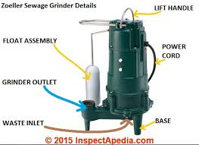





Recreation


Kids Block Party
Summer Recreation Program
Concerts on the Common
Adult Volleyball, Basketball, Pickle Ball, Softball
Town Wide Yard Sale
Halloween Decoration Contest
Christmas Decoration Contest
Youth Sports Leagues
Bus Trips

Economic Development


The Town is here to support and encourage the growth and success of all of businesses here in our community. It is our goal as a Town to provide you, the business leaders of our community with the resources and support to succeed in whatever their goals might be. If the Town can provide assistance in any way we are be happy to do so, what the Town can do for you. (Please talk to Terry about the one stop program.) If you have any questions relating to the Town and your business please contact the Economic Development and Tourism Coordinator for further assistance. (508) 347-1411







Town Clerk

Often considered the core of local government, the Town Clerk’s Office serves as the central information point for local residents and citizens at large.
The Town Clerk is the keeper of town records, the chief election official, a member of the Board of Registrars, official keeper of the Town Seal, registers all events occurring within the community, sends out Annual census to residents and issues Dog Licenses every year. The Town Clerk records and preserves birth, marriage and death records and provides certified copies of these records upon request.




