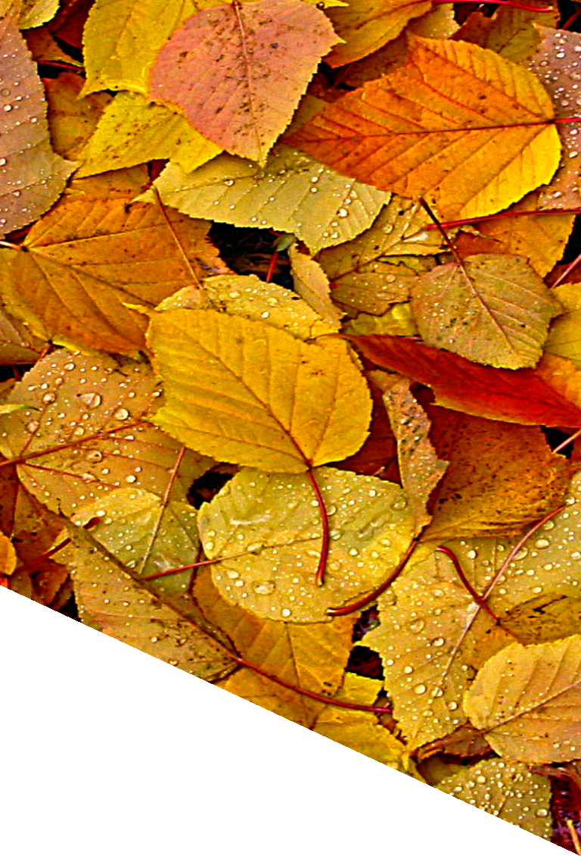

be a

LEAF
HERO

Did you
know?

Leaf litter leaches nutrients into stormwater runoff and contributes to pollution, causing algal
blooms and other water quality concerns. Proper use or disposal of leaves will help to avoid these contaminated flows.
more info on reverse...

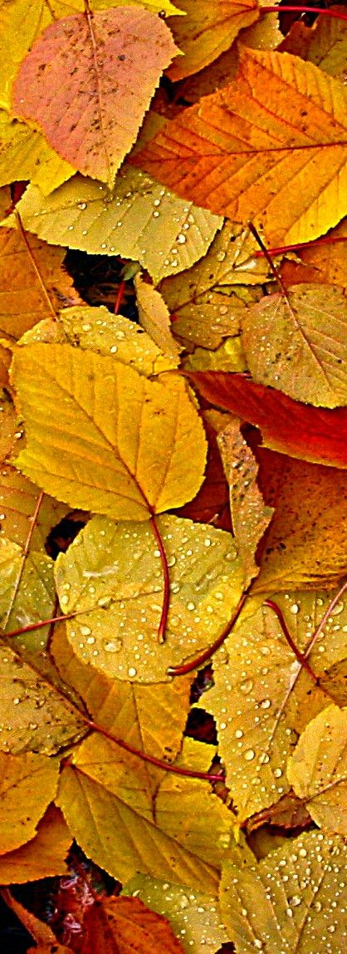
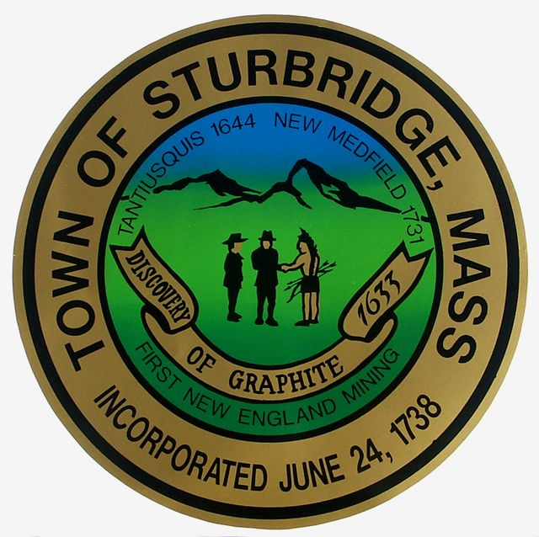

How to be a Leaf Hero

Mulch leaves in place with your lawn mower to put valuable nutrients back into your soil.
Gather leaves and other “yard waste” into a compost pile, let overwinter and decompose and then use as fertilizer next growing season.
Offer your leaves to a neighbor who may be able to use them for composting.
Check in with your city or town hall to find out how to properly dispose of leaves locally.

