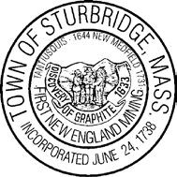 Town of Sturbridge
Sturbridge ARPA Sub-Committee Agenda
January 3, 2023
5:00 PM
Minute Man Hall
2nd Floor
Sturbridge Town Hall
308 Main Street, Sturbridge, MA 01566

- Call to order

- Approval of Minutes of December 5, 2022

- Discuss and Review Recommendations for the use of ARPA Funds to the BOS

- Next Meeting Date

- Adjourn

The items listed which may be discussed at the meeting are those reasonably anticipated by the Chair. Not all items listed may in fact be discussed and other items not listed may also be brought up for discussion to the extent permitted by law.

