
Town of Sturbridge
308 Main Street, Sturbridge, MA 01566
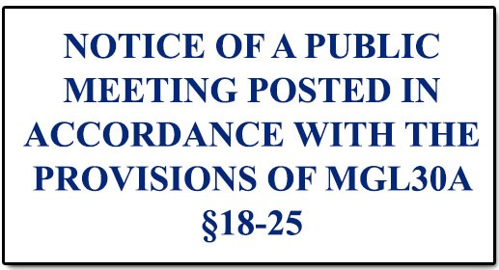
(508) 347-2500

BOARD/COMMITTEE/COMMISSION: Trails Committee
SUBMITTED TO TOWN CLERK: 6-22-26
MEETING DATE: 7-9-26
MEETING TIME: 7:00pm
LOCATION: Center Office Building

Topics the Chair Reasonably Anticipates will or could be Discussed: See Agenda Below.

SCHEDULED AGENDA ITEMS
1. Call to Order & Quorum Check
2. Approval of Previous Minutes*
3. Budget Review
4. Grants
5. Upcoming Events
6. Friends of Sturbridge Trails Update
7. Property Review
8. Upcoming Work Days
9. Old Business
10. New Business

*Votes likely to be taken
Additional Notes:

(Note: This listing of matters reflects those reasonably anticipated by the chair which may be discussed at the meeting. Not all items listed may in fact be discussed and other items not listed may also be brought up for discussion to the extent permitted by law.)

