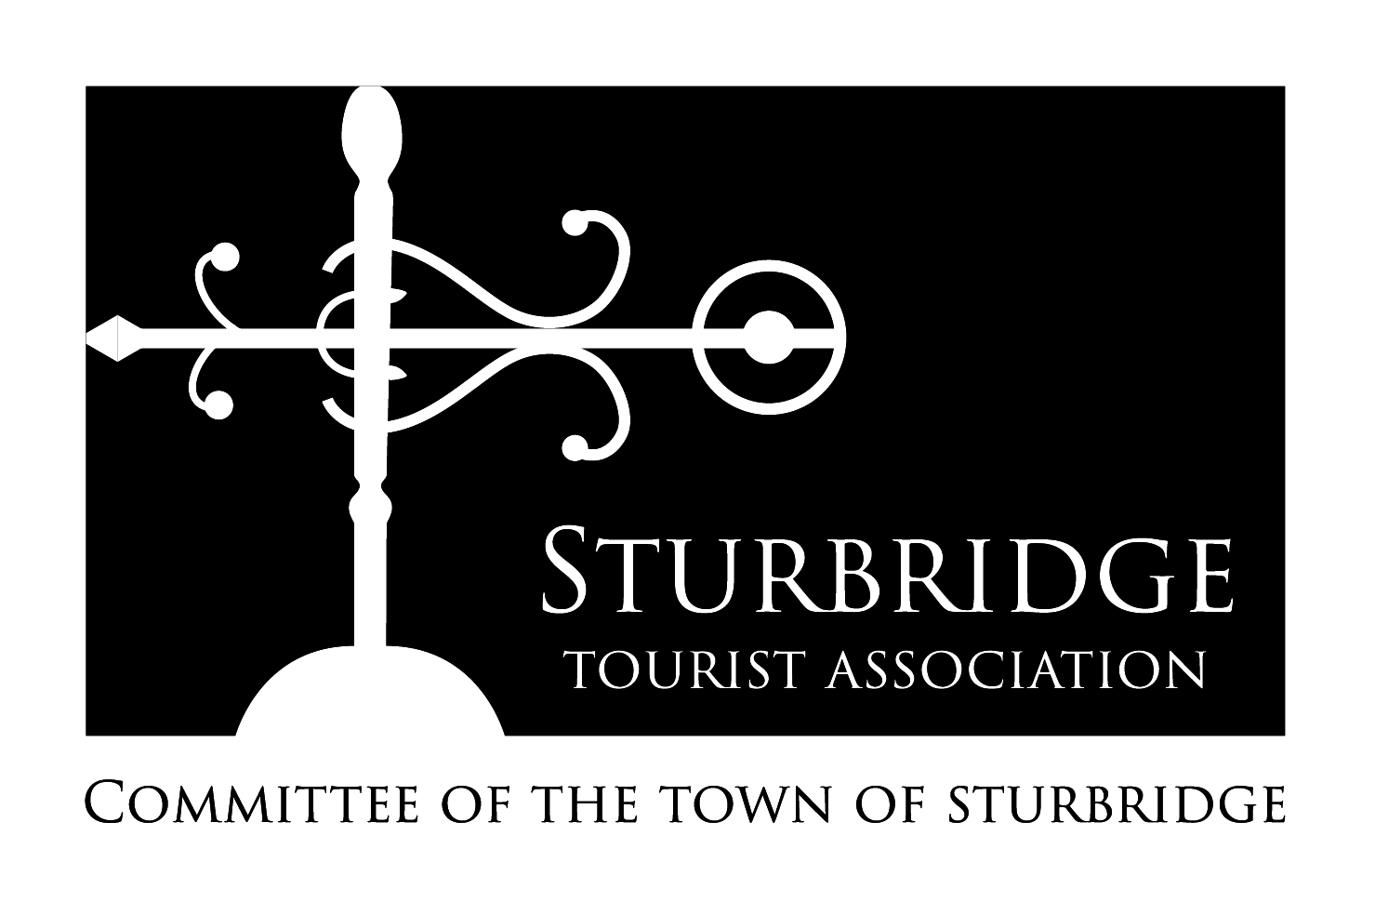
Sturbridge Tourist Association
  - A Committee of the Town of Sturbridge

Regular Meeting

10 January 2018, 5:00pm

301 Main Street, Center Office Building
- Call to Order

- Approval of Previous Minutes – 15 November 2017

- Treasurers Report

- New Business
  - Hartford Courant Funding Campaign
  - 2018 Marketing Plan
  - QR Coded Maps – Sturbridge
  - STA Membership / Advertising Opportunities
    - American Trails
    - Discover Central MA
    - The Last Green Valley

- Old Business

- Economic Development and Tourism Coordinator Report
  - Updated STA Applications

- Next Meeting

- Adjourn
The items listed which may be discussed at the meeting are those reasonably anticipated by the Chair. Not all items listed may in fact be discussed and other items not listed may also be brought up for discussion to the extent permitted by law.

