COMMUNITY PRESERVATION COMMITTEE
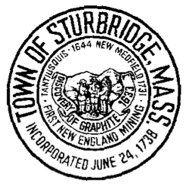

Community Preservation Members

Penny Dumas
Chairperson
At-Large

Edward Goodwin
Vice Chair
Conservation Commission

Kelly Emrich
Member
At-Large

Kadion Phillips
Member
Recreation Committee

Barbara Search
Member
Historic Commission

Walter Hersee
Member
Planning Board

Lauren Vivier
Member
Open Space Committee

308 Main Street
Sturbridge, MA 01566

www.sturbridge.gov

POSTING AND AGENDA
Monday, October 2, 2023 at 7:00 pm Julian Room, 2nd Floor
Sturbridge Town Hall

Quorum Check
- Meeting Minutes
- Reorganization of the committee for FY2024.
- Plan approach for Community Needs Survey Open Forum and set date/time and location.
- Adjourn.
The items which may be discussed at the meeting are those reasonably anticipated by the Chair. Not all items listed may in fact be discussed and other items not listed may also be brought up for discussion to the extent permitted by law.

