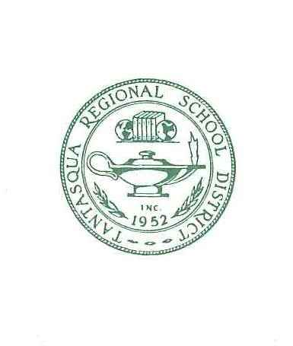
Tantasqua Regional/School Union 61 Districts
320A Brookfield Rd., Fiskdale, MA 01518
(508)347-3077
FAX (508)347-2697

Deborah J. Boyd
Superintendent of Schools

Jodi Bourassa Kristen Leo
Assistant Superintendent Business and Finance Director

Jessica Bolduc Gregory Rossow
Special Education Director Technology Director

NOTICE OF JOINT MEETING

The Tantasqua Regional and Union 61 (Brimfield, Brookfield, Holland, Sturbridge and Wales) School Committees will meet on Tuesday, May 26, 2026 at 6:00 p.m. at
Tantasqua Regional Junior High School library.
AGENDA

- Pledge of Allegiance

- Project 351 Jr. High School Students

- Reorganization-Union 61

- Approval of Minutes
- Regular Session – November 18, 2025

- District Improvement Plan Update

- Superintendent Evaluation 2025-2026
- Superintendent Goals 2026-2027

- Executive Session - Request to enter in Executive Session under M.G.L. Chapter 30A § 21A(3), to discuss strategy with respect to collective bargaining or litigation if an open meeting may have a detrimental effect on the bargaining or litigating position of the public body and the Chair so declares. The committee will return to Open Session.

- Superintendent’s Contract - Vote

- Charting the Course June 20, 2026
- Adjourn

Posted: XX-XX-XXXX

dl:
M. Valanzola W. Goodwin M. Fitzgerald D. Lamoureux-Kane K. Kowal
W. Haggerty N. Chaffee E. Gillen M. Mooney E. Jaeger
S. Noyes-Miller J. Custance E. Goodwin M. Panek
L. Alden A. Dunn C. Greene C. Randall
J. Custance E. Jaeger J. Fabrizio J. Venezia A. Zimmerly
J. Morin N. Chaffee C. LeBrun
L. Alden E. Iller C. Greene A. Joppas J. O’Connor
M. Burns J. Chechile S. Kaitbenski W. Goodwin K. Gendron
C. Randall E. Boyce C. Boehne A. Gallant J. Croke

cc:
D. Boyd J. Bourassa K. Leo
P. Dufresne J. Ribaudo G. Sturges B. Ledbetter K. Hosterman
T. Ferrentino K. Mahota K. Pelley J. Bolduc

Town Clerks: Please post

D. Fagerstrom, Brimfield M. Seery, Brookfield V. Lundin, Holland
L. Girouard, Sturbridge S. Ryan, Wales

publicaccess@brimfield.org bbutcher@sturbridge.gov

The items listed which may be discussed at the meeting are those reasonably anticipated by the Chair. Not all items listed may in fact be discussed and other items not listed may also be brought up for discussion to the extent permitted by law.

*Public Access is a grant of privilege of the Committee and members who wish to address the Committee must do so with respect. Comments shall be limited to two minutes and the Committee is under no obligation to respond.

