Finance Committee Meeting Minutes
Town Hall ~ April 5, 2018
Sturbridge, MA

Call to Order:
The Finance Committee chair called the Finance Committee meeting to order at 7:00pm. The following committee members were present: Kathy Neal (KN), Michael Serio (MS), Joni Light (JL), James Waddick (JW), Mike Hager (MH), Karen Davis (KD), Larry Morrison (LM) and Bruce Boyson (BB).
Absent: Jared Burns (JB)
Guests: Linda Cocalis (LC), Bri Eichstaedt (BE), Becky Plimpton (BP), Steve Mullen (SM), Jackie Belisle (JBe), Dolores Courtemanche (DC)

Review of FY19 Board of Health Budget – Linda Cocalis, Bri Eichstaedt
MS opened discussion of the budget, which is largely level funded from FY18, except for the request to review and approve continued funding of a new inspector position to perform Title V inspections. LC explained how the governor is looking at changing regulations. This will necessitate the Board of Health (BOH) to review and update all current town regulations which will be time consuming and require time of the new Health Agent. Additionally, the BOH will be updating their fee structure which will also take a fair amount of time from the agent. The additional position to conduct Title V inspections would allow the agent to spend more time in the office dealing directly with the residents. There was lengthy discussion around the funding, salary and specific duties for this position. KD brought the discussion to cost effective ways of funding the position, and asked how the current request to fund the position at 90% of the fee structure was determined, understanding that the town must cover both direct and indirect costs. LC informed the committed that the BOH can fund duties out of fees and/or their revolving account under MGL. LM asked again if the BOH did a cost benefit analysis for a consultant requesting that LC explain the steps and, if not, why not. LC shared some of the thinking behind their recommendation to fund the position at 90% of fees, but was unable to obtain certain indirect costs to put together a complete analysis. BE explained that in her six-week tenure in agent position she feels it more beneficial to the town to concentrate on the opioid crisis, impending marijuana regulations and better managing the overall department. With inspectors performing necessary health duties, such as restaurant reviews or pool inspections, she can be more available to the town for other issues.

Many questions were unanswered and given the amount of time spent discussing this matter it was asked that the BOH come back to the committee with more information. Specifically, it was suggested by several members for a detailed cost analysis and/or town comparison on how they compensate their Title V inspector; how compensation is provided i.e., percentage of fee or salaried; certification and how the current person was selected.

Review of FY19 Library Budget – Becky Plimpton
BP introduced the Library Trustees present. JL asked for confirmation of the current staff at the library as BP went through each line item. She was pleased with the additional hours for the downstairs children’s program, and it was working out well. MH asked about the library environment and if technology inhibited the attendance. BP said the library is not being used less, it is being used differently. They have more programs in place; over 400 this year. Other organizations utilize the meeting rooms for their gatherings, and tutors hold sessions daily. LM noted that as a patron he has always observed the staff to be helpful, competent and eager to assist. JL asked if she has been able to spend more time in the library with librarian duties rather than the building issues with the town employing a facility manager and custodians. BP said she still spends a fair amount of time working on building issues. There was further discussion on future space planning for the building.

Voting on Line Item Budgets

The following line items were reviewed for the Joshua Hyde Library Building. The motion was moved to recommend by KB.

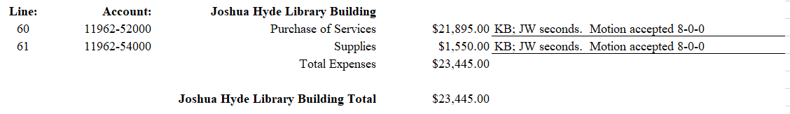

The following line items were reviewed for the Joshua Hyde Library Operations. The motion was moved to recommend by KB.

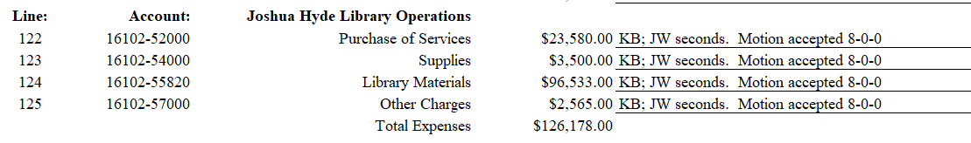

The following line items were reviewed for the Nursery School. The motion was moved to recommend by JW.

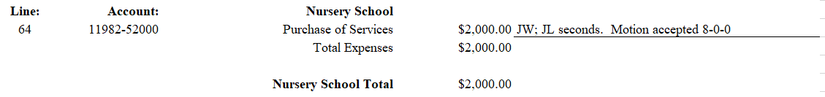

The following line items were reviewed for 8 Brookfield Road. The motion was moved to recommend by JW.

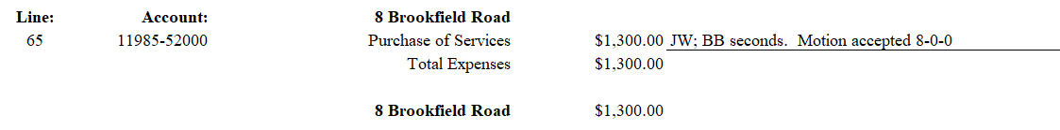

The following line items were reviewed for the Board of Health. The motion was moved to recommend by MS.

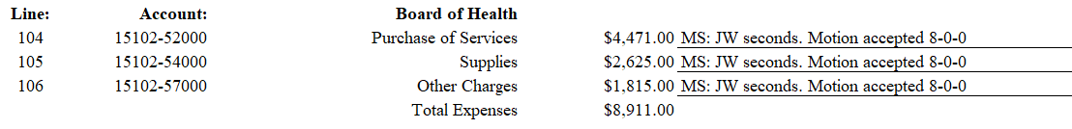

The following line items were reviewed for the Historical Commission. The motion was moved to recommend by MS.
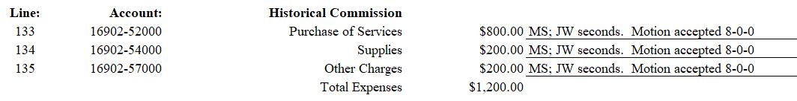

The following line items were reviewed for the Debt Service Principal. The motion was moved to recommend by KD.

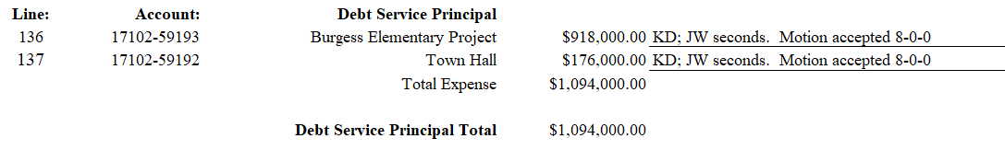

No Meeting Minutes to Approve

New Business
KN reminded the committee of the town elections on Monday, April 9. MS said he would follow up with the Board of Health on questions of the committee.

No Old Business/No Public Access

BB motions to adjourn. MH seconds. Motion accepted 8-0-0. Meeting adjourned at 9:22pm.

/jml

