Finance Committee Meeting Minutes
Town Hall ~ April 19, 2018
Sturbridge, MA

Call to Order:
The Finance Committee chair called the Finance Committee meeting to order at 7:00pm. The following committee members were present: Kathy Neal (KN), Michael Serio (MS), Joni Light (JL), James Waddick (JW), Mike Hager (MH), Jared Burns (JB), Karen Davis (KD), Larry Morrison (LM) and Bruce Boyson (BB).

Reserve Fund Transfer – Fire Department
Chief Grasso submitted a request for $23,148.00 to be transferred from the Reserve Fund to Fire Department Supplies for the equipment costs associated with the newly hired firefighters under the SAFER Grant. The grant awarded the town with four new firefighters over the course of 36 months. Equipment costs were not included in the grant.

JW moved the motion to approve the transfer of $23,148.00 from the Reserve Fund to the Fire Department Supplies Account 12202-54000; JL seconds. Motion accepted 9-0-0.

Line Item Budget Discussion and Votes
KN is waiting on the Board of Selectman votes for the department salary line items (personnel costs), and so requested that the committee set aside voting on these line items at another meeting.

The following line items were reviewed for the Board of Selectman. The motion was moved to recommend by MH.

The following line items were reviewed for the Town Administrator. The motion was moved to recommend by JB.

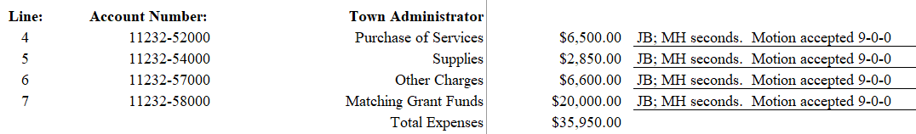

The following line items were reviewed for the Town Accountant. The motion was moved to recommend by KD.

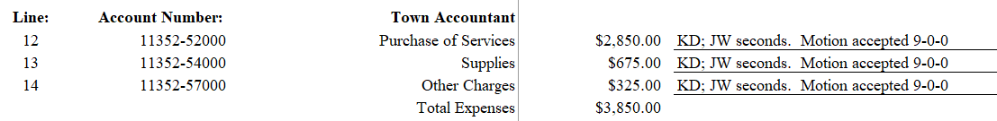

The following line items were reviewed for the Finance Director. The motion was moved to recommend by KD.

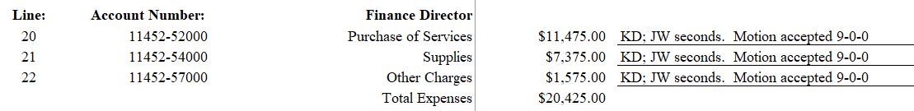

The following line items were reviewed for the Town Counsel. The motion was moved to recommend by JB.

The following line items were reviewed for Information Technology. The motion was moved to recommend by KD.

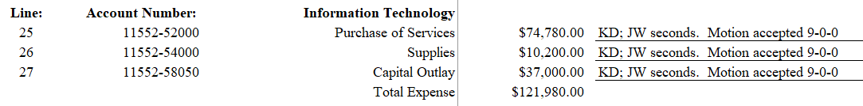

Discussion continued around the budget for Information Technology. MH raised concerns that other avenues were overlooked such as a third-party vendor who would be on call to handle issues as they arise.

JW explained how a person on-site would be a benefit to the employees in cases where some may have issues with email or printing problems, for example. Rather than have the finance director take time out of her day to help resolve it, which appears to happen in many cases, the on-site technology person would be able to take that responsibility. MS shared his experience with third party vendors, and said many ad hoc services in this industry are more expensive. Further, he went on to say that vendors would not be able to adequately plan for the town’s technology needs. KN reminded the committee that the amount of money spent in 2017 to fix the server issues probably exceeded the amount of money proposed had the town had a dedicated staff member.

JB asked if the benefit of having a dedicated IT position outweighed the cost of paying a third-party service which prompted discussion around costs, duties and responsibilities, and needs of the town. JL explained that this individual would be doing more than just troubleshooting desktop issues, but would be responsible for computer upgrades, inventory, as well as taking the burden off a few key people in town hall to get it done. MS concurred that this individual would be able to find the more cost-effective solutions to software upgrades, and be proactive to the town’s needs, and more.

The following line items were reviewed for Economic Development. The motion was moved to recommend by JB.

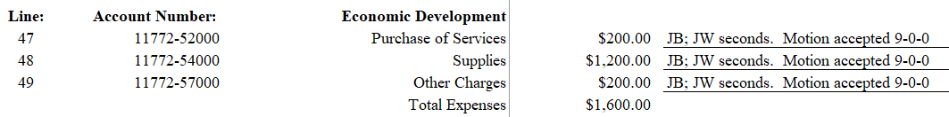

The following line items were reviewed for Facilities. The motion was moved to recommend by JB.

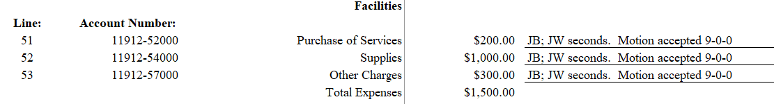

The following line items were reviewed for Town Hall. The motion was moved to recommend by BB.

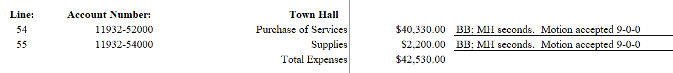

The following line items were reviewed for Center Office Building. The motion was moved to recommend by BB.

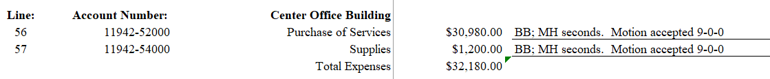

The following line items were reviewed for the Senior Center Building. The motion was moved to recommend by BB.

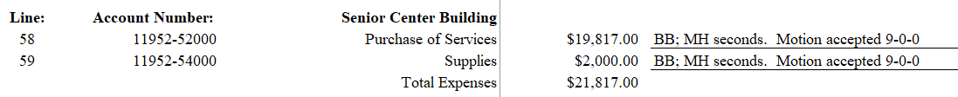

The following line items were reviewed for Council on Aging. The motion was moved to recommend by BB.

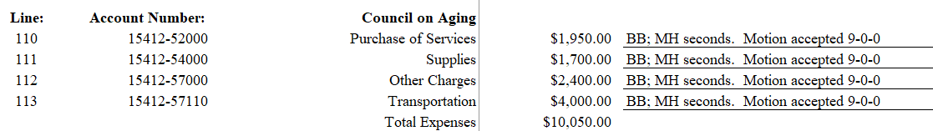

The following line items were reviewed for Veteran’s Services. The motion was moved to recommend by JB.

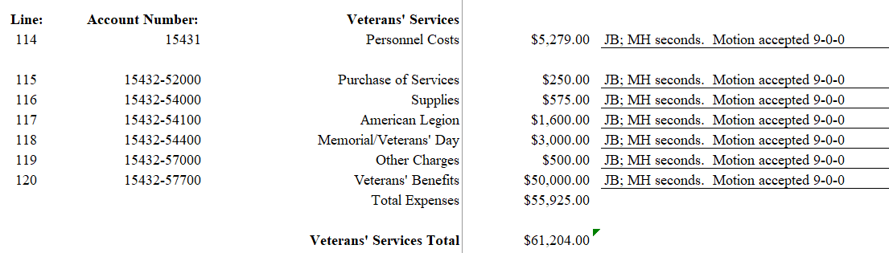

The following line items were reviewed for Unclassified. The motion was moved to recommend by KD.

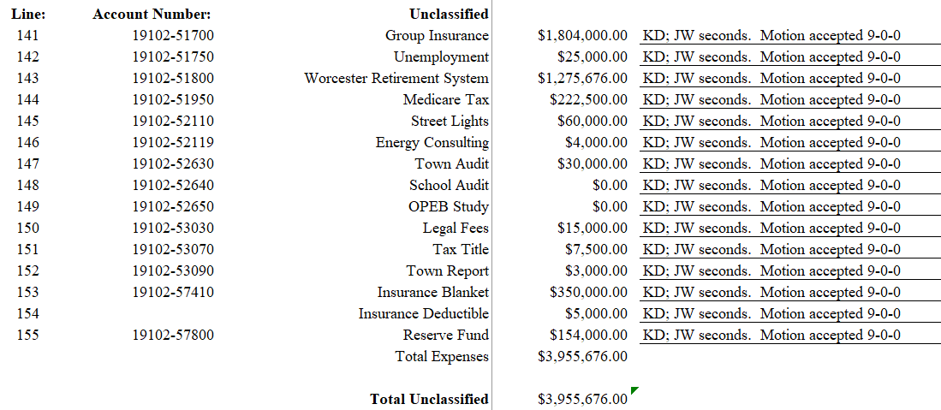

The following line items were reviewed for Central Purchasing. The motion was moved to recommend by KD.

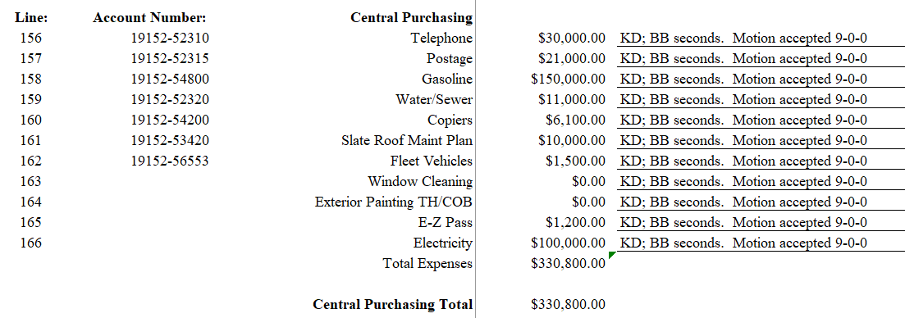
Annual Town Meeting Warrant Discussion and Votes
KN noted that a new version was sent, and the committee was reviewing that April 17 document.

JL moved the motion to accept Article 1 – Town Reports as written; JB seconds. Motion accepted 9-0-0.

JW moved the motion to accept Article 2 – Community Preservation Committee Report as written; JL seconds. Motion accepted 9-0-0.

MH was curious to know if the committee will get a report on how much money the total warrant entails. He would like to compare it to last year.

There was discussion only on Article 3 – Historic Cemetery Restoration, as this is part of a multi-year project.

The committee agreed to review the CPC article when that board meets with the committee.

JW moved the motion to accept Article 7 – Road Construction, Repairs and Maintenance as written; JL seconds. Motion accepted 9-0-0.

JW moved the motion to accept Article 8 – Town Budget as written; MH seconds. Motion accepted 9-0-0.

JL moved the motion to accept Article 11 – Sewer Project Debt as written; JW seconds. Motion accepted 9-0-0.

JL moved the motion to accept Article 12 – Public Access Department as written; MH seconds. Motion accepted 9-0-0.

Discussion continued around the cable access. JB asked if this was the right way to service the community with many homes seeking other options for internet and television. He was curious to know if there was information on the number of residences in town who have cable.

KD moved the motion to accept Article 16 – Betterment Committee as written; JW seconds. Motion accepted 9-0-0.

There was discussion on the Capital Plan as outlined in Article 17. LM noted that the article itself had no parenthetical numbers included in the body consistent with all articles. This is a housekeeping change that the moderator would expect to be corrected.

KD moved the motion to accept Article 17 – Capital Improvement Plan to include the parenthetical numbers of “$70,000.00” as amended; MH seconds. Motion accepted as amended 9-0-0.

MH moved the motion to accept Article 18 – Tree Planting Transfer of Funds as written; JW seconds. Motion accepted 9-0-0.

JL moved the motion to accept Article 19 – Ambulance Stabilization Fund as written; JW seconds. Motion accepted 9-0-0.

JB moved the motion to accept Article 20 – Fire Vehicle Stabilization Fund as written; JW seconds. Motion accepted 9-0-0.

JW moved the motion to accept Article 21 – OPEB Trust Fund as written; JL seconds. Motion accepted 9-0-0.

JL moved the motion to accept Article 23 – Capital Stabilization Fund as written; JW seconds. Motion accepted 9-0-0.

All other article would be reviewed and voted on in subsequent meetings.

Approval of Meeting Minutes
JL moved the motion to accept the minutes from April 10, 2018, as amended. JW seconds. Motion accepted 7-0-2 (LM, KD abstained).

JB moved the motion to accept the minutes from April 12, 2018, as amended. JW seconds. Motion accepted 7-0-2 (LM, KD abstained).

No Old Business/No New Business/No Public Access

MH moved the motion to adjourn. KD seconds; the motion carried 9-0-0 and the meeting is adjourned at 9:17pm.

/jml

